At Stockland Green School assessment and feedback procedures are intended to support the work of learning in the school by:

- Ensuring short and effective feedback leads to student progress and where appropriate, influences delivery, sequencing and selection of activities.
- Providing a range of assessors with feedback that promotes a Growth Mindset and student meta cognition.
- Ensuring there is an interaction between teacher and student in order to drive student progress thus maximising the potential of all students.
- Having a cumulative process which builds upon previous learning.
- Overcome issues with covid-19 guidance and isolating work, with a more focused approach to formative assessment and feedback leading to student progress.

The Teachers Standards specify that teachers should:
- Make accurate and productive use of assessment
- Know and understand how to assess the relevant subject and curriculum areas, including statutory assessment requirements.
- Make use of formative and summative assessment to secure learners’ progress.
- Use relevant data to monitor progress, set targets, and plan subsequent lessons.
- Give learners regular feedback, both orally and through accurate marking, and encourage learners to respond to the feedback.

Assessment

What do we want from our assessment models?
“Wrong forms of assessment impact on the breadth and depth of curriculum, understanding of standards and the tools we use to raise them.” – Christodoulou

- Low stakes, high frequency testing to inform planning and teaching, whilst sharing regular success with students
- Authentic assessment, focused on learning, not on generating datasets for the purposes or tracking performances of minute sub groups.
- Formative assessment geared towards identifying consequences. Providing information that can directly feed back into the teaching process. This needs to be specific, frequent and repetitive. Responsive teaching; short cycle, in the moment feedback, in tight loops.
- Summative assessment geared at creating a ‘shared meaning’, beyond the context of a classroom so that standards can be compared between classes and cohorts in school and the wider community. Infrequent. Subject specific assessment – in the form most useful for a particular discipline.

Knowledge and Meta Cognition
- At Stockland Green, we recognise the importance of knowledge acquisition to our student’s futures, and the need to build cultural capital. As such, our curriculum and assessment models link to create both knowledge and skills-based assessments. Lessons will start with low stakes, high frequency testing of subject content mixed with generic, wider contextual knowledge-based content.
- Low stakes testing is designed to help pupils embed and use knowledge frequently and develop their understanding. Retrieval of relevant and interleaved knowledge from previous lessons, previous units, and previous years.
- Students at Stockland Green are taught to think about their own learning processes and their understanding of their thoughts within this. Lessons have taken on more of an approach to develop cognitive load, through the incorporation of activities such as planning how to approach a learning task, using appropriate skills and strategies to solve a problem, monitoring one's own comprehension of texts, self-assessing and self-correcting in response to the self-assessment, and evaluating self-progress toward the completion of a task.
- Modelling of learning and tasks to provide feedback and guidance before a task is attempted.

Formative Assessment
“The process of regular testing can strengthen retrieval and improve our retention of knowledge in our long term memory.” – Bjork

- From September 2020, formative assessment will play a crucial role in monitoring student learning in line covid-19 restrictions.
- Formative assessment - Low stakes, open-question quizzes and multiple-choice questions. Responsive teaching, pupils receive instant feedback, correct mistakes and improve answers. More info on formative assessment
- Self-assessment opportunities embedded within lessons using criteria, checklists and model answers. Students correct and improve their answers immediately after completing the task.
- KS3 Knowledge Audits (AO1 – Assessment Books) - heavily knowledge focused. Multiple knowledge audit exams in every subject. These audits are cumulative, consolidating learning covered in previous units of work and not allowing students to forget content. KAs to be used half-termly, self-assessed and recorded.

Summative Assessment – adapted in line with Covid guidance
“Assessment has different forms in different subject disciplines. Imposing a general system loses the information that supports actual improvement.” - Sherrington
- Summative assessment regularity will be dependent on the needs of the subject. Maths and Science for example will have more ‘End of Unit’ style assessments than English and Humanities subjects would with longer essay assessed units of work.
- Reteach following summative assessments
- There is no ‘fixed’ summative assessment calendar, and faculty areas have mapped out, subject to their curriculum coverage and workload demands, their desired summative points throughout the year.
- The weeks leading up to summative assessments will focus on revision skills for students of all year groups.
- KS3 assessments and Year 9 are not graded, and instead teachers enter Working Towards, Meeting or Exceeding for students based against their EOY targets working back from Year 11.
- KS4 assessments in Year 10 and 11 are graded according to the national 9-1 scale.

Teacher Judgement
“Assessment data has no value in relation to improving the quality of student learning.” – Sherrington
- Too much assessment data will stop real learning, and overwork staff.
- In between assessment points, student work needs to be monitored, with misconceptions addressed and teaching processes reviewed and adapted to reflect this process.
- Teacher workload and wellbeing is important to us, and we trust our staff explicitly on the working levels of their students. To not overwork staff with extra marking, whilst also tracking student progress regularly, we rely in between assessment points on teacher judgement. These judgements will continue to be Working Towards, Meeting or Exceeding targets as set above, through standardisation processes.
- Frequency of teacher judgement between review points will depend wholly on the regularity of curriculum contact with students and will vary between CORE and Non-CORE faculty areas. A judgement should be made every time there is work of note to comment on.

Use of assessment data
To achieve expected progress over five years, curriculums are planned to ensure students make age related progress year on year to ensure a trajectory towards their End of Year 11 target grades. Targets are challenging rather than estimates of future performance. Please see whole school target setting for further guidance on target setting.

- Heads of Faculty, Subject Leaders, House and Pastoral Leaders should work where necessary with class teachers in reviewing the data at different stages throughout the year in order to inform future teaching and learning.
- There should be appropriate review points consisting of a student conference throughout the year according to the needs of individual subject curriculums. These review points will usually take the shape of summative assessments, but with Teacher Judgement cycles in between as necessary.

Following Review Points (Student Conferences)
There should be a standardised process following ‘review points’ from Heads of Faculty, House and Pastoral Leaders, SENCO. Calendared time should be used to assess current Attitudes to Learning and Attainment data, and performance of key sub groups, faculties and subject areas etc identified to target support. From these meetings a student conference is attended, where a shared and agreed set of actions for targeted students are determined in order to ‘close gaps’ in data and support a united T&L / pastoral approach.

It is the responsibility of the classroom teachers to ensure that the assessment data that they generate informs future planning, intervention and evaluations. Interventions should be put into place as a result of these analyses in order to ensure that all students are supported to make further progress.

Reporting
It is fundamental to student progress that parents / guardians are involved in the process of their child’s learning. Part of this process is the reporting, at various stages throughout the year, of a child’s attitude to learning, and progress towards their targets.

It is the responsibility of the classroom teacher to report to parents / guardians their child’s progress (KS3) / attainment (KS4) at specified review points in the year. A teacher should judge student’s attitude to learning as Not meeting SGS (Stockland Green Standard) (See Appendix 3) / Meeting SGS / Exemplifying SGS, and judge a student’s progress / attainment as Working Towards / Meeting / Exceeding.

All reports will require a short supporting statement from the classroom teacher where a student’s attainment, progress or attitude does not meet SGS. It is also expected that for students not meeting the required standards, contact home is made at the appropriate points throughout the year.

There is no expectation for full reports to be sent home, as all relevant information regarding a student should be communicated home regularly throughout the year.

Feedback

“Learning only happens in the detail of what students know and understand and the things they can do.”
At Stockland Green School we believe feedback is crucial to your child reaching his / her full potential. With this view, our new Feedback Policy includes the following main features:
- Summative feedback: This will be through the grading of examinations and other assessments.

- DIRT Feedback (See Appendix 1): After work has been assessed, the following lesson must include ‘DIRT’ (Dedicated Improvement and Reflection Time)
This DIRT should provide students with specific targets and the opportunity to respond, address misconceptions and improve responses. This will also allow teachers the opportunity to recognise excellent student work through rewards and support students who haven’t fully grasped concepts effectively. Students must respond to all targets in Green pen.

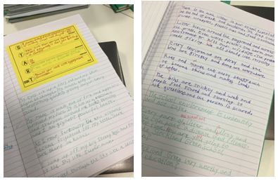
- Self / Peer feedback: Student will be expected to engage with marking criteria at appropriate intervals
- Whole class feedback: Following some assessment, students receive feedback that is prompt, immediately actioned, workload-efficient and effective in securing improvement.
- Live Feedback: Taking place during lesson time, this feedback will be responsive to student understanding as the lesson progresses. This will involve verbal feedback as teachers work alongside students to improve knowledge and correct errors / misconceptions. Use for visualisers and model answers to ensure teacher teach from the front.

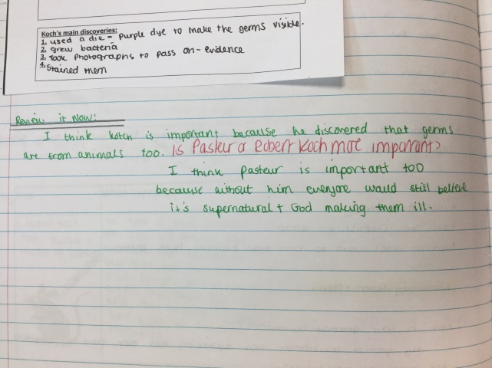

Marking / Frequency of Marking / Quality Assurance
All students have two exercise books per lesson. One exercise book (green) will be a work book. This will contain students practice notes and will not be formally marked. One exercise book (yellow) will be an assessment book. The assessment book will receive teacher, self and peer feedback and requires student DIRT to be evident following key assessments.

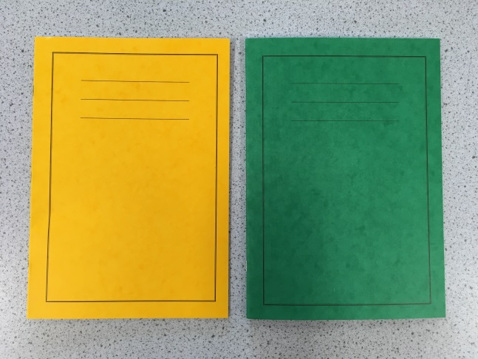

The frequency of marking in the yellow assessment books should be in line with the assessment calendar which aligns with Faculty curriculum needs. There is an expectation that all summative assessments must be marked using a model which provides a strength and offers specific feedback for improvement, one example used is the START marking formula, an example of which is demonstrated below.

Feedback may include both self and peer assessment opportunities. Assessment marking will be reviewed at scheduled points throughout the year by Faculty teams. This has been adapted in light of Covid, and is currently under review. (October 2020) Assessment books should also include intermittent ‘two stars and a wish’ diagnostic feedback to support students in their progress towards summative assessments.

Quality assurance: regular QA of students’ assessment books and lessons will take place in accordance with the assessment calendar and learning walk rota (adapted due to Covid). The focus of this will be quality and utility of feedback given. It is the responsibility of Heads of Faculty to conduct QA in Team meetings / CPD as appropriate, and to ensure follow up actions are completed.
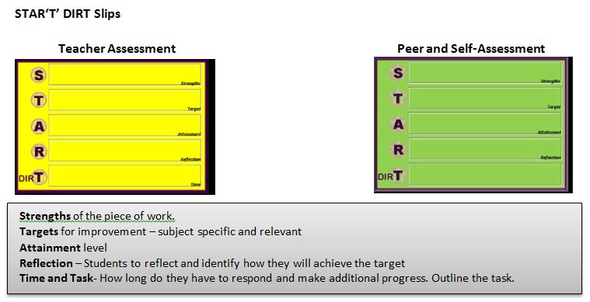
Literacy
Literacy must be marked using specified codes (see appendix 2)
It is recognised that it may not always be appropriate for every punctuation or grammatical error in a piece of writing to be corrected.
Corrections may be limited to subject specific key words and words it is felt that students should know. It is expected that correction of errors of literacy is a substantial focus in the marking of summative assessments.

Numeracy
Errors in calculations, vocabulary and units of measurement should be identified and students should make appropriate corrections.
Graphs tables and diagrams should be drawn in pencil and axes must be labelled correctly. When using computers, the correct graphs should be chosen, and axes must be labelled.
Teachers should comment on numeracy in feedback where relevant.
Numeracy skills to be assessed where relevant in low stakes testing

Who wrote the policy  With input from | Sean Castle  Sarah Cardwell  Patrick McCarthy  Samantha Windebank  HOFs | Deputy Head Teacher  Assistant Head Teacher  Head of English  Heads of Faculty  Student Leadership / Wellbeing groups
Who is responsible for making amendments
Version | One

Appendix 1 - DIRT (Dedicated Improvement and Reflection Time)
DIRT is about having the highest expectations of students and them having the highest expectations of themselves. DIRT is a great way for students to act upon the feedback that have been given from their teacher or peers. DIRT allows students to reflect/act upon the comments that have been written, as feedback. Ensuring the feedback is being put to use and is supporting progress. Not for their next piece of work but NOW!
‘DIRT lessons’ can form the starter or longer pieces of work; they could take the whole lesson. Students should complete the ‘DIRT’ work in a green where appropriate.
DIRT can be used for self and peer assessment – clear, measurable learning objectives, assessment bubbles or assessment objectives can support students reflecting or giving peer to peer assessment.
Keep it focused
Select the most relevant pieces of work, at the most appropriate time.

Directed
Give the process some structure. This will vary with subject and task. Don’t leave students with 15 minutes to fill and only your written comments to go on.

Model and scaffold
Use exemplar, giving students a high standard to reach for with their work. Reviewing a poor example, with the teacher, or improving upon a weak example of work also helps scaffold their understanding. DIRT time may seem to be about independent work, but teacher guidance is key.

Make oral feedback count
With good quality modelling and scaffolding students should be sufficiently focused to allow the teacher to undertake good quality ‘one to one feedback’ whilst DIRT is taking place.

Time
Plan for DIRT! Set aside some of your lesson time for this process, this might even be a whole lesson. Never a token 5 minutes.

Examples of DIRT Activity’s
Reflection and responding to precise feedback
Students using teacher feedback to analyse their own work, question by question improving methodology and accuracy of answer.

Feedback in the form of questions to extend students understanding
This scaffolds student understanding, step by step, with the expectation that students act upon their feedback using DIRT – writing an appropriate detailed response to teacher feedback.

Drafting and proof reading, their books with a clear signal that improving their writing and literacy is a basic, but crucial expectation of their learning. In this case DIRT marking is about improving extended writing and ensuring students proof read their work automatically.

Appendix 2 – SPAG as part of the Stockland Green Standard
Throughout the section of work that is marked, teachers and students will use the following notation to highlight Spelling, Punctuation and Grammar.

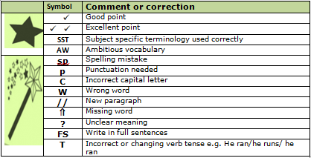
Appendix 3 – The Stockland Green Standard

Appendix 4 - Presentation Expectations (as part of the Stockland Green Standard)
