



Year 11 English

Exam Preparation Resource Booklet

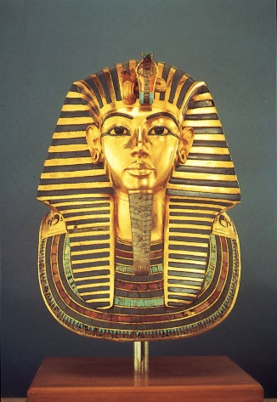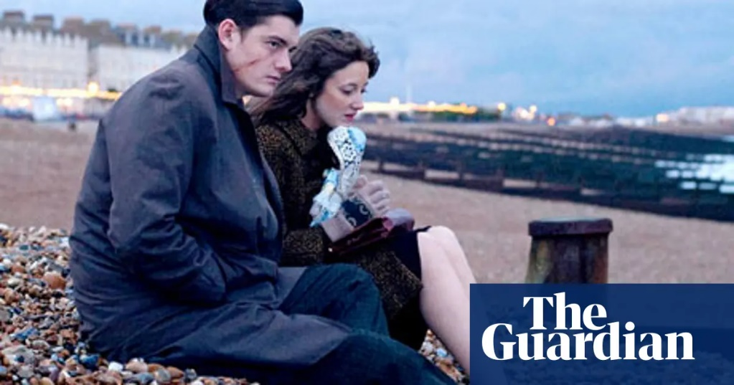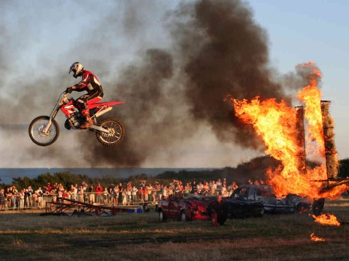

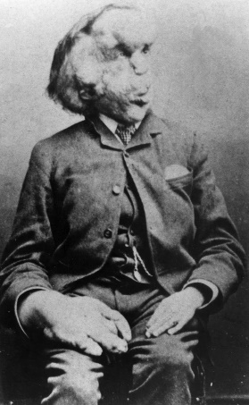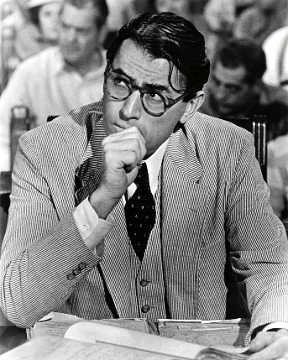

NAME:____________________________CLASS:_______________TEACHER:___________________

**Periodic Table of Language Elements: The Things You Need To Remember For All Of Your English Exams**

|  |  |  |  |  |  |  |
| --- | --- | --- | --- | --- | --- | --- |
| **Word Classes** | **Linguistic Devices** | **Rhetorical Devices** | **Figurative Language** | **Sentence Forms** | **Poetry Glossary** | **Poetic Structure** |
| **Pronoun**  **Pn**  **Replaces the noun in a sentence** | **Exclamation Mark**  **!**  **Indicates something amazing, surprising or spoken loudly** | **Listing**  **Lg**  **Grouping similar examples to create power** | **Imagery**  **Ig**  **Creating an image in the reader’s mind** | **Simple Sentence**  **Si**  **Has one idea: a single subject and verb** | **Oxymoron**  **Ox**  **Two opposing terms used together (e.g. bittersweet)** | **Stanza**  **Sz**  **A ‘paragraph’ or section in a poem** |
| **Noun**  **N**  **The name of a place, person or object** | **Question Mark**  **?**  **Indicates a question** | **Emotive Language**  **El**  **Using words which create an emotional response in the reader** | **Simile**  **S**  **Comparing two things using ‘like’ or ‘as’** | **Compound Sentence**  **Cd**  **Two simple sentences joined with a conjunction** | **Juxtaposition**  **Jx**  **Two contrasting ideas placed together** | **Rhyme**  **Rh**  **Repetition of sounds at the end of a line of poetry** |
| **Adjective**  **Aj**  **A word used to describes noun** | **Semi-Colon**  **;**  **Indicates a break between two dependent clauses** | **Facts and Statistics**  **Fs**  **Using real information or percentages to support argument** | **Metaphor**  **Me**  **Comparing two things as though one is the other** | **Interrogative**  **In**  **A sentence which asks a question** | **Caesura**  **Cs**  **A pause or break in the middle of a line of poetry** | **Couplet**  **Cp**  **Two lines of poetry which rhyme** |
| **Adverb**  **Av**  **Modifies the verb** | **Colon**  **:**  **Separates two independent clauses or begins a list** | **Hyperbole**  **Hy**  **Exaggerated statements** | **Personification**  **Ps**  **Giving an inanimate object human qualities** | **Imperative**  **Im**  **A sentence which gives a command** | **Enjambment**  **Ej**  **One line of poetry continuing onto the next** | **End Stop**  **Es**  **A full stop at the end of a line of poetry** |
| **Verb**  **V**  **Describes an action, state or occurrence** | **Comma**  **,**  **Used to separate items in a list or two clauses** | **Repetition**  **Rp**  **Saying the same thing more than once** | **Onomatopoeia**  **On**  **A word which sounds like it’s meaning** | **Exclamatory**  **Ex**  **Expressed surprise/anger- ends with a !** | **Persona**  **Pr**  **The speaker or character created within a piece of poetry** | **Rhythm**  **Ry**  **Regular pattern of movement or sound in poetry** |
| **Article**  **Ac**  **A type of determiner, such as ‘a’ or ‘the’** | **Full Stop**  **.**  **Ends a sentence.** | **Rhetorical Question**  **Rq**  **Asking questions to make the reader think** | **Alliteration**  **Al**  **Two or more words beginning with the same sound** | **Declarative**  **Dc**  **Expresses an opinion, statement or announcement** | **Sibilance**  **Sb**  **Repetition of ‘s’ sounds** | **Metre**  **M**  **The basic rhythm or structure of a poem** |

**Contents Page**

Understanding the Language papers- a breakdown ………………………………………………………… p4

What do good annotations look like? …………………………………………….…………………………………… p5

**Paper 1 Section A**

‘War of the Worlds’ by H.G. Wells

‘Blood on Snow’ by Jo Nesbo

‘Life of Pi’ by Yann Martel

‘Children of Men’ by P.D. James

**Paper 2 Section A**

Recap: finding TRUE pieces of information (AO1)

Recap: synthesising information (AO1)

Recap: comparing writers’ perspectives (AO3)

‘Voyage on the Beagle’ and ‘Howard Carter’s Diary’

‘The Elephant Man’ and ‘Stunt Performer’

**Annotating an extract PROPERLY: a guide**

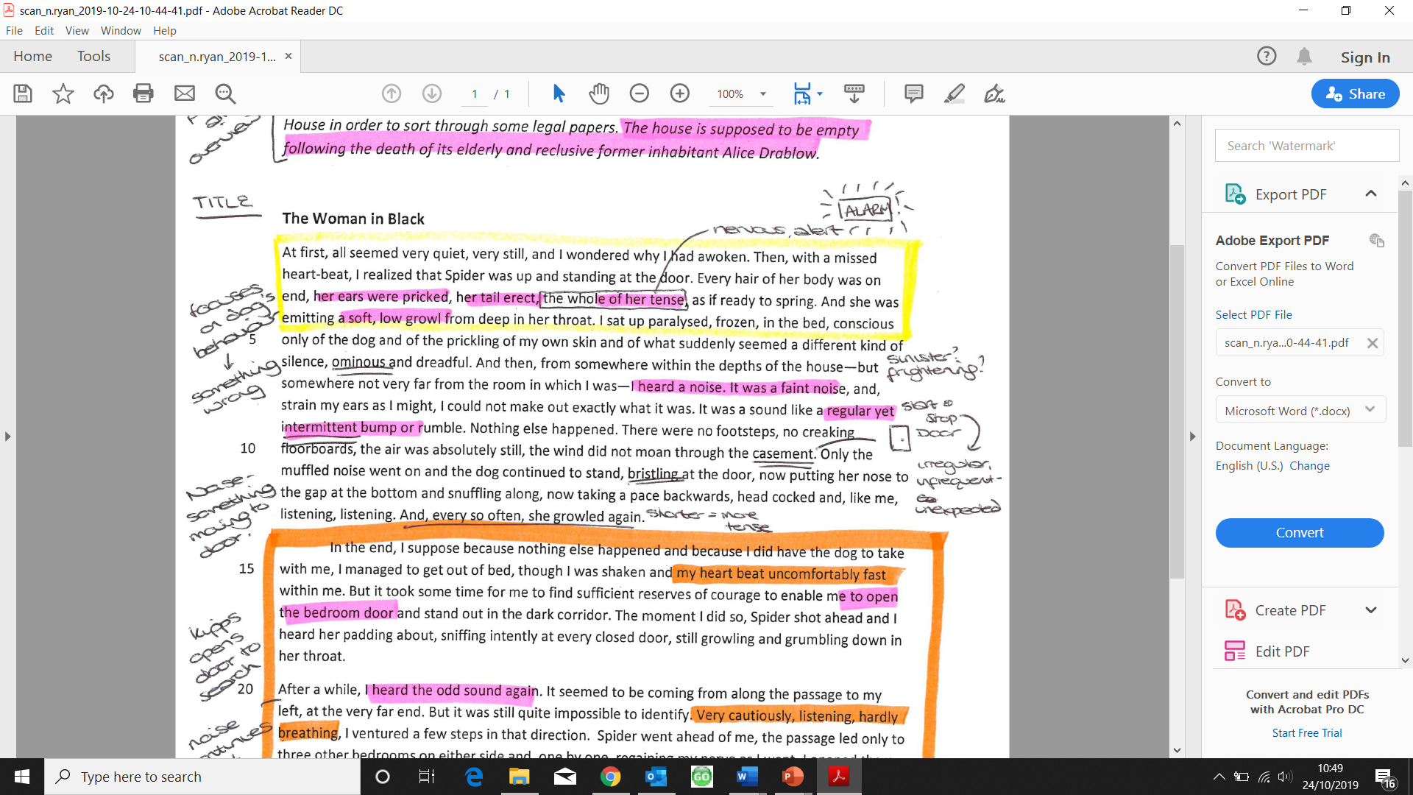

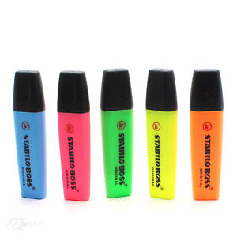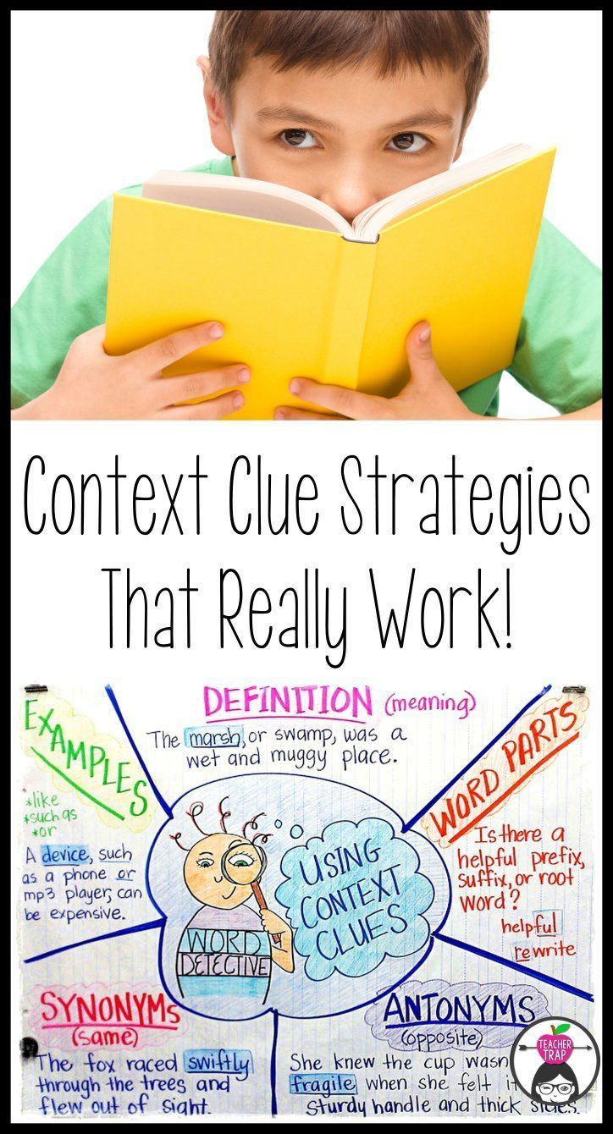

**Equipment**:

* 4 different coloured highlighters
* Use a different colour to annotate for each question

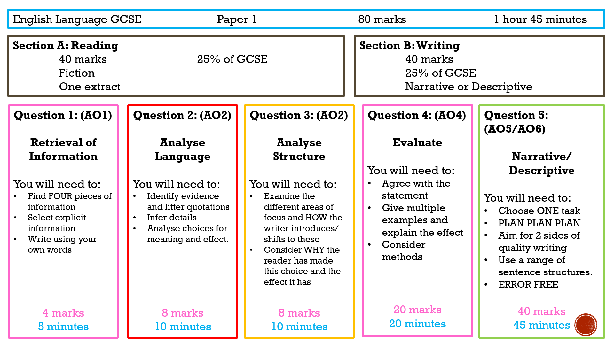

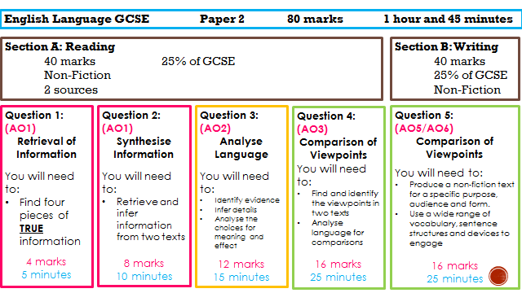

**Paper 1 Extract 1: ‘Blood on Snow’ by Jo Nesbo**

In this extract, the narrator, Olav, is a hired killer and has just shot a man. He is reflected on the job he has to do and what has happened, as well as the beauty of the winter setting.

**Annotate:**

**Vocab**

**Language choices/ effect**

**Give each paragraph a title**

The snow was dancing like cotton wool in the light of the street lamps. Aimlessly, unable to decide whether it wanted to fall up or down, just letting itself be driven by the hellish, ice-cold wind that was sweeping in from the great darkness covering the Oslo fjord. Together they swirled, wind and snow, round and round in the darkness between the warehouses on the quayside that were all shut for the night. Until the wind got fed up and dumped its dance partner beside the wall. And there the dry, windswept snow was settling around the shoes of the man I had just shot in the chest and neck.

      Blood was dripping down onto the snow from the bottom of his shirt. I don’t actually know a lot about snow – or much else, for that matter – but I’ve read that snow crystals formed when it’s really cold are completely different from wet snow, heavy flakes, or the crunchy stuff. That it’s the shape of the crystals and the dryness of the snow that make the haemoglobin in the blood retain that deep red colour. Either way, the snow under him made me think of a king’s robe, all purple and lined with ermine, like the drawings in the book of Norwegian folk tales my mother used to read to me. She liked fairy tales and kings. That’s probably why she named me after a king.

      The *Evening Post* had said that if the cold carried on like this until New Year, 1977 would be the coldest year since the war, and that we’d remember it as the start of the new ice age scientists had been predicting for a while. But what did I know? All I knew was that the man standing in front of me would soon be dead. There was no mistaking the way his body was shaking. He was one of the Fisherman’s men. It was nothing personal. I told him as much before he collapsed, leaving a smear of blood down the wall. If I ever get shot, I’d rather it was personal. I didn’t say it to stop his ghost coming after me – I don’t believe in ghosts. I just couldn’t think of anything else to say. Obviously I could have just kept my mouth shut. That’s what I usually do, after all. So there must have been something that made me so talkative all of a sudden. Maybe it was because there were only a few days to go before Christmas. I’ve heard that people are supposed to feel closer to each other around Christmas. But what do I know?

      I thought the blood would freeze on top of the snow and end up just lying there. But instead the snow sucked the blood up as it fell, drawing it in under the surface, hiding it, as if it had some sort of use for it. As I walked home I imagined a snowman rising up from the snowdrift, one with clearly visible veins of blood under its deathly pale skin of ice.

      On the way back to my flat I called Daniel Hoffmann from a phone box to tell him the job was done.

1. Read again the first part of the source from **lines 1 to 7.**

List four things about the snow from this part of the source. **(4 marks)**

1. ___________________________________________
2. ___________________________________________
3. ___________________________________________
4. ___________________________________________

2. Look in detail at this extract . .

The snow was dancing like cotton wool in the light of the street lamps. Aimlessly, unable to decide whether it wanted to fall up or down, just letting itself be driven by the hellish, ice-cold wind that was sweeping in from the great darkness covering the Oslo fjord. Together they swirled, wind and snow, round and round in the darkness between the warehouses on the quayside that were all shut for the night. Until the wind got fed up and dumped its dance partner beside the wall. And there the dry, windswept snow was settling around the shoes of the man I had just shot in the chest and neck.

How does the writer use language here to describe the weather?

You could include the writer’s choice of:

* Words and phrases
* Language features and techniques
* Sentence forms **(8 marks)**

3. Consider the whole text.

How has the writer structured the text to interest you as a reader?

You could write about:

* What the writer focuses your attention on at the beginning.
* How and why the writer changes focus as the source develops.
* Any other structural features that interest you.  **(8 marks)**

4. For this answer, you need to consider the whole text.

A reader of this extract said *“the murderer, Olav, feels no regret or remorse for the murder he’s committed”*

To what extent do you agree?

In your response, you could:

* Consider your own impressions of Olav.
* Evaluate how the writer shows that Olav feels no regret or remorse.
* Support your response with references to the text. **(20 marks)**

**Paper 1 Extract 2: ‘Life of Pi’ by Yann Martel**

This extract is from a novel by Yann Martel. In this section the central character, Pi, is on a sinking ship. The ship is carrying the animals belonging to Pi’s father, who owns a zoo.

Inside the ship, there were noises. Deep structural groans. I stumbled and fell. No harm done. I got up. With the help of the handrails I went down the stairwell four steps at a time. I had gone down just one level when I saw water. Lots of water. It was blocking my way. It was surging from below like a riotous crowd, raging, frothing and boiling. Stairs vanished into watery darkness. I couldn't believe my eyes. What was this water doing here? Where had it come from? I stood nailed to the spot, frightened and incredulous and ignorant of what I should do next. Down there was where my family was.

I ran up the stairs. I got to the main deck. The weather wasn't entertaining any more. I was very afraid. Now it was plain and obvious: the ship was listing badly. And it wasn't level the other way either. There was a noticeable incline going from bow to stern. I looked overboard. The water didn't look to be eighty feet away. The ship was sinking. My mind could hardly conceive it. It was as unbelievable as the moon catching fire.

Where were the officers and the crew? What were they doing? Towards the bow I saw some men running in the gloom. I thought I saw some animals too, but I dismissed the sight as illusion crafted by rain and shadow. We had the hatch covers over their bay pulled open when the weather was good, but at all times the animals were kept confined to their cages. These were dangerous wild animals we were transporting, not farm livestock. Above me, on the bridge, I thought I heard some men shouting.

The ship shook and there was that sound, the monstrous metallic burp. What was it? Was it the collective scream of humans and animals protesting their oncoming death? Was it the ship itself giving up the ghost? I fell over. I got to my feet. I looked overboard again. The sea was rising. The waves were getting closer. We were sinking fast.

I clearly heard monkeys shrieking. Something was shaking the deck, a gaur - an Indian wild ox -exploded out of the rain and thundered by me, terrified, out of control, berserk. I looked at it, dumbstruck and amazed. Who in God's name had let it out?

I ran for the stairs to the bridge. Up there was where the officers were, the only people on the ship who spoke English, the masters of our destiny here, the ones who would right this wrong. They would explain everything. They would take care of my family and me. I climbed to the middle bridge. There was no one on the starboard side. I ran to the port side. I saw three men, crew members. I fell. I got up. They were looking overboard. I shouted. They turned. They looked at me and at each other. They spoke a few words. They came towards me quickly. I felt gratitude and relief welling up in me. I said, "Thank God I've found you. What is happening? I am very scared. There is water at the bottom of the ship. I am worried about my family. I can't get to the level where our cabins are. Is this normal? Do you think-"

One of the men interrupted me by thrusting a life jacket into my arms and shouting something in Chinese. I noticed an orange whistle dangling from the life jacket. The men were nodding vigorously at me. When they took hold of me and lifted me in their strong arms, I thought nothing of it. I thought they were helping me. I was so full of trust in them that I felt grateful as they carried me in the air. Only when they threw me overboard did I begin to have doubts.

1. Read again the first part of the Source from lines 1 to 12.

List four things from this part of the text about the ship. **(4 marks)**

1. ___________________________________________
2. ___________________________________________
3. ___________________________________________
4. ___________________________________________

2. Look in detail at this extract . .

Where were the officers and the crew? What were they doing? Towards the bow I saw some men running in the gloom. I thought I saw some animals too, but I dismissed the sight as illusion crafted by rain and shadow. We had the hatch covers over their bay pulled open when the weather was good, but at all times the animals were kept confined to their cages. These were dangerous wild animals we were transporting, not farm livestock. Above me, on the bridge, I thought I heard some men shouting.

The ship shook and there was that sound, the monstrous metallic burp. What was it? Was it the collective scream of humans and animals protesting their oncoming death? Was it the ship itself giving up the ghost? I fell over. I got to my feet. I looked overboard again. The sea was rising. The waves were getting closer. We were sinking fast.

I clearly heard monkeys shrieking. Something was shaking the deck, A gaur-an Indian wild ox-exploded out of the rain and thundered by me, terrified, out of control, berserk. I looked at it, dumbstruck and amazed. Who in God's name had let it out?

How does the writer use language here to describe the narrator’s fright and confusion?

You could include the writer’s choice of:

* Words and phrases
* Language features and techniques
* Sentence forms **(8 marks)**

3. Consider the whole text.

How has the writer structured the text to interest you as a reader?

You could write about:

* What the writer focuses your attention on at the beginning.
* How and why the writer changes focus as the source develops.
* Any other structural features that interest you.  **(8 marks)**

4. For this answer, you need to consider the whole text from line 19 to the end.

A student, having read this section of the text, said: ‘The writer makes the reader feel sympathetic for the narrator.’

In your response, you could:

* Consider your own impressions of Olav.
* Evaluate how the writer shows that Olav feels no regret or remorse.
* Support your response with references to the text. **(20 marks)**

**Paper 1 Extract 3: ‘American Dirt’ by Jeannine Cummins**

The following extract is from the opening of a novel. Luca, an eight year-old Mexican boy, and his mother are hiding from the gunmen that have invaded a family party and killed the other guests.

One of the very first bullets comes in through the open window above the toilet where Luca is standing. He doesn't immediately understand that it's a bullet at all, and it's only luck that it doesn't strike him between the eyes. Luca hardly registers the mild noise it makes as it flies past and lodges into the tiled wall behind him. But the wash of bullets that follows is loud, booming, and thudding, clack-clacking with helicopter speed. There is a raft of screams, too, but that noise is short-lived, soon exterminated by the gunfire. Before Luca can zip his pants, lower the lid, climb up to look out, before he has time to verify the source of that terrible clamour, the bathroom door swings open and Mami is there.

'Come here,' she says, so quietly that Luca doesn't hear her.

Her hands are not gentle; she propels him toward the shower.

He trips on the raised tile step and falls forward onto his hands. Mami lands on top of him and his teeth pierce his lip in the tumble. He tastes blood. One dark droplet makes a tiny circle of red against the bright green shower tile. Mami shoves Luca into the corner. There's no door on this shower, no curtain. It's only a corner of his Grandma's bathroom, with a third tiled wall built to suggest a stall. This wall is around five and a half feet high and three feet long just large enough, with some luck, to shield Luca and his mother from sight. Luca's back is wedged, his small shoulders touching both walls. His knees are drawn up to his chin, and Mami is clinched around him like a tortoise's shell. The door of the bathroom remains open, which worries Luca, though he can't see it beyond the shield of his mother's body, behind the half barricade of his Grandma's shower wall. He'd like to wriggle out and tip that door lightly with his finger. He'd like to swing it shut. He doesn't know that his mother left it open on purpose. That a closed door only invites closer scrutiny.

The clatter of gunfire outside continues, joined by an odour of charcoal and burning meat. Dad is grilling meat out there and Luca's favourite chicken drumsticks. He likes them only a tiny bit blackened, the crispy tang of the skins. His mother pulls her head up long enough to look him in the eye. She puts her hands on sides of his face and tries to cover his ears. Outside, the gunfire slows. It ceases and then returns in short bursts, mirroring I thinks, the sporadic and wild rhythm of his heart. In between the racket, Luca can still hear the radio, a woman's voice announcing “The Best 100.1 FM Acapulco!” followed by Banda MS singing about how happy they are to be in love. Someone shoots the radio, and then there's laughter. Men's voices. Two or three, Luca can't tell. Hard bootsteps on Grandma's patio.

'Is he here?' One of the voices is just outside the window. 'Here.'

'What about the kid?'

'There's a boy here. This him?'

Luca's cousin Adriån. He's wearing cleats and his Hernåndez jersey. Adriån can juggle a balån defütbol on his knees forty-seven times without dropping it.

'I don't know. Looks the right age. Take a picture.'

'Hey, chicken!' another voice says. 'Man, this looks good. You want some chicken?'

Luca's head is beneath his mami's chin, her body knotted tightly around him.

'Forget the chicken, idiot. Check the house.'

Luca's Mami rocks in her squatting position, pushing Luca even harder into the tiled wall. She squeezes against him, and together they hear the squeak and bang of the back door. Footsteps in the kitchen. The intermittent rattle of bullets in the house. Mami turns her head and notices, vivid against the tile floor, the lone spot of Luca's blood, illuminated by the slant of light from the window. Luca feels her breath snag in her chest. The house is quiet now. The hallway that ends at the door of this bathroom is carpeted. Mami tugs her shirtsleeve over her hand, and Luca watches in horror as she leans away from him, toward that tell-tale splatter of blood. She runs her sleeve over it, leaving behind only a faint smear, and then pitches back to him just as the man in the hallway uses the butt of his AK-47 to nudge the door the rest of the way open.

1. Read again the first part of the Source from lines 1 to 7.

List four things from this part of the text about the attack. **(4 marks)**

1. ___________________________________________
2. ___________________________________________
3. ___________________________________________
4. ___________________________________________

2. Look in detail at this extract . .

He trips on the raised tile step and falls forward onto his hands. Mami lands on top of him and his teeth pierce his lip in the tumble. He tastes blood. One dark droplet makes a tiny circle of red against the bright green shower tile. Mami shoves Luca into the corner. There's no door on this shower, no curtain. It's only a corner of his Grandma's bathroom, with a third tiled wall built to suggest a stall. This wall is around five and a half feet high and three feet long just large enough, with some luck, to shield Luca and his mother from sight. Luca's back is wedged, his small shoulders touching both walls. His knees are drawn up to his chin, and Mami is clinched around him like a tortoise's shell. The door of the bathroom remains open, which worries Luca, though he can't see it beyond the shield of his mother's body, behind the half barricade of his Grandma's shower wall. He'd like to wriggle out and tip that door lightly with his finger. He'd like to swing it shut. He doesn't know that his mother left it open on purpose. That a closed door only invites closer scrutiny.

How does the writer use language here to describe Luca’s hiding place?

You could include the writer’s choice of:

* Words and phrases
* Language features and techniques
* Sentence forms **(8 marks)**

3. Consider the whole text.

How has the writer structured the text to interest you as a reader?

You could write about:

* What the writer focuses your attention on at the beginning.
* How and why the writer changes focus as the source develops.
* Any other structural features that interest you.  **(8 marks)**

4. For this answer, you need to consider the whole text from ‘the clatter of gunfire’ to the end.

A student, having read this section of the text, said: ‘The fact the intruders break in and disturb what seems like a normal family scene makes it more terrifying and unsettling for the reader.’

In your response, you could:

* Consider your own impressions of Olav.
* Evaluate how the writer shows that Olav feels no regret or remorse.
* Support your response with references to the text. **(20 marks)**

**Paper 1 Extract 4: ‘Children of Men’ by P.D. James**

This extract is from a novel by PD James. The extract comes when the main character goes to watch a “quietus” – the group suicide of elderly people in a dystopian future.

The mud-grey sea heaved sluggishly under a sky the colour of thin milk, faintly luminous at the horizon as if the fickle sun were about once more to break through. Above this pale transparency there hung great bunches of darker-grey and black cloud, like a half-raised curtain. Thirty feet below him he could see the stippled underbelly of the waves as they rose and spent themselves with weary inevitability, as if weighted with sand and pebbles. The rail of the promenade, once so pristine and white, was rusted and in parts broken, and the grassy slope between the promenade and the beach huts looked as if it hadn’t been cropped for years. Once he would have seen below him the long shining row of wooden chalets with their endearingly ridiculous names, ranged like brightly painted dolls’ houses facing the sea. Now there were gaps like missing teeth in a decaying jaw and those remaining were ramshackle, their paint peeling, precariously roped by staves driven into the bank, waiting for the next storm to sweep them away. At his feet the dry grasses, waist-high, beaded with dry seed pods, stirred fitfully in the breeze which was never entirely absent from this easterly coast.

Apparently the embarkation was to take place not from the pier itself but from a specially erected wooden jetty alongside it. He could see in the distance the two low boats, their decks festooned with garlands of flowers, and, on the end of the pier overlooking the jetty, a small group of figures some of whom he thought were in uniform. About eighty yards in front of him three coaches were drawn up on the promenade. As he approached, the passengers began to get down. First came a small group of bandsmen dressed in red jackets and black trousers. They stood chatting in a disorderly little group, the sun glinting on the brass of their instruments. One of them gave his neighbour a playful cuff. For a few seconds they pretended to spar, then, bored with the horseplay, lit cigarettes and stared out to sea. And now came the elderly people, some able to descend unaided, others leaning on nurses. The luggage hold of one of the coaches was unlocked and a number of wheelchairs dragged out. Last of all the most frail were helped from the coach and into the wheelchairs.

Theo kept his distance and watched as the thin line of bent figures straggled down the sloping path which bisected the cliff, towards the beach huts on the lower promenade. Suddenly he realised what was happening. They were using the huts for the old women to change into their white robes, huts which for so many decades had echoed with the laughter of children, and whose names, not thought of for nearly thirty years, now came unbidden to his mind, the silly, happy celebrations of family holidays: Pete’s Place, Ocean View, Spray Cottage, Happy Hut. He stood grasping the rusty rail at the top of the cliff, watching as, two by two, the old women were helped up the steps and into the huts. The members of the band had watched but made no movement. Now they conferred a little together, stubbed out their cigarettes, picked up their instruments and made their own way down the cliff. They formed themselves into a line and stood waiting. The silence was almost eerie. Behind him the row of Victorian houses, shuttered, empty, stood like shabby memorials of happier days. Below him the beach was deserted; only the squawk of gulls disturbed the calm..

1. Read again the first part of the Source from lines _________________________.

List four things from this part of the text about ____________________. **(4 marks)**

1. ___________________________________________
2. ___________________________________________
3. ___________________________________________
4. ___________________________________________

Look in detail at this extract from **lines ___________** of the Source:

|  |
| --- |
| [space for extract] |

How does the writer use language to describe _____________________________?

You could include the writer’s choice of:

* Words and phrases
* Language features and techniques
* Sentence forms **[8 marks]**

You now need to think about the **whole** of the **Source**. The text is from the middle of a novel.

How has the writer structured the text to interest you as a reader?

You could write about:

* What the writer focusses your attention on at the beginning
* How and why the writer changes the focus as the Source develops
* Any other structural features that interest you **[8 marks]**

Focus this part of your answer on the second part of the Source from **line __________________.**

A student, having read this section of the text said: _______________________________________________________________________________________ _______________________________________________________________________________________

To what extent do you agree?

In your response, you could:

* Write about your own impressions of the atmosphere
* Evaluate how the writer has created this atmosphere
* Support your opinions with references to the text

**[20 marks]**

**Paper 1 Extract 5: ‘War of the Worlds’ by H.G.Wells**

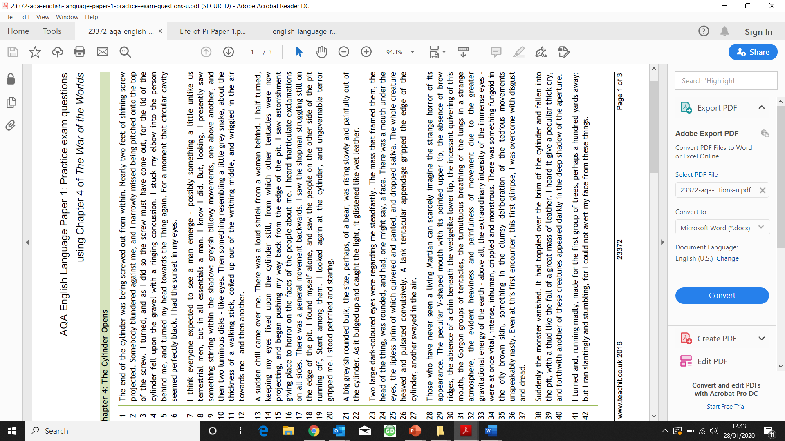

The following extract is taken from Chapter 4 of ‘War of the Worlds’, a science fiction novel by H.G. Wells. Here, an extra-terrestrial force has landed on earth and is beginning to emerge in front of a crowd of people.

1. Read again the first part of the Source from lines _________________________.

List four things from this part of the text about ____________________. **(4 marks)**

1. ___________________________________________
2. ___________________________________________
3. ___________________________________________
4. ___________________________________________

Look in detail at this extract from **lines ___________** of the Source:

|  |
| --- |
| [space for extract] |

How does the writer use language to describe _____________________________?

You could include the writer’s choice of:

* Words and phrases
* Language features and techniques
* Sentence forms **[8 marks]**

You now need to think about the **whole** of the **Source**. The text is from the middle of a novel.

How has the writer structured the text to interest you as a reader?

You could write about:

* What the writer focusses your attention on at the beginning
* How and why the writer changes the focus as the Source develops
* Any other structural features that interest you **[8 marks]**

Focus this part of your answer on the second part of the Source from **line __________________.**

A student, having read this section of the text said: _______________________________________________________________________________________ _______________________________________________________________________________________

To what extent do you agree?

In your response, you could:

* Write about your own impressions of the atmosphere
* Evaluate how the writer has created this atmosphere
* Support your opinions with references to the text

**[20 marks]**

**Paper 2: Serial Killers (Source A: Ed Gein)**

*In small town Plainfield, Wisconsin, a hard-working farming and hunting community in the 1950s, local bachelor Ed Theodore Gein was a trusted neighbour. He did odd jobs as a handyman, and babysat local children — while seen as maybe a little odd, he was nonetheless invited into their homes and offered a seat at their dinner table. He later became known as the Plainfield Butcher.*

On the opening day of hunting season in the fall of 1957, almost all the menfolk of Plainfield were off looking for deer. All except Gein, who was ironically known for being squeamish at the sight of blood and uncomfortable with the idea of hunting.

He stopped in to see Bernice Worden at Worden’s Hardware and Implement Store, where he picked up some anti-freeze. He’d brought a .22-caliber bullet with him in his pocket, which he put into one of the hunting rifles for sale in the shop, and took down Worden. When her disappearance from the store was noted, along with a pool of blood reminiscent of the Mary Hogan scene, Gein’s name was noticed in the receipts from his anti-freeze purchase.

The police rushed to the Gein farmhouse, but found it deserted, as Gein was having supper with some neighbours. While a couple of cops went to look for Gein for questioning, and ended up arresting him, others began to poke around his property, looking for anything suspicious. The horrors they found ensured Gein’s place in the history of depraved killers and ghouls, despite his only being known to have slain two people, and only ever tried for one murder.

Police found the body of Bernice Worden, headless, suspended upside-down, gutted and “dressed” as one would a deer. Gein’s gloomy and decay- and stench-filled home offered even more nightmares. Just a few other findings, among many, were human skulls on his bedposts and used for soup bowls, a pair of lips hanging on a window shade, a belt made from human skin, a skin lamp shade, an oatmeal box full of brain matter, and, hanging on a wall, nine human faces, fashioned into masks. One of these had belonged to Mary Hogan. Bernice Worden’s heart was found on Gein’s stove.

When it became clear that the remains of Hogan and Worden were the only two of the many found that could be linked to any disappearances, Gein explained that he had collected all the other human remains from robbing local graves.

Under investigation for murder in 1957, he was interrogated by District Attorney Earl Kileen. Gein admitted: “I started to visit graveyards in the area regularly about 18 months after my mother died. Most nights, I would just stand and have private conversations … with my ma…. Other times, I couldn’t make myself go home without raisin’ one of ’em up first. Maybe on about nine occasions, I took somebody, or part of somebody, home with me. It was kind of an evil spirit I couldn’t control.” Gein explained that he was able to get away with this for a period of about five years, as he always left the graves in “apple-pie order” when he was finished robbing them. He went on to state that he would watch the obituaries for when women, particularly those with a similar body type to his mother, were laid to rest and visit the next night to steal their corpses, as he had begun to have “an uncontrollable desire to see a woman’s body.” Some accounts claim that he did also dig up his mother’s corpse and bring her home.

One of the grisliest artefacts found was basically a woman suit — a pair of skin leggings and a vest made from a torso…

**Paper 2: Serial Killers (Source B- Jack the Ripper)**

*In the 1880s, the city of London came under threat from a mysterious killer who was nicknamed Jack the Ripper. This newspaper report was written shortly after the Ripper had killed his fourth victim.*

London lies to-day under the spell of a great terror. A nameless reprobate - half beast, half man - is at large, who is daily gratifying his murderous instincts on the most miserable and defenceless classes of the community. There can be no shadow of a doubt now that our original theory was correct, and that the Whitechapel murderer, who has now four, if not five, victims to his knife, is one man, and that man a murderous maniac. There is murderer in our midst. Hideous malice, deadly cunning, insatiable thirst for blood - all these are the marks of the mad homicide. The ghoul-like creature who stalks through the streets of London, stalking down his victim like a Pawnee Indian, is simply drunk with blood, and he will have more. The question is, what are the people of London to do? Whitechapel is garrisoned with police and stocked with plain-clothes men. Nothing comes of it. The police have not even a clue. They are in despair at their utter failure to get so much as a scent of the criminal.

Now we have a moral to draw and a proposal to make. We have carefully investigated the causes of the miserable and calamitous breakdown of the police system. They are chiefly two: (1) the inefficiency and timidity of the detective service, owing to the manner in which Sir Charles has placed it in leading strings and forbidden it to move except under instructions; (2) the inadequate local knowledge of the police. To add to the list of clumsy follies which have made Sir CHARLES WARREN'S name stink in the nostrils of the people of London, the CHIEF COMMISSIONER has lately transferred the whole of the East-end detectives to the West and moved the West-end men to the East. Our reporters have discovered that the Whitechapel force knows little of the criminal haunts of the neighbourhood. Now, this is a state of things which obtains in no other great city in the world but London, and is entirely due to our centralised system. In New York the local police know almost every brick in every den in the district, and every felon or would-be felon who skulks behind it. In Whitechapel many of the men are new to their work, and others who have two or three years' local experience have not been trained to the special work of vigilant and ceaseless inspection of criminal quarters.

Now there is only one thing to be done at this moment: the people of the East-end must become their own police. They must form themselves at once into Vigilance Committees. There should be a central committee, which should map out the neighbourhood into districts, and appoint the smaller committees. These again should at once devote themselves to volunteer patrol work at night, as well as to general detective service. The unfortunates who are the objects of the man-monster's malignity should be shadowed by one or two of the amateur patrols. They should be cautioned to walk in couples. Whistles and a signalling system should be provided, and means of summoning a rescue force should be at hand. We are not sure that every London district should not make some effort of the kind, for the murderer may choose a fresh quarter now that Whitechapel is being made too hot to hold him.

The hunt for the madman in our midst must begin in earnest; but the bloodhounds must be fed.

**Q1**: Read **Source A**.

Shade **four** correct statements.

Choose a **maximum** of four statements.

1. Ed Gein enjoyed hunting.
2. Bernice Worden was killed with a .22 calibre bullet.
3. Gein recollected robbing at least 8 graves.
4. Hogan and Worden’s remains were the only ones identified.
5. Ed Gein was uncomfortable with hunting.
6. Gein recalled robbing at least 9 graves.
7. Bernadette Worden was killed with a .22 calibre bullet.
8. None of Gein’s victims were ever identified.

**Q2**. Refer to **Source A and Source B**.

Write a **summary** to describe the differences in the ways these killers’

crimes are each described.

**Q3**. Now read **Source B**.

How does the writer use **language** to convey his opinions of the killer?

**Q4**. Now refer to **both Source A and Source B**.

**Compare** how the two writers convey their attitudes to the murderers

that they describe.

In your answer, you should:

* Compare their attitudes
* Compare the methods they use to convey their attitudes
* Support your ideas with references to both texts

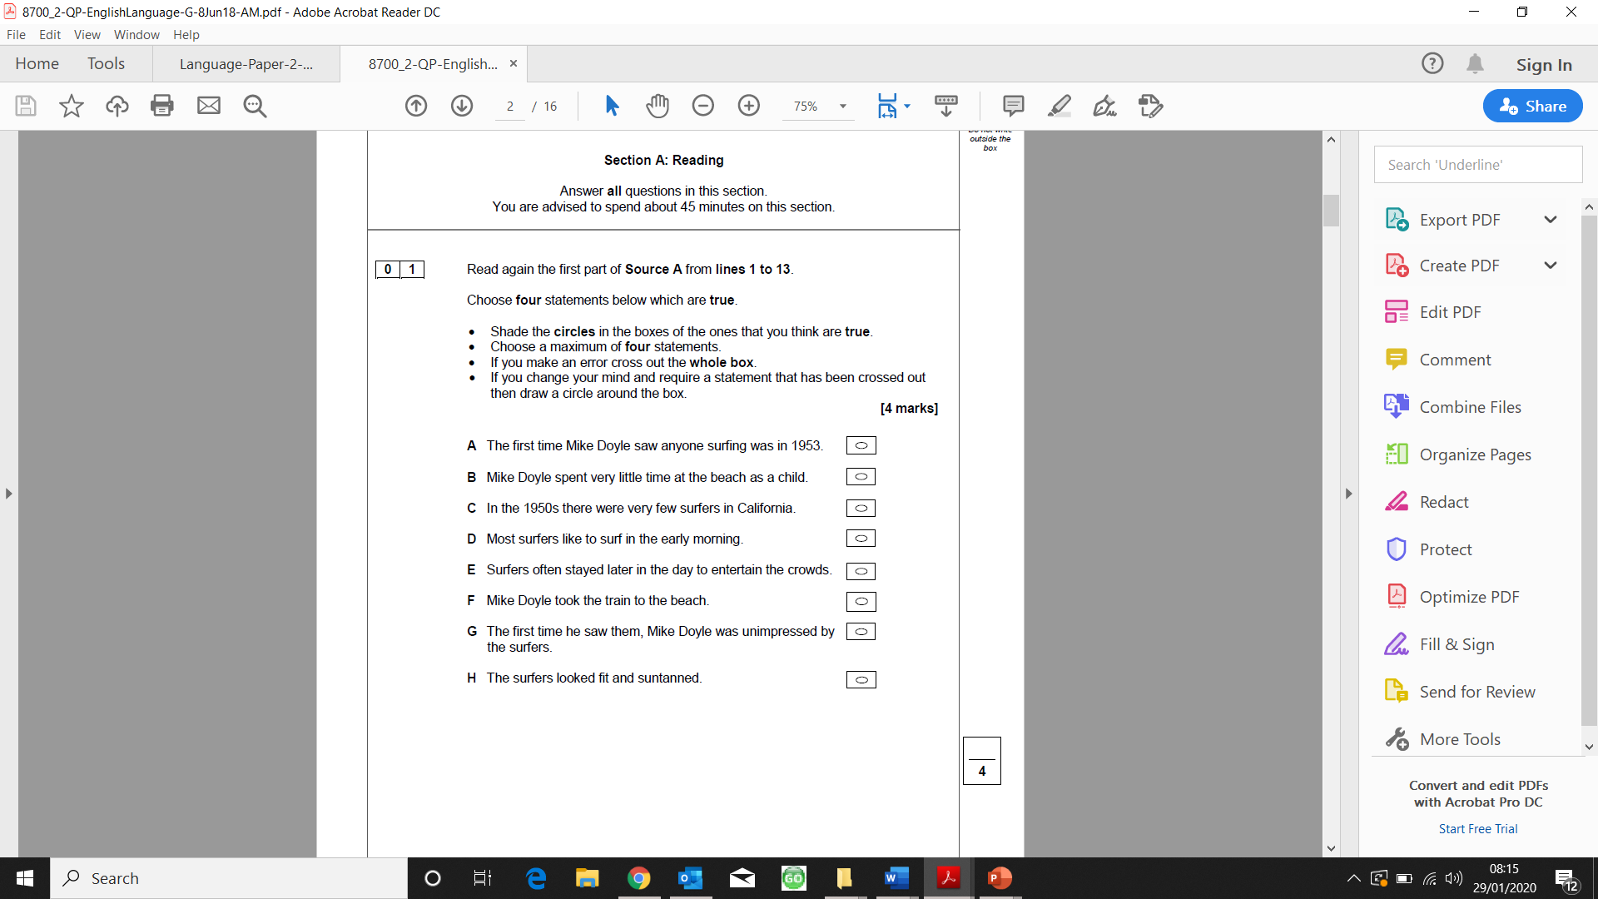

2. You need to refer to Source A and Source B for this question.

Both sources describe the type of boards used for surfing.

Use details from **both** sources to write a summary about what you understand about the different boards used by surfers. [8 marks]

1. You now only need to refer to Source B, from lines 18 to 25.

How does the writer use language to describe the surfers and the sea? [12 marks]

1. For this question, you need to refer to the whole of Source A and the whole of Source B.

Compare how the writer’s convey their different perspectives on surfing.

In your answer you could:

* Compare their different perspectives on surfing
* Compare the methods the writer’s use to convey their perspectives.
* Support your response with references to both texts. [20 marks]