Paper 1 Section B: Narrative and Descriptive Writing
You are going to enter a creative writing competition.
Your entry will be judged by a panel of people of your own age.

Either: Write a description suggested by this picture:

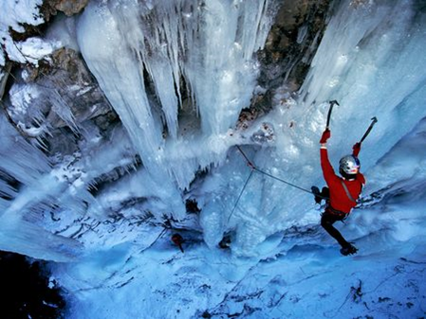

Or: Write a part of a story about a place in extreme cold.
(24 marks for content and organisation; 16 marks for technical accuracy)
[40 marks]

Paper 1 Section B: Narrative and Descriptive Writing
You are going to enter a creative writing competition.
Your entry will be judged by a panel of people of your own age.

Either: Write a description suggested by this picture

Or: Write the opening to a story in which a dramatic event occurs.
(24 marks for content and organisation; 16 marks for technical accuracy)
[40 marks]

Paper 1 Section B: Narrative and Descriptive Writing
You are going to enter a creative writing competition.
Your entry will be judged by a panel of people of your own age.

Either: Write a story, set in a mountainous area, as depicted in this image.
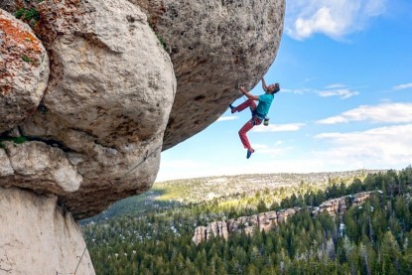

Or: Write the opening to a story with the title ‘Discovery’
(24 marks for content and organisation; 16 marks for technical accuracy)
[40 marks]

Paper 1 Section B: Narrative and Descriptive Writing
You are going to enter a creative writing competition.
Your entry will be judged by a panel of people of your own age.

Either: Write a description suggested by this picture
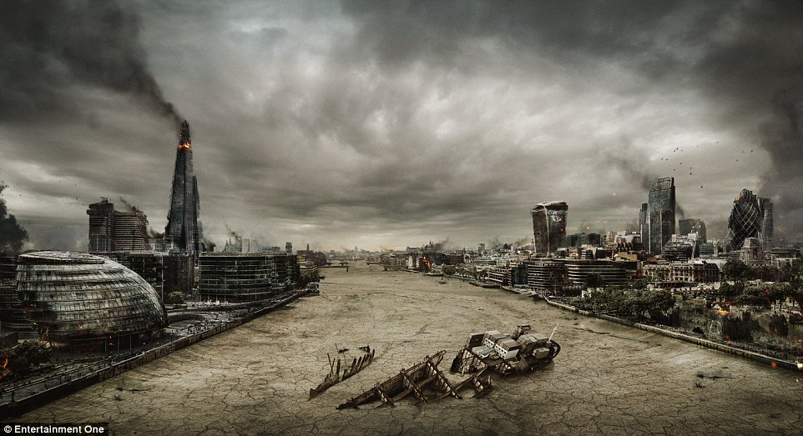

Or: Write the opening to a story in which a dramatic event occurs.
(24 marks for content and organisation; 16 marks for technical accuracy)
[40 marks]

Paper 1 Section B: Narrative and Descriptive Writing
You are going to enter a creative writing competition.
Your entry will be judged by a panel of people of your own age.

Either: Write a description of an old person, as suggested by this picture

Or: Write the opening to a story about a time where things turn out unexpectedly.
(24 marks for content and organisation; 16 marks for technical accuracy)
[40 marks]

