An Inspector Calls Chronological Timeline
- Arthur Birling Fires Eva Smith from his factory.
- She was fired due to the fact that she was one of the ring leaders of the strike movement that was taking place at that time. Birling stated " She'd had a lot to say- far too much- so she had to go."
- Sheila has Eva Smith Fired from Milwards because of Sheila complaining.
- Sheila was shopping and trying on dresses when a dress that didn't look good on her made her upset because she was feeling insecure. Eva Smith happened to be there and Sheila did not like that she was prettier than her.
- Gerald gives Daisy (as Eva is now known) a place to stay.
- Gerald meets Daisy and feels bad for her since she has nowhere to go. He installs her in his friend’s rooms (he is gone to Canada so he is not needing them at the moment).
- Eric forces his way into Daisy/ Eva's room
- Eric, after a drunken night, forces his way into Dairy/Eva's room. She ends up pregnant. Eric gives her stolen money, which she rejects based on her morals.
- Mrs B meets Eva Smith and rejects her application for help.
- Mrs B does not like Eva because she presents herself under a false name (Mrs Birling) when she arrives at the charity. She also lies about being married, which causes Mrs B to dislike her more.
- The Birling family is having a dinner to celebrate Sheila and Gerald's engagement.
- Birling spends most of the dinner talking business, which annoys everyone at the dinner because it is not appropriate talk for an engagement dinner.
- Inspector Goole comes to the house to investigate Eva Smith's suicide.
- Inspector Goole begins by questioning Birling on his involvement with Eva's death.
- Birling feels no remorse for Eva's death.
- Goole then moves on to Sheila's involvement. She feels remorse for her actions.
- Goole then questions Gerald. This is where we learn that Gerald was having an affair with Eva/Daisy.
- The questioning results in Sheila ending the engagement between them.
- Goole turns his questions to Mrs Birling.
- Mrs Birling feels no remorse for rejecting Eva because she feels justified since Eva lied.
- Mrs Birling states that the father of the child that Eva was pregnant with is to blame for Eva's death.
- Inspector Goole turns his questioning to Eric.
- Eric confesses to the events that led up to the pregnancy. He confesses to stealing money from his father's company.
- Birling responds with how he is going to have to cover up the theft to save face and prevent Eric from being arrested.
- Inspector Goole delivers his final speech. He states that we need to be responsible for each other. This speech shows Priestley's views as he was a socialist.
- After Inspector Goole leaves, Sheila and Eric feel remorse for their actions. However, Mr Birling feels no remorse whatsoever. Mrs Birling only feels bad about killing her grandchild, but not for anything else.

Skimming
Read the text as quickly as you can. Which words tell you the most about Mrs Birling’s personality?

Predicting
Who will win this battle of wills and how can you tell?

Keywords
Bear investigation
claim
Bitterly
culprit

Mrs Birling: if you think you can bring any pressure to bear upon me, Inspector, you're quite mistaken. Unlike the other three, I did nothing I'm ashamed of or that won't bear investigation. The girl asked for assistance. We were asked to look carefully into the claims made upon us. I wasn't satisfied with the girl's claim – she seemed to me not a good case – and so I used my influence to have it refused. And in spite of what's happened to the girl since, I consider I did my duty. So if I prefer not to discuss it any further, you have no power to make me change my mind.
Inspector: Yes I have.
Mrs Birling: No you haven't. Simply because I've done nothing wrong – and you know it.
Mrs Birling: first, the girl herself.
Sheila: (bitterly) for letting father and me have her chucked out of her jobs!
Mrs Birling: secondly, I blame the young man who was the father of the child she was going to have. If, as she said, he didn't belong to her class, and was some drunken young idler, then that's all the more reason why he shouldn't escape. He should be made an example of. If the girl's death is due to anybody, then it's due to him.
Inspector: and if her story is true – that he was stealing money-
Mrs Birling: (rather agitated now) there's no point in assuming that-
Inspector: but suppose we do, what then?
Mrs Birling: then he'd be entirely responsible – because the girl wouldn't have come to us, and have been refused assistance, if it hadn't been for him-
Inspector: so he's the chief culprit anyhow.
Mrs Birling: certainly. And he ought to be dealt with very severely-

Sheila: (with sudden alarm) mother – stop – stop!

Birling: Be quiet, sheila!

Sheila: but don't you see-

Mrs Birling: (severely) you're behaving like an hysterical child tonight.

// Sheila begins crying quietly. Mrs Birling turns to the Inspector. //

and if you'd take some steps to find this young man and then make sure that he's compelled to confess in public his responsibility – instead of staying here asking quite unnecessary questions – then you really would be doing your duty.

Scanning
Find and record the following:
A word that tells us Mrs Birling thinks she is in the right____________________
A word that shows Sheila’s disgust with her mother_________________________
A stage direction that shows Mrs Birling isn’t completely certain______________________

Close reading
1. How does Mrs Birling try to intimidate the inspector?________________________________________________________
2. Why does Mrs Birling not want to discuss any further?_________________________________________________________
3. How is the inspector baiting Mrs Birling?_________________________________________________________
4. What do the interruptions show us about Mrs Birling’s state of mind?_________________________________________________________________________________________

Questions
Ask Mrs Birling three questions about what she has done?
1)
2)
3)

Importance?
What does Mrs Birling think is meant by responsibility?

Understanding
1. What did Mrs Birling refuse to do?
2. Why did she make this decision?
3. Who does she blame?
4. What does she suggest should happen to the person responsible?
5. What does she mean by ‘did my duty’?

Exploration
1. Which words in this quotation tells us the most about Mrs Birling? Why? “Unlike the other three, I did nothing I'm ashamed of or that won't bear investigation.”
2. When Mrs Birling describes the father of Eva Smith’s child as “some drunken young idler” what impression does this create? Why is this ironic?
3. Why do you think that the Inspector says so little in this scene?
4. Look at all of the abstract nouns used by Mrs Birling. What do they reveal about her character?

Keywords

Predicting
How will the relationship between parents and children be by the end of the play?

Skimming
Read the stage directions quickly. What do each show us about the relationship between the young and the old?

Scanning
Find and record the following:
A phrase that shows that Birling doesn’t understand his children
___________________________________________
A phrase that shows us how regretful Eric is_________________________________
Evidence that shows that Eric is past caring about much now
_______________________________________________

Eric: I do take some interest in it. I take too much, that's my trouble.
Sheila: It's mine too.
Birling: Now listen, you two. If you're still feeling on edge, then the least you can do is to keep quiet. Leave this to us. I'll admit that fellow's antics rattled us a bit. But we've found him out – and all we have to do is to keep our heads. Now it's our turn.
Sheila: Our turn to do – what?
Mrs Birling: ( sharply) To behave sensibly, Sheila – which is more than you're doing.
Eric: ( bursting out) What's the use of talking about behaving sensibly. You're beginning to pretend now that nothing's really happened at all. And I can't see it like that. This girl's still dead, isn't she? Nobody's brought her to life, have they?
Sheila: (eagerly) That's just what I feel, Eric. And it's what they don't seem to understand.
Eric: whoever that chap was, the fact remains that I did what I did. And mother did what she did. And the rest of you did what you did to her. It's still the same rotten story whether it's been told to a police inspector or to somebody else. According to you, I ought to feel a lot better - ( To Gerald.) I stole some money, Gerald, you might as well know - ( As Birling tries to interrupt.) I don't care, let him know. The money's not the important thing. It's what happened to the girl and what we all did to her that matters. And I still feel the same about it, and that's why I don't feel like sitting down and having a nice cosy talk.
Sheila: And Eric's absolutely right. And it's the best thing any one of us has said tonight and it makes me feel a bit less ashamed of us. You're just beginning to pretend all over again.

Close reading
1. Name at least 3 things that Eric feels that he is responsible for beyond Daisy’s death?
________________________________________________________________________________________________________________________________
2. What has he learnt about himself during the play?
________________________________________________________________________________________________________________________________
3. What does he look down on his parents for?
________________________________________________________________________________________________________________________________
4. By the end of the scene does he seem mature or immature? Explain.
________________________________________________________________________________________________________________________________

Questions
Think of at least 3 questions you’d like to ask Eric at this point in the text.
1)
2)
3)

View of responsibility?
How does Eric view responsibility? How are his views different from his parents?

Understanding
1. How do Eric and Sheila feel in this scene?
2. How do their parents feel?
3. What do Mr. & Mrs Birling want to do?
4. How does Eric feel about his parents at this point?

Exploration
1. Which words in this quotation tells us the most about Eric’s feelings? Why? “It's still the same rotten story whether it's been told to a police inspector or to somebody else.”
2. When Mrs Birling says “To behave sensibly, Sheila – which is more than you're doing”, Why is this ironic?
3. How does this scene illustrate the divide between the older and younger generation?
4. Look at all of the verbs used by Eric. What do they reveal about his character?

Inspector: ( taking charge, masterfully) Stop!
// They are suddenly quiet, staring at him.//
And be quiet for a moment and listen to me. I don't need to know any more. Neither do you. This girl killed herself – and died a horrible death. But each of you helped to kill her. Remember that. Never forget it. (He looks from one to the other of them carefully.) But then I don't think you ever will. Remember what you did, Mrs Birling. You turned her away when she most needed help. You refused her even the pitiable little bit of organized charity you had in your power to grant her. Remember what you did-
Inspector: But just remember this. One Eva Smith has gone – but there are millions and millions and millions of Eva Smiths and John Smiths still left with us, with their lives, their hopes and fears, their suffering and chance of happiness, all intertwined with our lives, and what we think and say and do. We don't live alone. We are members of one body. We are responsible for each other. And I tell you that the time will soon come when, if men will not learn that lesson, then they well be taught it in fire and bloody and anguish. Good night.

Predicting
How will his speech effect each of the family members? Who will learn the most and how do you know?

Skimming
Read the text quickly. Which image feels like the most important? What is his message?

Scanning
Find and record the following:
A word that tells us he has had enough of the Birlings___________________________________
A word that tells us how disgusted he is with Mrs Birling ___________________________________
A phrase that tells the family more about the people they should be responsible for an makes them seem more real___________________________________________________________________________________

Close reading
1. What or who do Eva Smith and John Smith represent?
_____________________________________________________________
2. What does he mean by “we don’t live alone”?
______________________________________________________________________________________________
3. What does he refer to when he says “fire, blood and anguish”?______________________________________________________________________________________________________________________________________________________

Questions
What 3 questions would you like to ask the inspector?
1)
2)
3)

Keywords

Importance?
What does responsibility mean to the inspector?

Understanding
1. What does the Inspector accuse the Birlings of doing?
2. Paraphrase the Inspector’s speech. Rewrite his advice to the Birlings in your own words.
3. What does “fire and blood and anguish” mean?
4. Which specific person does the Inspector name? Why do you think that he chose to do this?

Exploration
1. Which words in this extract tell us the most about the Inspector’s feelings towards the Birlings? Why?
2. When the Inspector says “millions and millions and millions of Eva Smiths and John Smiths still left with us” who is he referring to? How does this relate to the theme of socialism?
3. How does Priestley use imagery in this scene?
4. Look at all of the emotive language used by the Inspector. How does this help to reveal his/Priestley’s views?
5. Why do you think the Inspector leaves after giving this speech?

Sheila: I'm going anyhow in a minute or two. But don't you see, if all that's come out tonight is true, then it doesn't much matter who it was who made us confess. And it was true, wasn't it? You turned the girl out of one job, and I had her turned out of another. Gerald kept her – at a time when he was supposed to be too busy to see me. Eric – well, we know what Eric did. And mother hardened her heart and gave her the final push that finished her. That's what's important – and not whether a man is a police inspector or not.
Eric: He was our police inspector all right.
Sheila: That's what I mean, Eric. But if it's any comfort to you – and it wasn't to me – I have an idea – and I had it all alone vaguely – that there was something curious about him. He never seemed like an ordinary police inspector-

Predicting
How will Eric, Mr and Mrs Birling react to what Sheila is saying and why?

Skimming
Read the text quickly: Which words tell you the most about Sheila’s personality?

Scanning
Find and record the following:

A phrase which shows Sheila can stand up to her family now___________________________
A phrase that tells us she had suspicions about the inspector too_______________
Another word for home____________________________

Close reading
1. Why doesn’t it matter to Sheila who made them confess?

2. How is she different from the rest of her family and why is she different?

3. What has she learned about each of her family members?

4. What do you think Priestley thinks of Sheila at this point?

Questions
Think of at least 3 questions you’d like to ask Sheila now.
1)
2)
3)

Keywords

View of responsibility?
How is Sheila showing she feels responsible for the death of Eva Smith?

Visualise and imagine
How does Sheila feel about herself at this point? How does she feel towards her family?

Understanding
1. Sum up Sheila’s view of her family’s actions.
2. List the “crimes” that they have committed in your own words.
3. What does Sheila think of the Inspector?
4. What do you think Eric means when he says “he was our police inspector all right”?

Exploration
1. Which words in this quotation reveal most about Sheila’s sense of guilt? “Then it doesn't much matter who it was who made us confess” Why?
2. What do we learn about Sheila’s feelings towards her mother from the line “And mother hardened her heart and gave her the final push that finished her.”?
3. What does Sheila think is important about their experience with the Inspector?
4. Which themes does this scene illustrate? Why do you think this?
5. How is Sheila’s conscience evident in this scene? Find evidence to support your ideas.

Skimming
Read the text quickly: Which words tell you the most about Gerald’s character?

Keywords

Predicting
How will Eric, Mr and Mrs Birling react to what Gerald is saying and why?

Scanning
Find and record the following:

A phrase which shows Gerald felt sorry for Eva Smith
__________________________________
A phrase that tells us that Sheila suspected Gerald of having an affair
__________________________________

Close reading
1. Why id Gerald emotional during this conversation?

2. How Gerald different to the other characters in his relationship with Eva Smith?

3. How does Gerald try to explain his behaviour?

4. What do you think Priestley thinks of Gerald at this point?

View of responsibility?
To what degree does this extract present Gerald as responsible for Eva’s Death?

Gerald: we went along to the county hotel, which I knew would be quiet at that time of night, and we had a drink or two and talked.
Inspector: did she drink much at the time?
Gerald: no. she only had a port and lemonade – or some such concoction. All she wanted
was to talk – a little friendliness – and I gathered that joe meggarty's advances had left her rather shaken – as well they might--
Inspector: she talked about herself?
Gerald: yes. I asked her questions about herself. She told me her name was Daisy Renton,
that she'd lost both parents, that she came originally from somewhere outside Brumley. She also
told me she'd had a job in one of the works here and had had to leave after a strike. She said
something about the shop too, but wouldn't say which it was, and she was deliberately vague
about what happened. I couldn't get any exact details from her about herself – just because she
felt I was interested and friendly – but at the same time she wanted to be Daisy Renton – and not
Eva Smith. In fact, I heard that name for the first time tonight. What she did let slip – though she
didn't mean to – was that she was desperately hard up and at that moment was actually hungry. I
made the people at the county find some food for her.
Inspector: and then you decided to keep her – as your mistress?
_{Mrs Birling: what?}
Sheila: of course, mother. It was obvious from the start. Go on, Gerald. Don't mind mother.
Gerald: (steadily ) I discovered, not that night but two nights later, when we met again –
not accidentally this time of course - that in fact she hadn't a penny and was going to be turned
out of the miserable back room she had. It happened that a friend of mine, Charlie Brunswick,
had gone off to canada for six months and had let me have the key of a nice little set of rooms he
had – in morgan terrace – and had asked me to keep an eye on them for him and use them if I
wanted to. So I insisted on Daisy moving into those rooms and I made her take some money to
keep her going there. (carefully, to the inspector.) I want you to understand that I didn't install
her there so that I could make love to her. I made her go to morgan Terrace because I was sorry
for her, and didn't like the idea of her going back to the palace bar. I didn't ask for anything in
_{return.}
_{Inspector: I see.}
Sheila: yes, but why are you saying that to him? You ought to be saying it to me,
Gerald: I suppose I ought really. I'm sorry, Sheila. Somehow I--
Sheila: (cutting in, as he hesitates) I know. Somehow he makes you.
Inspector: but she became your mistress?
Gerald: yes. I suppose it was inevitable. She was young and pretty and warm hearted –
and intensely grateful. I became at once the most important person in her life – you understand?

‘AN INSPECTOR CALLS’ QUOTATIONS BY CHARACTER
MR BIRLING | MRS BIRLING | ERIC | SHEILA | GERALD | THE INSPECTOR
‘…Crofts and Birlings… working together, for lower costs and higher prices.’  ‘We’re in for a time of steadily increasing prosperity.’  ‘I’m talking as a hard-headed, practical man of business. And I say there isn’t a chance of war.’  There’ll be peace and prosperity and rapid progress everywhere.’  ‘I don’t want to lecture you two fellows again.’  ‘Community and all that nonsense’  ‘Just keep quiet, Eric, and don’t get excited.’  ‘It has nothing to do with the wretched girl’s suicide.’  ‘I can’t accept any responsibility.’  ‘She was a lively good looking-girl.’  ‘There isn’t the slightest reason why my daughter should be dragged into this unpleasant business.’  ‘It isn’t going to do us much good. The Press might easily take it up-‘  ‘Look, Inspector – I’d give thousands – yes, thousands ‘  ‘There’ll be a public scandal.’  ‘The famous younger generation who know it all. And they can’t even take a joke-‘ | ‘When you’re married you’ll realise that men with important work to do sometimes have to spend nearly all their time and energy on their business. You’ll have to get used to that, just as I had.’  ‘Girls of that class-’  ‘Though naturally I don’t know anything about this girl.’  ‘We’ve done a great deal of useful work in helping deserving cases.’  ‘I think she had only herself to blame.’  ‘I didn’t like her manner.’  ‘I did nothing I’m ashamed of.’  ‘I used my influence to have it refused.’  ‘You have no power to make me change my mind.’  ‘I’ve done nothing wrong – and you know it.’  ‘Go and look for the father of the child. It’s his responsibility.’  ‘She was here alone, friendless, almost penniless, desperate.’  ‘As if a girl of that sort would ever refuse money.’  ‘I accept no blame for it at all.’  ‘You don’t get drunk.’  ‘If you want to know, it’s you two who are being childish.’  ‘In the morning they’ll be as amused as we are.’ | ‘What about war?’  ‘What’s the joke? Started telling stories?’  ‘Yes, you’ve piled it on a bit tonight, Father’  ‘He could have kept her on instead of throwing her out. I call it tough luck.’  ‘Why shouldn’t they try for higher wages?’  ‘Could I have a drink first?’  ‘I was in that state when a chap easily turns nasty.’  ‘She was pretty and a good sport.’  ‘You’re not the kind of father a cha could go to when he’s in trouble – that’s why.’  ‘Then – you killed her. She came to you to protect me’  ‘My God – I’m not likely to forget.’  ‘The money’s not the important thing. It’s what happened to the girl and what we all did to her that matters.’  ‘You lot may be letting yourselves out nicely, but I can’t.’ | ‘Careful! I’ll never let it go out of my sight for an instant.’  ‘I can’t help thinking about this girl – destroying herself so horribly…’  ‘You talk as if we were responsible.’  ‘But these girls aren’t cheap labour – they’re people.’  ‘So I’m really responsible?’  ‘If I could help her now, I would.’  ‘It’s the only time I’ve ever done anything like that, and I’ll never, never do it again.’  ‘You mustn’t try to build up a kind of wall between us and that girl.’  ‘No, he’s giving us the rope – so that we’ll hang ourselves.’  ‘And probably between us we killed her.’  ‘You were the wonderful Fairy Prince. You must have adored it, Gerald.’  ‘I rather respect you more than I’ve ever done before.’  ‘You and I aren’t the same people who sat down to dinner here.’  ‘I suppose we’re all nice people now.’ | ‘I’ve told you – I was awfully busy at the works at the time.’  ‘And I drink to you – and hope I can make you as happy as you deserve to be.’  ‘You seem to be a nice well-behaved family’  ‘Unless Eric’s been up to something. And that would be awkward, wouldn’t it?’  ‘It’s a favourite haunt of women of the town –‘  ‘I made her go to Morgan Terrace because I was sorry for her… I didn’t ask for anything in return.’  ‘I became at once the most important person in her life.’  ‘She was very gallant about it.’  ‘I’m rather more – upset – by this business than I probably appear to be.’  ‘That man wasn’t a police officer.’  ‘But how do we know it’s the same girl?’  ‘Everything’s all right now, Sheila. What about this ring?’ | ‘He creates at once an impression of massiveness, solidity and purposefulness’  ‘She’d swallowed a lot of strong disinfectant.’  ‘She was in great agony.’  ‘A chain of events.’  ‘There are a lot of young women living that sort of existence in every city and big town in this country.’  ‘A girl died tonight. A pretty, lively sort of girl, who never did anybody any harm.’  ‘If there’s nothing else, we’ll have to share our guilt.’  ‘Public men, Mr Birling, have responsibilities as well as privileges.’  ‘I shall do my duty.’  ‘Each of you helped to kill her.’  ‘Remember what you did.’  ‘There are millions and millions and millions of Eva Smiths and John Smiths…’  ‘We are members of one body. We are responsible for each other.’  ‘They will be taught it in fire and blood and anguish.’

Stave One | - Introduced to Ebenezer Scrooge on Christmas Eve. He is a lonely miser obsessed with money. He won’t pay to heat the office properly – meaning Bob Cratchit is very cold  - We learn Jacob Marley, Scrooge’s business partner, died exactly 7 years earlier.  - Scrooge is irritated that Christmas Day seems to be interrupting his business. Scrooge is visited by  his nephew Fred, who invites his uncle to Christmas dinner. Scrooge refuses.  - Scrooge is visited by two charity workers, asking for donations. Scrooge refuses and exclaims he wants to be left alone.  - Scrooge allows Bob to have Christmas Day off.  - Scrooge, when he is home, is visited by the Ghost of Jacob Marley – warning him he will be visited by three more ghosts to help him change his ways.
Stave Two | - Scrooge is visited by the Ghost of Christmas Past who takes him to witness his past.  - Scrooge is taken first to his schoolboy years and he is reminded how his friends would go home from Christmas while he was left at school.  - We see him with his sister, who one year took him home for the holidays.  - Next we are shown Scrooge as a young apprentice, working for Fezziwig. Dickens describes the Christmas ball Fezziwig organised for his employees.  - Finally, Scrooge is taken to see his ex-fiancée, Belle. We see the scene when they break up, as money has taken over Scrooge’s life.  - Scrooge cannot bear to see any more and struggles with the spirit.
Stave Three | - Scrooge is then visited by the Ghost of Christmas Present.  - The spirit shows Scrooge how the Cratchit family celebrate Christmas. Scrooge asked if Tiny Tim will life. The spirit explain unless there are changes, he will die. The spirit reminds Scrooge of his earlier words: ‘If he is to die, he had better do it, and decrease the surplus population’  - Scrooge is then taken to see how others celebrate Christmas: miners, lighthouse workers, sailors on a ship.  - He is then taken to Fred’s house at Christmas, where they are playing games.  - The spirit then begins to age, and see under the spirit’s robes two children: Want and Ignorance.  - The Ghost of Christmas Future then appears.
Stave Four | - The Ghost of Christmas Future is described.  - The spirit takes Scrooge to see a group of businessmen discussing someone who has died.  - Scrooge is then taken to see Old Joe, where he is in the process of buying property of the dead man – which have been stolen.  - Scrooge then returns to Bob Cratchit’s house, where it is revealed Tiny Tim has died.  - Scrooge is then taken to the graveyard and is shown a grave stone and realises this is for him.  - Scrooge falls to his knees and begs that he will change his ways.
Stave Five | - Scrooge wakes up in his own bed.  - Scrooge wonders how much time has passed and calls to a boy. He then sends the boy to the poulterer for the prize turkey to give to Bob Cratchit,  - Scrooge meets one of the charity collectors from earlier and whispers to him that he will give a large donation.  - Scrooge then goes to Fred’s house and is welcomed in. He enjoys the dinner and party.  - On Boxing Day, Scrooge arrives early to work, and plays a trick on Bob. Scrooge then tells him he is going to raise his salary and promises to help Bob’s struggling family.  Scrooge is described to have completely changed and becomes a ‘second father’ to Tiny Tim – ‘who did not die.’
A Christmas Carol Sequence of Events
Predicting
Use your knowledge organiser. What lessons will Scrooge learn over the course of the novel?

Skimming
Read the text as quickly as you can. What are the most important pieces of information?

Oh! But he was a tight-fisted hand at the grind- stone, Scrooge! a squeezing, wrenching, grasping, scraping, clutching, covetous, old sinner! Hard and sharp as flint, from which no steel had ever struck out generous fire; secret, and self-contained, and solitary as an oyster. The cold within him froze his old features, nipped his pointed nose, shrivelled his cheek, stiffened his gait; made his eyes red, his thin lips blue and spoke out shrewdly in his grating voice. A frosty rime was on his head, and on his eyebrows, and his wiry chin. He carried his own low temperature always about with him; he iced his office in the dogdays; and didn't thaw it one degree at Christmas.
External heat and cold had little influence on Scrooge. No warmth could warm, no wintry weather chill him. No wind that blew was bitterer than he, no falling snow was more intent upon its purpose, no pelting rain less open to entreaty. Foul weather didn't know where to have him. The heaviest rain, and snow, and hail, and sleet, could boast of the advantage over him in only one respect. They often "came down" handsomely, and Scrooge never did.
Nobody ever stopped him in the street to say, with gladsome looks, "My dear Scrooge, how are you? When will you come to see me?" No beggars implored him to bestow a trifle, no children asked him what it was o'clock, no man or woman ever once in all his life inquired the way to such and such a place, of Scrooge. Even the blind men's dogs appeared to know him; and when they saw him coming on, would tug their owners into doorways and up courts; and then would wag their tails as though they said, "No eye at all is better than an evil eye, dark master!"
But what did Scrooge care? It was the very thing he liked. To edge his way along the crowded paths of life, warning all human sympathy to keep its distance, was what the knowing ones call "nuts" to Scrooge.
Explore the meaning of each of these quotations – what can the reader infer about Scrooge?
1) “The cold within him froze his old features.”

2) “No wind that blew was bitterer than he.”

3) “Nobody ever stopped him in the street to say, with gladsome looks, "My dear Scrooge, how are you?”

Scanning
Find and record the following:
A word that means to be isolated or alone:

A word that means greedy:

A word that means something of little value:

Close reading
1. Which words are most effective in shaping our ideas of Scrooge and why?

2. What is the simile used to describe Scrooge? Why is it effective?

3. How does Scrooge feel about other people? Find evidence to support your idea.

How does Dickens present the character of SCROOGE to the reader?
Scanning
List THREE things that show that Scrooge was a different man in the past.
___________________________
___________________________
___________________________
___________________________
Find evidence that Scrooge and Dick respect Fezziwig
_________________________________________________________________________________
Find the metaphor Dickens used to show how happy Fezziwig is
_____________________________________________________________________________________________________________________________________________________________________
FOCUS ON EXAM QUESTION
What do we learn about the power of memory in this extract?
1)

2)

What do we learn about memory elsewhere in the story so far?

Skimming
How would you describe the mood in this extract? What does this tell you about Fezziwig?

Predicting
How will this memory alter Scrooge’s behaviour?

Summary
What do we learn about Scrooge’s past?

How does Dickens present ideas about Memory?

"Why, it's old Fezziwig! Bless his heart; it's Fezziwig alive again!"
Old Fezziwig laid down his pen, and looked up at the clock, which pointed to the hour of seven. He rubbed his hands; adjusted his capacious waistcoat; laughed all over himself, from his shows to his organ of benevolence; and called out in a comfortable, oily, rich, fat, jovial voice:
"Yo ho, there! Ebenezer! Dick!"
Scrooge's former self, now grown a young man, came briskly in, accompanied by his fellow-prentice.
"Dick Wilkins, to be sure," said Scrooge to the Ghost. "Bless me, yes. There he is. He was very much attached to me, was Dick. Poor Dick. Dear, dear."
"Yo ho, my boys!" said Fezziwig. "No more work to-night. Christmas Eve, Dick. Christmas, Ebenezer. Let's have the shutters up," cried old Fezziwig, with a sharp clap of his hands, "before a man can say Jack Robinson."
You wouldn't believe how those two fellows went at it. They charged into the street with the shutters -- one, two, three -- had them up in their places -- four, five, six -- barred them and pinned then -- seven, eight, nine -- and came back before you could have got to twelve, panting like race-horses.
"Hilli-ho!" cried old Fezziwig, skipping down from the high desk, with wonderful agility. "Clear away, my lads, and let's have lots of room here. Hilli-ho, Dick! Chirrup, Ebenezer."
Clear away! There was nothing they wouldn't have cleared away, or couldn't have cleared away, with old Fezziwig looking on. It was done in a minute. Every movable was packed off, as if it were dismissed from public life for evermore; the floor was swept and watered, the lamps were trimmed, fuel was heaped upon the fire; and the warehouse was as snug, and warm, and dry, and bright a ball-room, as you would desire to see upon a winter's night.…
"Why! Is it not! He has spent but a few pounds of your mortal money: three or four perhaps. Is that so much that he deserves this praise?"
"It isn't that," said Scrooge, heated by the remark, and speaking unconsciously like his former, not his latter, self. "It isn't that, Spirit. He has the power to render us happy or unhappy; to make our service light or burdensome; a pleasure or a toil. Say that his power lies in words and looks; in things so slight and insignificant that it is impossible to add and count them up: what then? The happiness he gives, is quite as great as if it cost a fortune."

Close reading: Find the quotations.
- How does Dickens show that Scrooge has fond memories of Fezziwig?

- How does Dickens present Fezziwig as the opposite of Scrooge?

- How does Dickens show that Scrooge’s memories are influencing his thoughts/values?

FOCUS ON EXAM QUESTION
What do we learn about young Scrooge’s relationship in this extract?
1)
2)
3)
What do we learn about relationships elsewhere?

He was not alone, but sat by the side of a fair young girl in a mourning-dress: in whose eyes there were tears, which sparkled in the light that shone out of the Ghost of Christmas Past.

"It matters little," she said, softly. "To you, very little. Another idol has displaced me; and if it can cheer and comfort you in time to come, as I would have tried to do, I have no just cause to grieve."

"What Idol has displaced you?" he rejoined.

"A golden one."

"This is the even-handed dealing of the world!" he said. "There is nothing on which it is so hard as poverty; and there is nothing it professes to condemn with such severity as the pursuit of wealth!"

"You fear the world too much," she answered, gently. "All your other hopes have merged into the hope of being beyond the chance of its sordid reproach. I have seen your nobler aspirations fall off one by one, until the master-passion, Gain, engrosses you. Have I not?"

"What then?" he retorted. "Even if I have grown so much wiser, what then? I am not changed towards you."

She shook her head.

"Am I?"

"Our contract is an old one. It was made when we were both poor and content to be so….”

"Have I ever sought release?"

"In words? No. Never."

"In what, then?"

"In a changed nature; in an altered spirit; in another atmosphere of life; another Hope as its great end. In everything that made my love of any worth or value in your sight. If this had never been between us," said the girl, looking mildly, but with steadiness, upon him; "tell me, would you seek me out and try to win me now? Ah, no!"

He seemed to yield to the justice of this supposition, in spite of himself. But he said with a struggle," You think not?"

"I would gladly think otherwise if I could," she answered, "Heaven knows. When I have learned a Truth like this, I know how strong and irresistible it must be. But if you were free to-day, to-morrow, yesterday, can even I believe that you would choose a dowerless girl -- you who, in your very confidence with her, weigh everything by Gain: or, choosing her, if for a moment you were false enough to your one guiding principle to do so, do I not know that your repentance and regret would surely follow? I do; and I release you. With a full heart, for the love of him you once were."

He was about to speak; but with her head turned from him, she resumed.

"You may -- the memory of what is past half makes me hope you will -- have pain in this. A very, very brief time, and you will dismiss the recollection of it, gladly, as an unprofitable dream, from which it happened well that you awoke. May you be happy in the life you have chosen."

She left him, and they parted.

Close reading
1. How does Belle’s personality compare to Scrooge’s?
________________________________________________________________________________________________________________________________________________________
2. How does Belle explain her reasons for leaving Scrooge? What do we learn from this?
__________________________________________________________________________________________________________________
3. How might the things we’ve learned about his past here help us to understand the adult Scrooge’s character?
__________________________________________________________________________________________________________________

Scanning
Language relating to business several times in the extract. Suggest reasons why this might be.
___________________________________________
___________________________________________
___________________________________________
Identify three ways in which Belle shows her feelings towards Scrooge
_________________________________________________________________________________________________________________________________
What impression is created of Scrooge here? Support with evidence.
_________________________________________________________________________________________________________________________________
Predicting
Why would the adult Scrooge feel sad to see his former fiancée here?

Skimming
How would you describe the mood in this extract? How does this contrast with Scrooge earlier in this Stave?

How does Dickens present Relationships in this extract?
Summary
Where does this scene take place and how did Scrooge arrive there?

Scanning
Find some words to describe Scrooge’s reaction to the children. ___________________________
___________________________
___________________________
___________________________
Find some words which can be related to need or desperation ____________________________________________________________________________________
Find some vocabulary which relates to the children being poor.
____________________________________________________________________________________
FOCUS ON EXAM QUESTION
What do we learn about the needs of the poor in this extract?
1)

2)

What do we learn about this theme elsewhere in the story?

From the foldings of its robe, it brought two children; wretched, abject, frightful, hideous, miserable. They knelt down at its feet, and clung upon the outside of its garment.
"Oh, Man, look here! Look, look, down here!" exclaimed the Ghost.
They were a boy and a girl. Yellow, meagre, ragged, scowling, wolfish; but prostrate, too, in their humility. Where graceful youth should have filled their features out, and touched them with its freshest tints, a stale and shrivelled hand, like that of age, had pinched, and twisted them, and pulled them into shreds. Where angels might have sat enthroned, devils lurked, and glared out menacing. No change, no degradation, no perversion of humanity, in any grade, through all the mysteries of wonderful creation, has monsters half so horrible and dread.
Scrooge started back, appalled. Having them shown to him in this way, he tried to say they were fine children, but the words choked themselves, rather than be parties to a lie of such enormous magnitude.
"Spirit, are they yours?" Scrooge could say no more.
"They are Man's," said the Spirit, looking down upon them. "And they cling to me, appealing from their fathers. This boy is Ignorance. This girl is Want. Beware them both, and all of their degree, but most of all beware this boy, for on his brow I see that written which is Doom, unless the writing be erased. Deny it!" cried the Spirit, stretching out its hand towards the city. "Slander those who tell it ye. Admit it for your factious purposes, and make it worse. And abide the end."
"Have they no refuge or resource?" cried Scrooge.
"Are there no prisons?" said the Spirit, turning on him for the last time with his own words. "Are there no workhouses?"
Close reading: Find the quotations.
- How does Dickens present the children as evil? Why is this?

- Why are the children being described as old before their time?

- Why are the Ghost’s final words significant here?

How does Dickens present ideas about THE NEEDS OF THE POOR in this extract?
Summary
What does the Ghost of Christmas Present show Scrooge?

Predicting
What message does the Ghost of Christmas Present have here?

Skimming
What are the children called? Why do you think this is?

Skimming
Name THREE reasons these characters give for taking the belongings.

How would you describe these characters here as a result of this?

Summary
When does this episode take place?

What has happened before this?

What is about to happen?

FOCUS ON EXAM QUESTION
How can the ideas in this extract be linked to elsewhere in the novella?
1)

2)

3)

CHALLENGE: Can you evidence this?

Close reading
1. What is meant by the expression ‘pick holes in each other’s coats’?
____________________________________________________________________________________
2. How and why do the characters justify their actions?
______________________________________________________________________________________________________________________________
3. What is he suggesting about human nature here?
____________________________________________________________________________________

Scanning
List the vocabulary which suggests a lack of sympathy:
________________________________________________________
________________________________________________________
________________________________________________________List vocabulary that suggests fairness or justice: ________________________________________________________________________________________________________________
________________________________________________________
Vocabulary to suggest unkindness or conflict: ________________________________________________________________________________________________________________
________________________________________________________
Predicting
Here, Dickens describes three characters taking the belongings of a dead man.
What is he suggesting about human nature and your behaviour?
Glossary:
Parlour- a room in a building built for receiving guests ( a living room)
Flaunting- to show off in order to provoke envy or admiration
Screw- a cheat or unkind/untrustworthy person
Bundle- a collection of items wrapped together using material

The parlour was the space behind the screen of rags. The old man raked the fire together with an old stair-rod, and having trimmed his smoky lamp (for it was night), with the stem of his pipe, put it in his mouth again. While he did this, the woman who had already spoken threw her bundle on the floor, and sat down in a flaunting manner on a stool; crossing her elbows on her knees, and looking with a bold defiance at the other two. “What odds then. What odds, Mrs Dilber.” said the woman. “Every person has a right to take care of themselves. He always did.”
“That’s true, indeed,” said the laundress. “No man more so.”
“Why then, don’t stand staring as if you was afraid, woman; who’s the wiser? We’re not going to pick holes in each other’s coats, I suppose?”
“No, indeed,” said Mrs Dilber and the man together. “We should hope not.”
“Very well, then!” cried the woman. “That’s enough. Who’s the worse for the loss of a few things like these? Not a dead man, I suppose.”
“No, indeed,” said Mrs Dilber, laughing. “If he wanted to keep them after he was dead, a wicked old screw,” pursued the woman, “why wasn’t he natural in his lifetime? If he had been, he’d have had somebody to look after him when he was struck with Death, instead of lying gasping out his last there, alone by himself.”
“It’s the truest word that ever was spoke,” said Mrs Dilber. “It’s a judgment on him.”
“I wish it was a little heavier judgment,” replied the woman; “and it should have been, you may depend upon it, if I could have laid my hands on anything else. Open that bundle, old Joe, and let me know the value of it. Speak out plain. I’m not afraid to be the first, nor afraid for them to see it. We know pretty well that we were helping ourselves, before we met here, I believe. It’s no sin. Open the bundle, Joe.”
How does Dickens present ideas about HUMAN NATURE in this extract?
FOCUS ON EXAM QUESTION
What do we learn about redemption in this extract?
1)

2)

How can we see ideas about redemption in the rest of the novella?

Yes! and the bedpost was his own. The bed was his own, the room was his own. Best and happiest of all, the Time before him was his own, to make amends in!
`I will live in the Past, the Present, and the Future.' Scrooge repeated, as he scrambled out of bed. `The Spirits of all Three shall strive within me. Oh Jacob Marley. Heaven, and the Christmas Time be praised for this. I say it on my knees, old Jacob, on my knees.'
He was so fluttered and so glowing with his good intentions, that his broken voice would scarcely answer to his call. He had been sobbing violently in his conflict with the Spirit, and his face was wet with tears.
`They are not torn down.' cried Scrooge, folding one of his bed-curtains in his arms,' they are not torn down, rings and all. They are here -- I am here -- the shadows of the things that would have been, may be dispelled. They will be. I know they will.'
His hands were busy with his garments all this time; turning them inside out, putting them on upside down, tearing them, mislaying them, making them parties to every kind of extravagance.
`I don't know what to do.' cried Scrooge, laughing and crying in the same breath; and making a perfect Laocoon of himself with his stockings. `I am as light as a feather, I am as happy as an angel, I am as merry as a schoolboy. I am as giddy as a drunken man. A merry Christmas to everybody. A happy New Year to all the world. Hallo here. Whoop. Hallo.'
He had frisked into the sitting-room, and was now standing there: perfectly winded.
We have hundreds more books for your enjoyment. Read them all!
`There's the saucepan that the gruel was in.' cried Scrooge, starting off again, and going round the fireplace. `There's the door, by which the Ghost of Jacob Marley entered. There's the corner where the Ghost of Christmas Present, sat. There's the window where I saw the wandering Spirits. It's all right, it's all true, it all happened. Ha ha ha.'
Really, for a man who had been out of practice for so many years, it was a splendid laugh, a most illustrious laugh. The father of a long, long line of brilliant laughs.

Close reading
- How does Scrooge feel in the opening lines of this extract?

- What might Dickens be suggesting about Scrooge’s emotions in the quotation: “laughing and crying in the same breath”

- How might the last line be a sign of things to come for Scrooge?

How does Dickens present ideas about REDEMPTION in this extract?
Summary
What happens in this extract? What promises does Scrooge make?

Scanning
Find the FOUR similes Scrooge uses to describe himself.
___________________________
___________________________
___________________________
___________________________
Find the LIST of actions that suggests Scrooge is over-excited _________________________________________________________________________________
How does Scrooge feel about the spirits visit now?
_____________________________________________________________________________________________________________________________________________________________________
Predicting
What is Scrooge’s message about redemption/change here?

Skimming
How has Scrooge’s character changed?

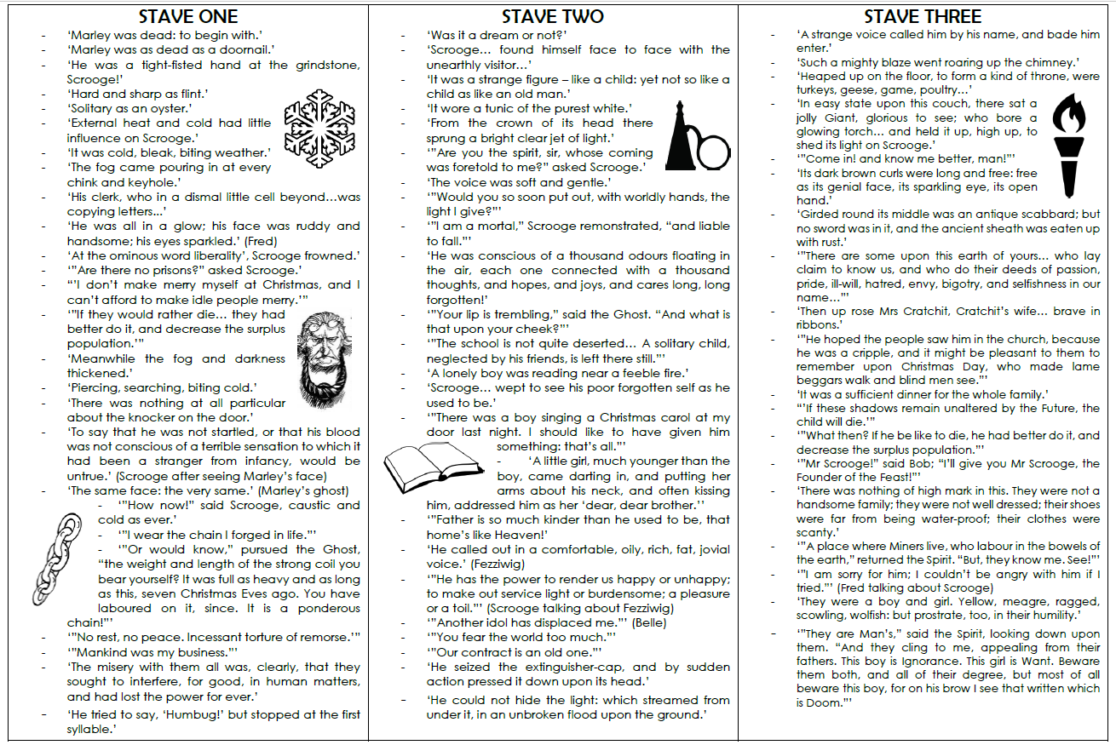

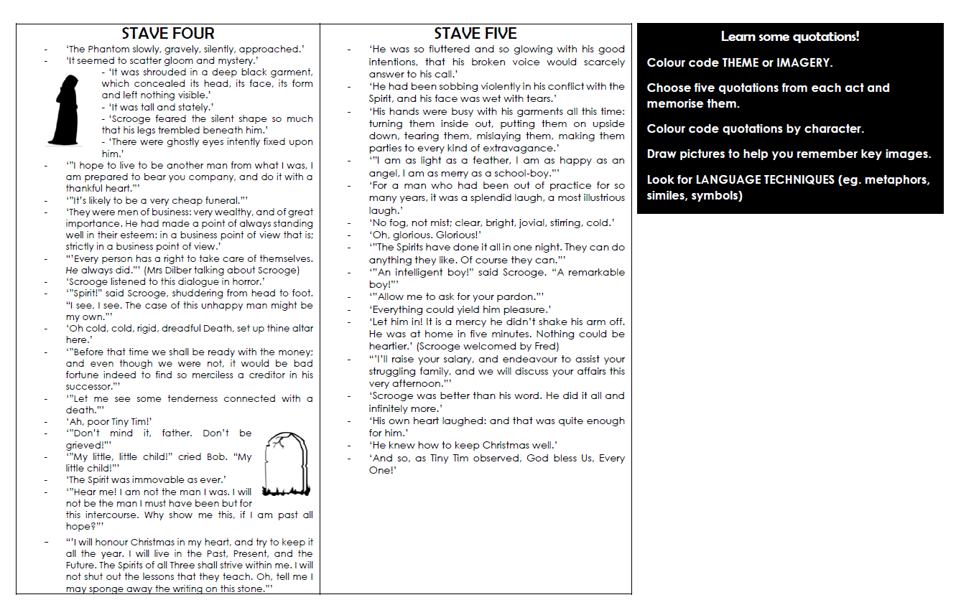

Romeo and Juliet Sequence of Events

Act | Day | Time | Plot Event | Text Clues
I | Sunday | Morning | A fight breaks out between the Capulet and Montegue servants.  Prince Escalus changes Verona law regarding public fighting.  Benvolio confronts Romeo regarding his depression and behavior. | Romeo: Is the day so young?  Benvolio: But new struck nine.  (I.1.169-170)
I | Sunday | Afternoon | Paris asks Lord Capulet if he can marry Juliet.  Romeo and Benvolio discover the guest list includes Rosaline while assisting Capulet's illiterate servant.  The Capulets get ready for the evening's party. | Capulet: This night I hold an old-accustomed feast. (I.2.20)  Romeo:...God-den, good fellow.  Servant: God gi'go-den. I pray, sir, can you read?  (1.2.60-61)  Servingman: Madam, the guests are come, supper served up...(I.2.109-110)
I | Sunday | Evening | Romeo and his friends make their way to the Capulet party. | Scene 4 includes repeated references to night, torches and darkness--night has obviously fallen.  Benvolio: Supper is done, and we shall come too late. (I.4.113)
I | Sunday | Night | The Capulet Party:  - Romeo and Juliet meet, kiss, fall in love  - Tybalt loses his temper and gets kicked out; swears revenge  - The guests leave because it is very late | Capulet: It it e'en so? Why then, I thank you all. I thank you, honest gentlemen. Good night. More torches here! Come on then, let's to bed.  Ah, sirrah, by my fay, it waxes late;  I'll to my rest. (I.5.137-142)
II | Sunday/  Monday | Night-  Pre-dawn | Romeo hides from his friends.  The famous balcony scene takes place. | Romeo: Lady, by yonder blessed moon I swear, (II.2.116)  Juliet: ...That I shall say good night till it be morrow. (1.2.208)
II | Monday | early morning | Romeo convinces Friar Laurence to perform the marriage ceremony. | Friar: What early tongue so sweet saluteth me?  Young son, it argues a distempered head  So soon to bid good morrow to thy bed. (II.3.34-36)
II | Monday | Noon | Romeo runs into his friends, who are looking for him to give him a warning.  The Nurse interrupts their conversation.  Romeo tells her to tell Juliet to come to Friar Laurence's cell that afternoon.  He also says his servant will bring a rope ladder to the Nurse within the hour to facilitate the wedding night. | Nurse: Is it good-den?  Mercutio: Tis no less, I tell ye, for the bawdy hand of the dial is now upon the prick of noon. (II.4.116-118)
III | Monday | Afternoon | Romeo encounters his friends as they are confronting Tybalt.  Romeo tries to talk Tybalt out of fighting.  Mercutio steps in and draws Tybalt into a duel. Mercutio is killed. Romeo, mad with grief over his friend, kills Tybalt. The Prince exiles him as punishment. | When Juliet learns of the fight, she refers to herself as Romeo's 'three-hours wife.' (III.2.109)
III | Monday | Late Afternoon/  Early Night | Juliet learns of the fight; she is so distraught, the Nurse promises to sneak Romeo in to see her to comfort her.  Romeo, hiding with Friar Laurence, learns he is banished.  Romeo leaves to sneak into Juliet's room | Juliet: ...thy three-hours wife... (III.2.109)  Friar: Go hence; good night;...(III.3.183)
III | Monday-  Tuesday | Night-daybreak | Paris is given permission to marry Juliet to cure her of her grief.  Romeo sneaks out of Juliet's room just as dawn breaks and her mother comes to give her the news of her engagement to Paris. | Capulet: Tis very late; she'll not come down tonight (III.4.5)  Romeo: Night's candles are burnt out, and jocund day stands tiptoe on the misty mountaintops. (III.5.9-10)
III | Tuesday | Morning | Juliet is told to marry Paris on Thursday or else.  Juliet goes to Friar Laurence for advice. | Capulet: Thursday is near; ...I'll give you to my friend. (III.5.218)  Friar: Wednesday is tomorrow. (IV.1.100)
IV | Tuesday | Afternoon | Juliet sets the plan in motion by telling her father she will marry Paris. He is so relieved he moves the wedding up to Wednesday, crucially altering the timeline of the plan Juliet and the Friar have agreed on. | Lady Capulet: We shall be short in our provision.  Tis now near night. (IV.2.42-43)
IV | Wednesday | Morning | Juliet's "corpse" is discovered. The family begins arrangements to lay her in the Capulet Mausoleum that day. | Paris: have thought long to see this morning's face...(IV.5.49)
V | Wednesday | Afternoon | Romeo's servant comes to him in Mantua to tell him he's seen Juliet's body in the Capulet's Mausoleum. Romeo goes to buy a poison and then heads back to Verona. | Timing is tricky here. If the body was laid in the vault early morning, Balthazar could have made it to Mantua by early afternoon and Romeo could make it back by late night--just barely. (It's about 25 miles one way.)  Romeo: Well, Juliet, I will lie with thee tonight. (V.1.37)
V | Wednesday | Night | Paris is keeping a lover's vigil at Juliet's tomb when Romeo arrives; both mistake the other's intentions and fight. Paris dies. Romeo gives him his last wish and carries him in to lie his body by Juliet's.  Romeo says farewell to his bride, kisses her and kills himself.  Juliet is woken up by the Friar, sees Romeo and kicks the Friar out of the tomb before she kills herself. | Paris:...Muffle me, night, awhile. (V.3.21)  Friar: St. Francis be my speed! how oft tonight  Have my old feet stumbled at graves! (V.3.124-125)
V | Thursday | Morning | The Friar is caught in the graveyard. The bodies are discovered in the Capulet Mausoleum. An unexpected death is revealed. The full truth of the the secret relationship is revealed to the families. | Prince: What misadventure is so early up,  That calls our person from our morning rest? (V.3.206-207)  Prince: A glooming peace this morning with it brings.  The sun for sorrow will not show his head. (V.3.330-
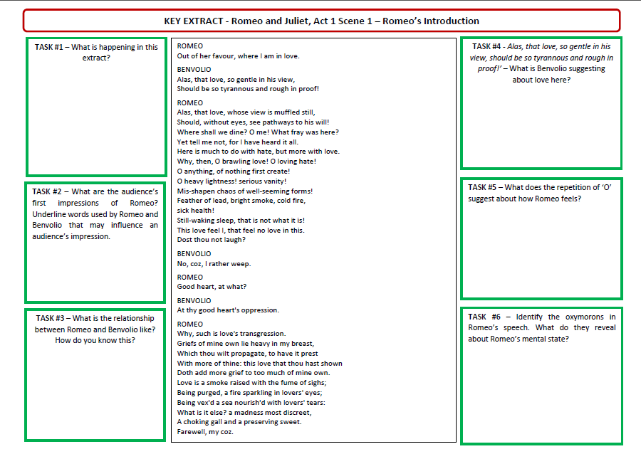
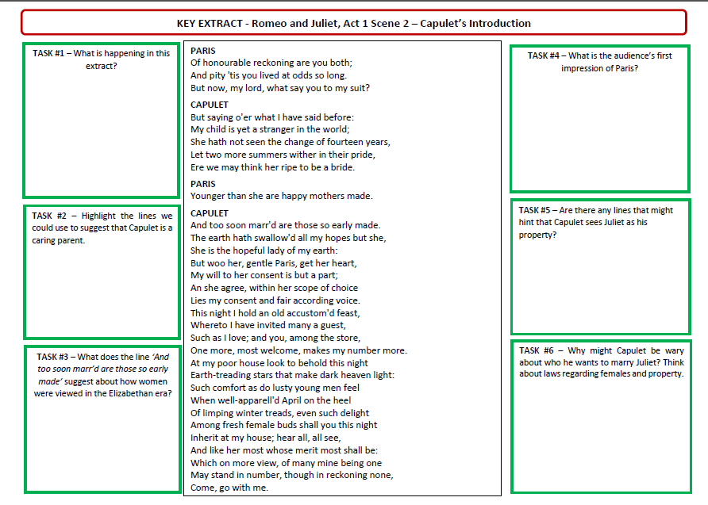
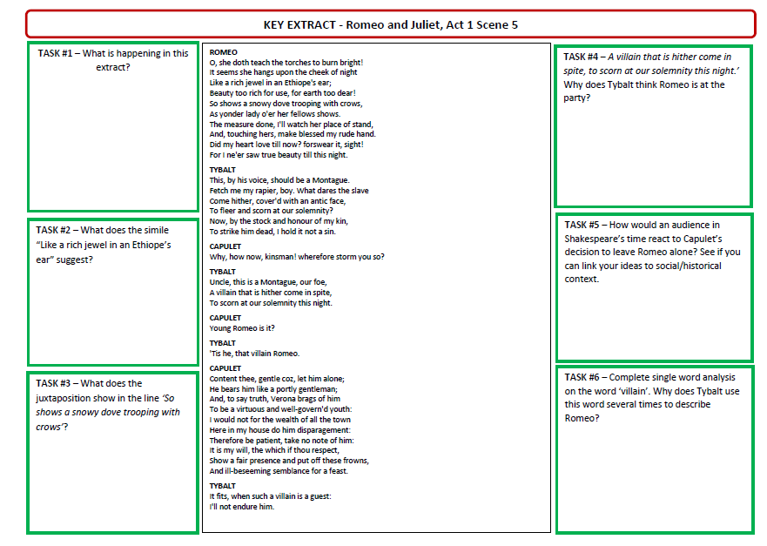

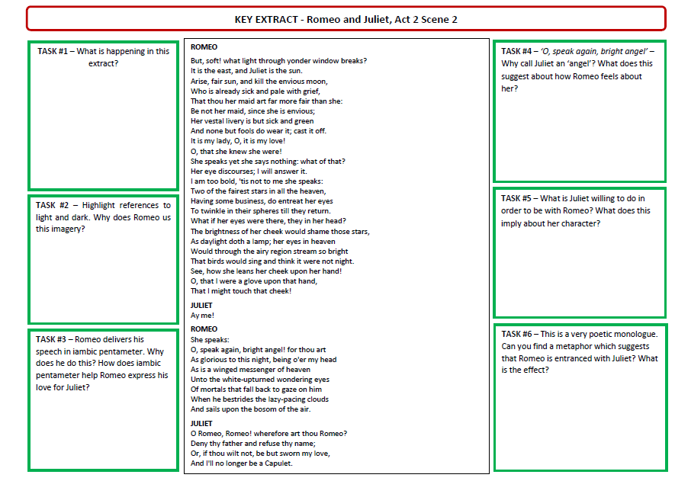
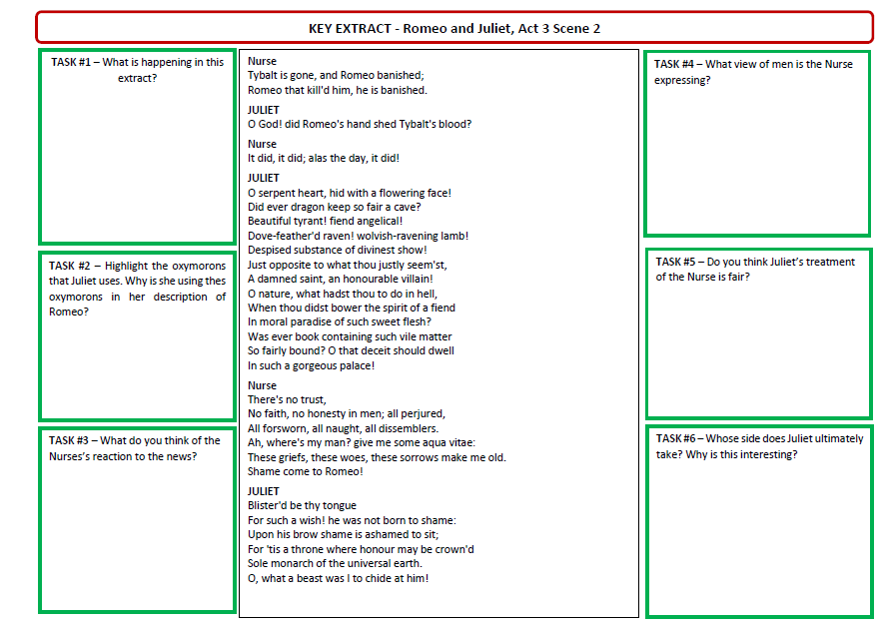
2.
3.
3 point plan
1.
Glossary:
Osier- a willow (type of tree)
Baleful- threatening harm/ menacing
Mickle- a very large amount
Encamp- to settle in and establish a camp
Predominant- the strongest or main element

Predicting
Friar Lawrence uses his plants and nature as a metaphor for human nature.
What is he suggesting about human nature and their behaviour?

Scanning
List the vocabulary which relates to love and care
_____________________________________________________________
_____________________________________________________________
_____________________________________________________________
List vocabulary that relates to evil: ________________________________ _____________________________________________________________
_____________________________________________________________
Vocabulary to suggests challenge or conflict: :____________________________________________________________ _____________________________________________________________
_____________________________________________________________
Close reading
1. What does Friar Lawrence describe happening to the ‘small flower’?
________________________________________________________________________________________________________________________
2. Why does he draw comparisons to the natural world? How?
____________________________________________________________________________________________________________________________________________________________________________________
3. What is he suggesting about human nature here?
________________________________________________________________________________________________________________________

FOCUS ON EXAM QUESTION
How can the ideas in this extract be linked to elsewhere in the play?
1)

2)

3)

CHALLENGE: Can you evidence this?

FRIAR LAWRENCE:
The gray-eyed morn smiles on the frowning night,
Checkering the eastern clouds with streaks of light,
And fleckled darkness like a drunkard reels
From forth day’s path and Titan’s fiery wheels.
Now, ere the sun advance his burning eye,
The day to cheer and night’s dank dew to dry,
I must upfill this osier cage of ours
With baleful weeds and precious-juicèd flowers.
The earth, that’s nature’s mother, is her tomb.
What is her burying, grave that is her womb.
And from her womb children of divers kind
We sucking on her natural bosom find,
Many for many virtues excellent,
None but for some and yet all different.
Oh, mickle is the powerful grace that lies
In herbs, plants, stones, and their true qualities.
For naught so vile that on the earth doth live
But to the earth some special good doth give.
Nor aught so good but, strained from that fair use
Revolts from true birth, stumbling on abuse.
Virtue itself turns vice, being misapplied,
And vice sometime by action dignified.
Enter ROMEO
Within the infant rind of this small flower
Poison hath residence and medicine power.
For this, being smelt, with that part cheers each part;
Being tasted, stays all senses with the heart.
Two such opposèd kings encamp them still,
In man as well as herbs—grace and rude will
And where the worser is predominant,
Full soon the canker death eats up that plant
Skimming
Name THREE reasons why Friar Lawrence celebrates the Earth and the things it can give to us

What is Friar Lawrence’s attitude to earth and nature?

Summary
When does this scene take place?

What has happened before this?

What is about to happen?

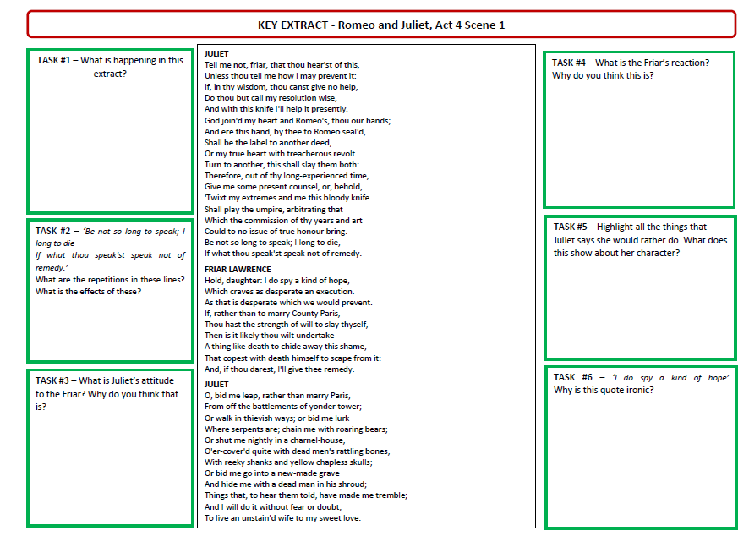
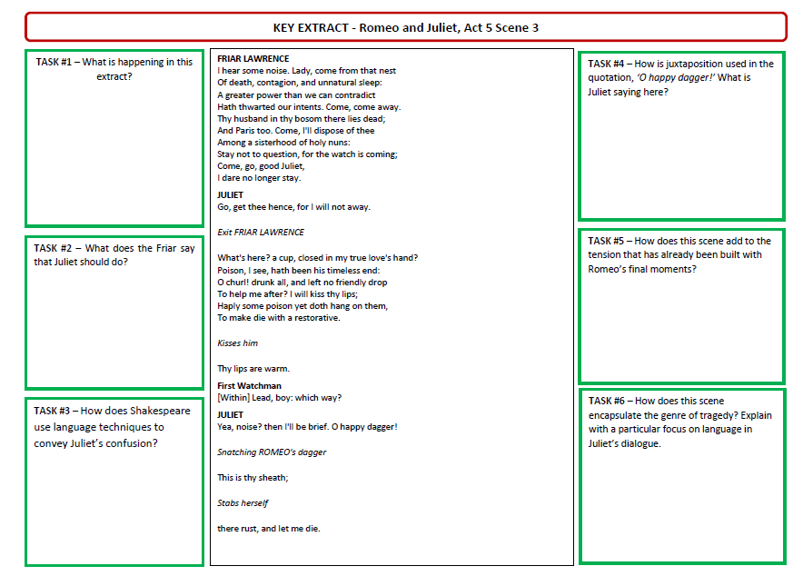
Romeo:
O my love! my wife!
Death, that hath suck'd the honey of thy breath,
Hath had no power yet upon thy beauty:
Thou art not conquer'd; beauty's ensign yet
Is crimson in thy lips and in thy cheeks,
And death's pale flag is not advanced there.
Tybalt, liest thou there in thy bloody sheet?
O, what more favour can I do to thee,
Than with that hand that cut thy youth in twain
To sunder his that was thine enemy?
Forgive me, cousin! Ah, dear Juliet,
Why art thou yet so fair? shall I believe
That unsubstantial death is amorous,
And that the lean abhorred monster keeps
Thee here in dark to be his paramour?
For fear of that, I still will stay with thee;
And never from this palace of dim night
Depart again: here, here will I remain
With worms that are thy chamber-maids; O, here
Will I set up my everlasting rest,
And shake the yoke of inauspicious stars
From this world-wearied flesh. Eyes, look your last!
Arms, take your last embrace! and, lips, O you
The doors of breath, seal with a righteous kiss
A dateless bargain to engrossing death!

Love/Death/Fate
How are each of these themes evident in the extract?

Keywords

Close reading
1. Name at least 3 things that Romeo says about Juliet?
________________________________________________________________________________________________________________________________
2. What has he learnt about himself during the play?
________________________________________________________________________________________________________________________________
3. What does he do at the end of the scene?
________________________________________________________________________________________________________________________________
4. Why does Shakespeare choose to personify deathin this scene?
________________________________________________________________________________________________________________________________

Scanning
Find and record the following:
A phrase that means a loved one
___________________________________________
A phrase that shows us how regretful Romeo is_________________________________
Evidence that shows that Romeo feels cursed
______________________________________________________________________________________

Skimming
What is happening in this scene? Write a summary

Predicting
How will this event affect the relationship between the Montagues and Capulets??

