STOCKLAND GREEN YEAR 11

ENGLISH LANGUAGE



Name: _______________Teacher:_______

READING 50% overall mark

WRITING 50% overall mark

**Which questions are your areas of strength and why?**

Wow._______________________________________________________________________________________________________________

**Which questions are your areas of weakness and why?**

Now._____________________________________________________________________________________________________________________________________________

**Paper 1 – Fiction**

**Section A: Reading**

1. **Finding information [4]**
2. **How does the writer? [8]**
3. **How does the writer use structure? [8]**
4. **Evaluation (how far do you agree?) [20]**

**Section B: Writing**

**Narrative Writing and descriptive writing [40]**

**Paper 2 – Non fiction**

**Section A: Reading**

1. **True/false [4]**
2. **Synthesis of differences [8]**
3. **How does the writer? [12]**
4. **Comparison of narrator’s views [16]**

**Section B: Writing**

**Explanatory or persuasive letter/article [40]**

**Section A – Reading [40 marks]**

**Activity 1**

How well do you know your terminology? Sort the words in blue into the correct columns.

|  |  |  |  |  |
| --- | --- | --- | --- | --- |
| Alliteration | Onomatopoeia | Verbs | Noun phrases | Repetition |
|  |  |  |  |  |
|  |  |  |  |  |
|  |  |  |  |  |
|  |  |  |  |  |

**Louder and louder/broken trees/buzzing/dull red clay/flop!flop!/jagged little piece/CRASH/red flash/flare-lights/hollow bang/flat on our faces/unlit suburb/hissing/burst/dazzled/bump/whizzed**

**Activity 2**

What do you understand but by the term symbolism?

__________________________________________________________________________________________________________________________________

What do each of these images symbolise?

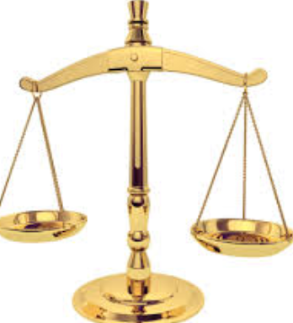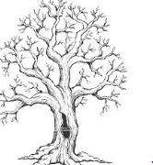 

__________________________________________________________________________________________________________________________________________________________________________________________________________________________________________________________________________________________________________________________________________________________

**QUESTION 1 – retrieval of information [4 marks]**

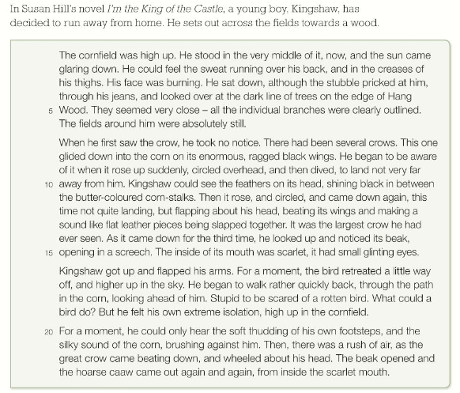

* **What is the tone of the writing?**
* **Where is it set?**
* **What is it about?**
* **What type of writing is it?**

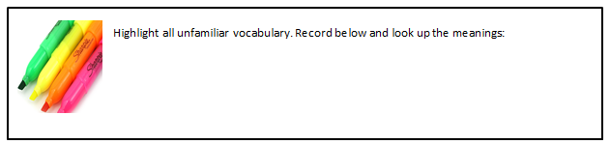

[](https://www.google.co.uk/url?sa=i&rct=j&q=&esrc=s&source=images&cd=&cad=rja&uact=8&ved=0ahUKEwjmxteLhfDNAhVnKsAKHSkrCogQjRwIBw&url=https://blog.udemy.com/how-to-write-a-summary-of-an-article/&psig=AFQjCNFyu8ahKYLEQ5ZQaIeIJ8KkwHDSTA&ust=1468485539155196)

Using lines 7-15, list 4 things about the crow’s behaviour that Kingshaw finds frightening:

1)_________________________________________________________

2)_________________________________________________________

3)_________________________________________________________

4)_________________________________________________________

**QUESTION 2 – How does the writer use language? [8 marks]**

**How does Graves use symbolism in his description of the field mice and frogs?**

**__________________________________________________________________________________________________________________________________________________________________________________________________________________________________________________________________________________________________________________________________________________________________________________________________**

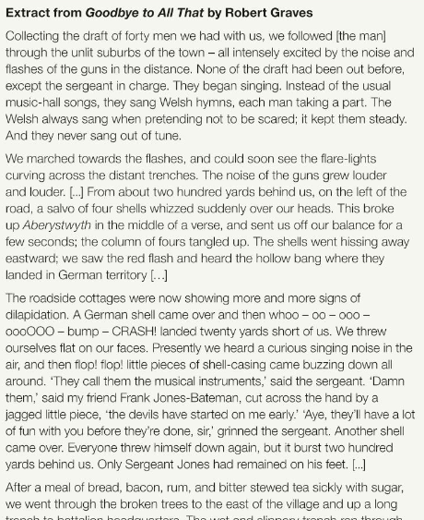

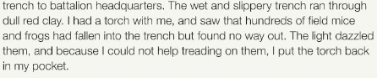

* **What is the tone of the writing?**
* **Where is it set?**
* **What is it about?**
* **What type of writing is it?**



[](https://www.google.co.uk/url?sa=i&rct=j&q=&esrc=s&source=images&cd=&cad=rja&uact=8&ved=0ahUKEwjmxteLhfDNAhVnKsAKHSkrCogQjRwIBw&url=https://blog.udemy.com/how-to-write-a-summary-of-an-article/&psig=AFQjCNFyu8ahKYLEQ5ZQaIeIJ8KkwHDSTA&ust=1468485539155196)

**Question 1 – retrieval of information [4 marks]**

What 4 things did the soldiers see and do on their march to the trenches in paragraph 2?

1)_________________________________________________________

2)_________________________________________________________

3)_________________________________________________________

4)_________________________________________________________

**Progress check – A01 Retrieval of information**

|  |  |  |  |
| --- | --- | --- | --- |
| Skills | I am confident that I can do this | I think I can do this but may need more practice | This is one of my weaker areas so I need to practice |
| I can identify the genre of the text |  |  |  |
| I can identify the main content of the text |  |  |  |
| I can identify the setting of the text |  |  |  |
| I can identify the tone of a text |  |  |  |
| I can select relevant pieces of explicit information |  |  |  |
| I can quote or paraphrase from the text |  |  |  |

What is your plan for improving your areas of weakness?  
_________________________________________________________________________________________________________________________________________________________________________________________________________

**Question 2 – How does Robert Graves create a sense of growing unease as the soldiers march towards the trenches? [8 marks]**

Find 3 examples of quotations which show that the trenches are unpleasant:

**Now highlight the part of speech that you will analyse in each.**



**Progress check – A02 How does the writer use language?**

|  |  |  |  |
| --- | --- | --- | --- |
| **Skills** | **I am confident that I can do this** | **I think I can do this but may need more practise** | **This is one of my weaker areas so I need to practise** |
| **I can identify a wide range of parts of speech** |  |  |  |
| **I can accurately use subject specific terminology when writing about sentence structures and language.** |  |  |  |
| **I can identify key ideas within the text** |  |  |  |
| **I can make inferences based on language choices** |  |  |  |
| **I can comment on the writer’s intention** |  |  |  |
| **I can comment on the reader’s reaction** |  |  |  |
| **I can select evidence effectively and look at patterns across the text.** |  |  |  |
| **I can embed evidence within my answer and litter quotations.** |  |  |  |

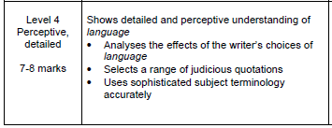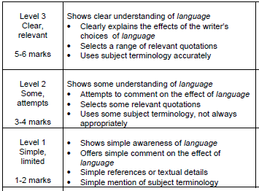

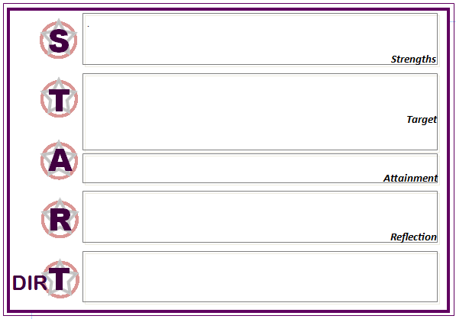

**Question 3 – How does Paton use structure in his writing to interest the reader? [8 marks]**

Text structure involves manipulating the reader through the order in which things are revealed, including plot twists and withholding information.

It also includes how the text begins, ends and how paragraphs and ideas are grouped or linked together.

To write about structure we must also analyse how the structure will affect the reader and why the writer might have chosen to order information in this way.

The following extract is an opening of a short story called The Waste Land by Alan Paton, in which a man finds himself trapped in a remote area by a gang of men. Despite having no idea who the man is, we are plunged into a tense situation from the very first sentence.

List as many structure specific terms as you can think of:

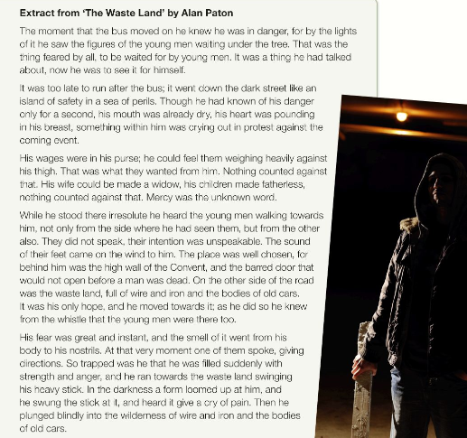



[](https://www.google.co.uk/url?sa=i&rct=j&q=&esrc=s&source=images&cd=&cad=rja&uact=8&ved=0ahUKEwjmxteLhfDNAhVnKsAKHSkrCogQjRwIBw&url=https://blog.udemy.com/how-to-write-a-summary-of-an-article/&psig=AFQjCNFyu8ahKYLEQ5ZQaIeIJ8KkwHDSTA&ust=1468485539155196)

The text is in chronological order. How does each paragraph develop and build tension? How is the focus shifted slightly in each paragraph and how does this support the build up of tension?

|  |  |  |  |
| --- | --- | --- | --- |
| Paragraph | Evidence | Shifting focus? | How is tension built? |
| 1 |  |  |  |
| 2 |  |  |  |
| 3 |  |  |  |
| 4 |  |  |  |
| 5 |  |  |  |

The second paragraph contains a long complex sentence to describe what is happening to the man. What effect does this have on the reader? Which phrase in the sentence warns the reader of what is to come?

________________________________________________________________________________________________________________________________________________________________________________________________________________________________________________________________________________________________________________________________________________________________________________________________________________________________________________________________________________

The third paragraph contains several short statements. Why do you think the writer has chosen to include them at this point?

________________________________________________________________________________________________________________________________________________________________________________________________________________________________________________________________________________________________________________________________________________________________________________________________________________________________________________________________________________

Challenge: Sometimes writers withhold information from the reader. An example of this comes in the first paragraph: “That was the thing feared by all, to be waited for by young men.” How does this add to the tension of the story, even though we do not yet understand the significance of the line?

________________________________________________________________________________________________________________________________________________________________________________________________________________________________________________________________________________________________________________________________________________________________________________________________________________________________________________________________________________

**Progress check – A02 How does the writer use structure?**

|  |  |  |  |
| --- | --- | --- | --- |
| **Skills** | **I am confident that I can do this** | **I think I can do this but may need more practice** | **This is one of my weaker areas so I need to practice** |
| **I can identify a wide range of structural features.** |  |  |  |
| **I can accurately use subject specific terminology when writing about sentence structures and whole text structure** |  |  |  |
| **I can identify key ideas within the text** |  |  |  |
| **I can make inferences based the layout of the whole text.** |  |  |  |
| **I can comment on the writer’s intention** |  |  |  |
| **I can comment on the reader’s reaction** |  |  |  |
| **I can select evidence effectively and look at patterns across the text.** |  |  |  |
| **I can embed evidence within my answer and litter quotations.** |  |  |  |

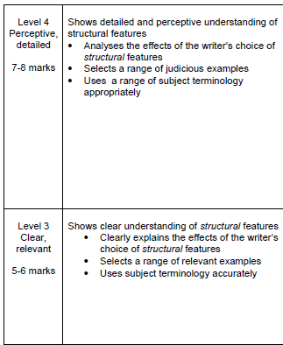



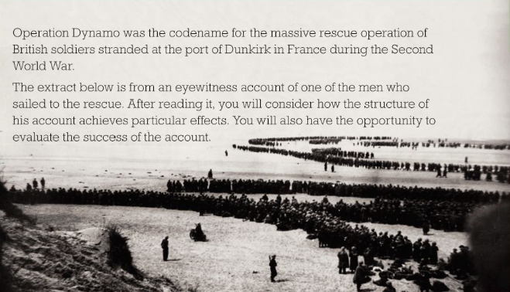

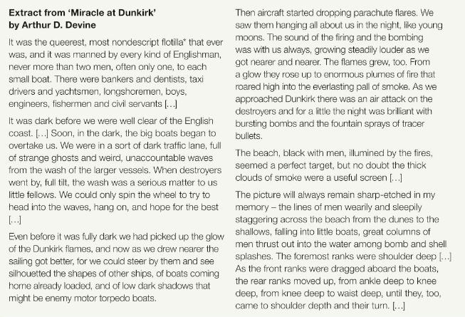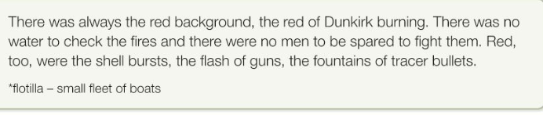



[](https://www.google.co.uk/url?sa=i&rct=j&q=&esrc=s&source=images&cd=&cad=rja&uact=8&ved=0ahUKEwjmxteLhfDNAhVnKsAKHSkrCogQjRwIBw&url=https://blog.udemy.com/how-to-write-a-summary-of-an-article/&psig=AFQjCNFyu8ahKYLEQ5ZQaIeIJ8KkwHDSTA&ust=1468485539155196)

**QUESTION 4 – Evaluation – how far do you agree [20 marks]**

Evaluating the text means judging how well you think the writer has succeeded in achieving their purpose and the effects they wanted to create. This means writing about ideas, language and structure in just the same way as you have been practising already and bringing them all together in one essay.

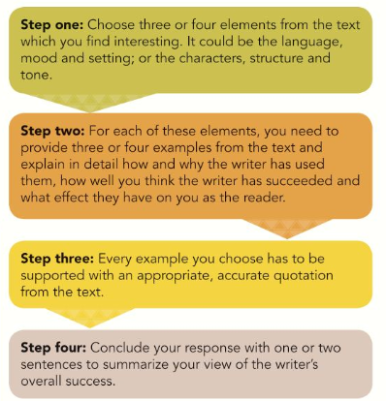

**One student wrote the following about ‘Miracle at Dunkirk’: “It really brings alive what it was like to be there that night. You can almost see the “plumes of fire” he describes.”**

**How far do you agree with this student?**

**What is your first reaction to this question and why?**

|  |  |  |  |
| --- | --- | --- | --- |
| Step one – element plus point | Step two – 3/4 example of the writer’s point of view from the text | Step 3 – quotation with connotations and device used/effect | Step 4 – summary of view of writer’s overall success |
| Language |  |  |  |
| Mood |  |  |  |
| Setting |  |  |  |
| Characters/people |  |  |  |

**Progress check – A04 Critical evaluation of texts**

|  |  |  |  |
| --- | --- | --- | --- |
| **Skills** | **I am confident that I can do this** | **I think I can do this but may need more practice** | **This is one of my weaker areas so I need to practice** |
| **I can evaluate the effect of a variety of the writer’s choices of language and structure** |  |  |  |
| **I can accurately use subject specific terminology when writing about language, sentence structures and whole text structure** |  |  |  |
| **I can identify and evaluate the writer’s ideas** |  |  |  |
| **I can build a critical argument using academic language.** |  |  |  |
| **I can comment on the writer’s intention** |  |  |  |
| **I can comment on the reader’s reaction** |  |  |  |
| **I can select evidence effectively and look at patterns across the text.** |  |  |  |
| **I can embed evidence within my answer and litter quotations.** |  |  |  |

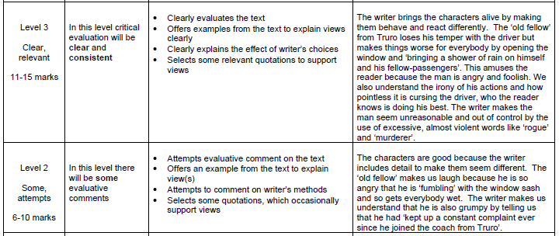



**Section B – Writing [40 marks]**

[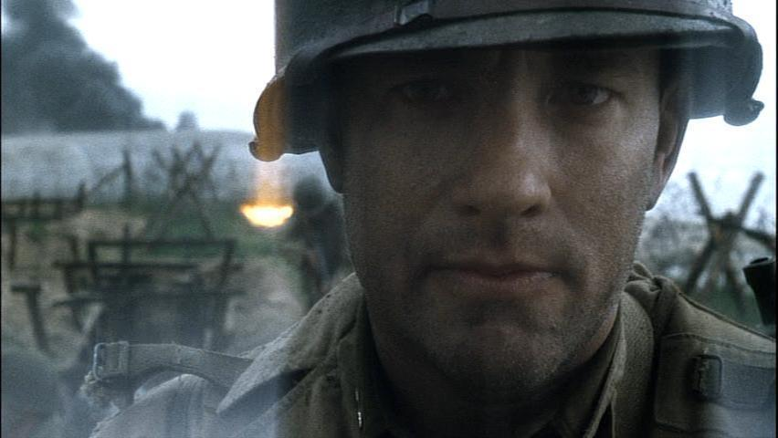](http://www.google.co.uk/url?sa=i&rct=j&q=&esrc=s&source=images&cd=&cad=rja&uact=8&ved=0ahUKEwj4pe60q_XMAhVqBMAKHRp2DHcQjRwIBw&url=http://www.fanpop.com/clubs/saving-private-ryan/images/10832066/title/tom-hanks-fanart&psig=AFQjCNEy1uljN64pBFzIFalxdqFeJwz-9Q&ust=1464269580451345)

**Create a piece of narrative writing from the point of view of a soldier in the D-Day landings.**

**Mercy.** Mercy was not a factor being offered by the skies of the English Channel. Not even in the summer month of June, not even as a reward for offering our lives, not even because a glimpse of solar comfort here could be our last.

The boat to which we had entrusted our lives; like an older brother was bucking like a wild bull. Tormented by the merciless waves. Eventually the drone of last minute instructions, far off explosions and an ironically enthusiastic engine became our poison. Causing almost all of us to retch or shake. This illness divided the men. Half would swig at their hip flasks, almost as thought the previous morsel of *Dutch courage* did somehow not count when there were lives at stake. The remaining rattling skeletons of soldiers would press their lips against rusted crucifixes like a new born child’s forehead. Then process to cross themselves, tears glazing their eyes. The thoughts of home were obvious, glaring from their pupils like slides in a slideshow. For a second I pondered whether or not God would even be bothering to look down on us right now. I concluded that he would not be, not even his eyes could pierce the opaque smoky carpet that we had all been swept under.

To be frank I don’t believe that any being or spirit would choose to view the horrors that were about to commence. If my heart had not been slamming against my chest in tangible thuds, it would have been possible to suggest time had stopped. Since the order; “clear the ramp- thirty seconds” had been issued, the engine had slowed to a low murmur. With many of the men turning white like snowflakes. Only my war torn mind could have conceived the irony the irony that; for many men, their last moments of life were spent as pale and motionless as they would spend all of eternity.

[](http://www.google.co.uk/url?sa=i&rct=j&q=&esrc=s&source=images&cd=&cad=rja&uact=8&ved=0ahUKEwjLvbLNrfXMAhXjLsAKHSWkDeAQjRwIBw&url=http://www.fotosearch.com/CSP991/k11753225/&psig=AFQjCNE9OGafrmHAq3kop93A-XQH87x7yQ&ust=1464270020138345)**Highlight the narrative writing above – which bits stand out as especially sophisticated?**

**Content and organisation mark scheme [24 marks]**

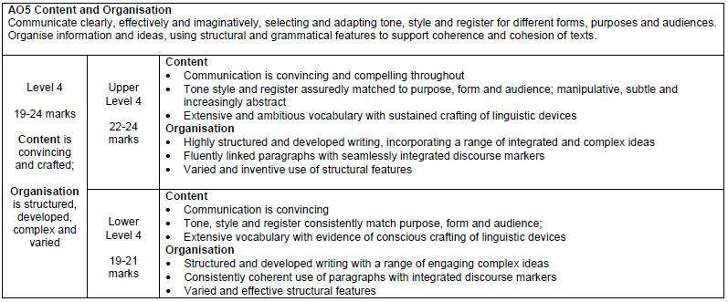

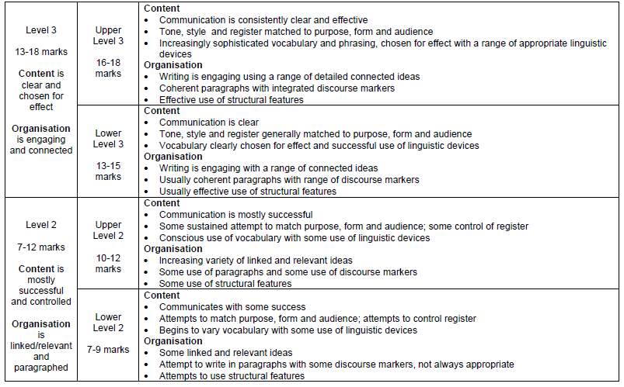

**SPAG mark scheme [16 marks]**

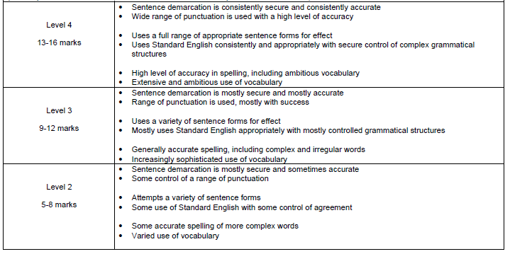

THINK: What would the examiner like or dislike about the writing?

|  |  |  |
| --- | --- | --- |
|  | Content and organisation | SPAG |
| What mark would you award it |  |  |
| Why? What skills have been shown? |  |  |

What is the soldier next to you doing? How is he doing it?

SECTION ONE: WAITING ON THE BOAT

It’s a countdown: you’re nearly there…the last memory you have from home is…

What is the general mood? What are the other soldiers doing? Look around at you; describe at least 3 other soldiers reacting in different ways:







[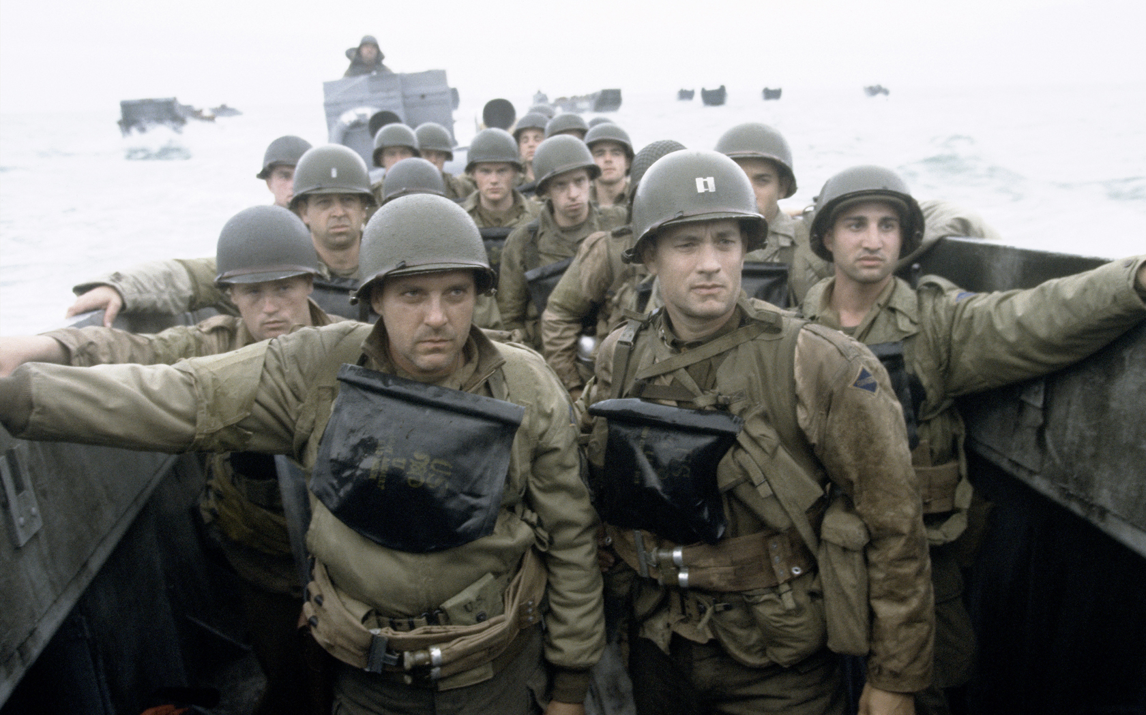](http://www.google.co.uk/url?sa=i&rct=j&q=&esrc=s&source=images&cd=&cad=rja&uact=8&ved=0ahUKEwj0iIH85PTMAhXnJ8AKHZP3AHgQjRwIBw&url=http://filmmakeriq.com/2014/06/the-onion-looks-back-at-saving-private-ryan/&psig=AFQjCNF8dkk9UCbRlI-AL8o_KUAEJxTCRw&ust=1464250666873919)

What is your character thinking about and feeling?

Describe the sea, the noise of the engines, the waves, the sky….

What is the captain screaming at you all?

SKILL ONE: PUNCTUATING SPEECH

[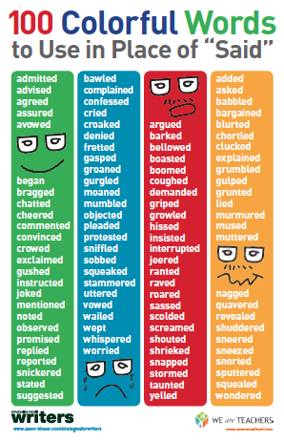](https://www.google.co.uk/url?sa=i&rct=j&q=&esrc=s&source=images&cd=&cad=rja&uact=8&ved=0ahUKEwj_qunzgfXMAhWnJ8AKHWE_AugQjRwIBw&url=https://pauljennynyc.com/2015/02/19/be-a-straight-shooter-use-straightforward-dialogue-tags/&psig=AFQjCNF5mUYGYBqZWOYRjD2N3vqg8Z_1iA&ust=1464258440902336)

Miller_________________________ I want you to clear those murder holes. I’ll see you on the beach.

Delancey tries to look away but Miller grips him by the jaw and forces him to lock eyes. Miller smiles. Delancey is terrified.

Delancey _________________________Captain, are we all going to die?

Miller______________________Hell no, to-thirds, tops.

Delancey___________________________Oh Jesus…

Miller________________________I want every one of you to look at the man on your left. Now look at the man on your right. Feel sorry for those sons-of-bitches, they’re going to get it, you’re not going to get a scratch.

A few, including Delancey, manage thin smiles. Miller release his grip on Delancey who moves his jaw as if to see if it’s broken. Miller pats him on the cheek and moves on to the bow.

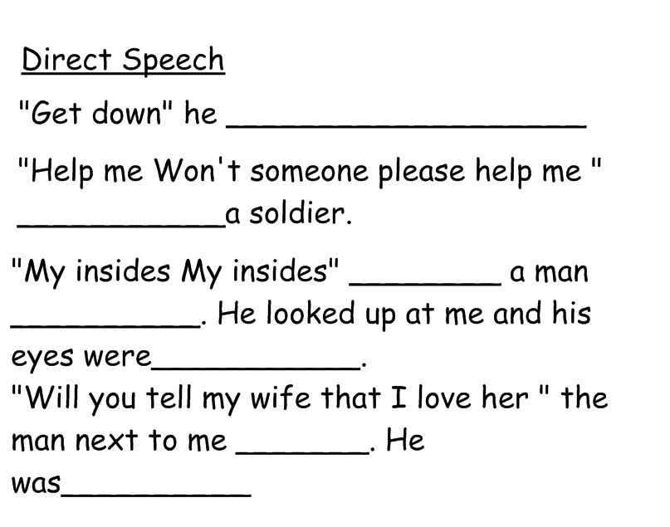

SKILL TWO: USING SENSORY DETAILS

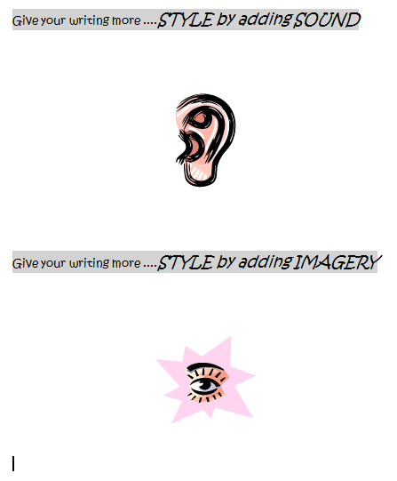

**Watch the video clip from the start of Saving Private Ryan.**

**Record as many ideas as possible about what the soldiers could hear and see.**



Write 200 words about waiting on the boat, getting ready to get off the boat, getting onto the beach.

What do you hear, see, taste, touch, smell?

Include short snippets of dialogue with fellow soldiers. Include interesting speech tags.

_________________________________________________________________________________________________________________________________________________________________________________________________________________________________________________________________________________________________________________________________________________________________________________________________________________________________________________________________________________________________________________________________________________________________________________________________________________________________________________________________________________________________________________________________________________________________________________________________________________________________________________________________________________________________________________________________________________________________________________________________________________________________________________________________________________________________________________________________________________________________________________________________________________________________________________________________________________________________________________________________________________________________________________________________________________________________________________________________________________________________________________________________________________________________________________________________________________________________________________________________________________________________________________________________________________________________________________________________________________________________________________________________________________________

Write yours out NOW:

1)____________________________________________________________________

2)__________________________________________________________________________________________________________________________________________

3)__________________________________________________________________________________________________________________________________________

Use these in your writing above!

Catch the examiner’s eye from the 1st paragraph

1) Write a first sentence containing a colon. **:**

2) Vary your sentences 7 word, 3 word, 14 word.

3) Use the varied sentence starters *If, if, if then/the more, the more/ 3_ ed*

SECTION TWO: GETTING OFF THE BOAT

Sentence Starters for YOU!!

Whizzing past my head was….

My last thought was…

Swirling around my feet the water looked…

Up ahead of me was…

Sand was flying…

Around me other soldiers were…

My legs felt…

Overhead the sky was…

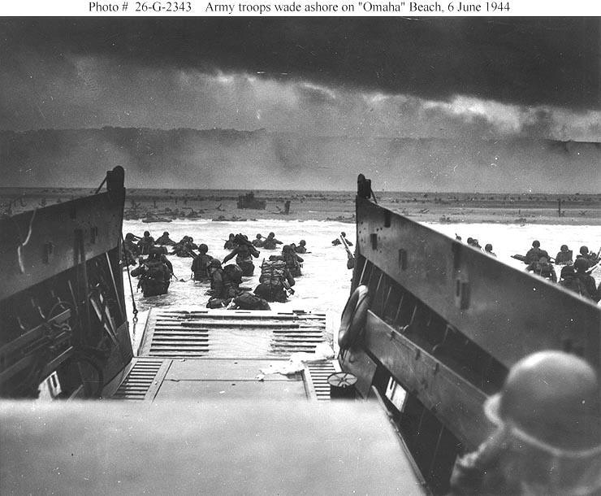

Describe how you get off the boat:

What happens to the sand around you:

What can you see in the air around you?

What is the first thing you do as you run up the beach:

What are the sounds around you?

What is the first thing you do as you run up the beach:

Describe the water – what does it do to your clothes? What are the waves like? Does it hamper your progress?

What are the last thoughts you have before getting off the boat?

SKILL THREE: SENTENCE VARIETY

Add two of your own to the lists below. (Make sure that they would suit the scene you are writing about)

|  |  |  |
| --- | --- | --- |
| -ly adverbs | -ing verbs | -ed verbs |
| Menacingly, | Rolling, | Terrified, |
| Devastatingly, | Thundering, | Horrified, |
|  |  |  |
|  |  |  |

Now select 3 from above and create 3 sentences about the scene that you can insert into your writing.

1)____________________________________________________________________________________________________________________________________________________________________________________________

2)____________________________________________________________________________________________________________________________________________________________________________________________3)___________________________________________________________________________________________________________________________________________________________________________________________

**Add adverbs of manner to give this writing more style:**

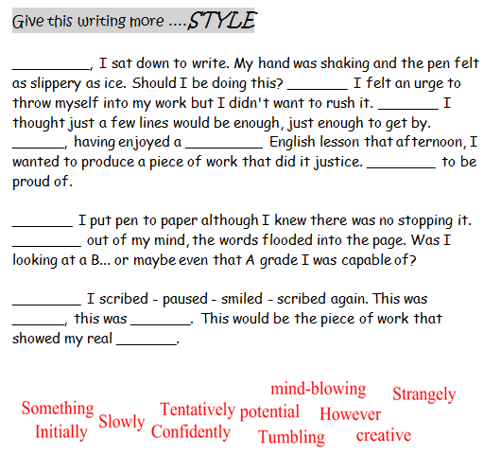

SKILL THREE: MORE UNUSUAL SENTENCES

|  |  |
| --- | --- |
| 3 ed sentence |  |
| De:de sentence |  |
| Outside/inside sentence |  |
| If, if, if then |  |
| The more, the more |  |



Write 200 words about getting off the boat, into the water. What do you do? Are you coping?

What do you hear, see, taste, touch, smell?

Include short snippets of dialogue with fellow soldiers. Include varied sentences starters.

_________________________________________________________________________________________________________________________________________________________________________________________________________________________________________________________________________________________________________________________________________________________________________________________________________________________________________________________________________________________________________________________________________________________________________________________________________________________________________________________________________________________________________________________________________________________________________________________________________________________________________________________________________________________________________________________________________________________________________________________________________________________________________________________________________________________________________________________________________________________________________________________________________________________________________________________________________________________________________________________________________________________________________________________________________________________________________________________________________________________________________________________________________________________________________________________________________________________________________________________________________________________________________________________________________________________________________________________________________________________________________________________________________________________

Creative Writing

Saving Private Ryan – A soldier’s perspective.

It was seven in the morning. It was Black. Tension building clouds loomed overhead, as we inched closer to our destination. Beads of salty sweat appeared on my forehead, and rain water dripped slowly down to the end of my nose. Sea water crashed against the side of the landing craft where me and my fellow soldiers stood. I felt sick. The frantic rocking of the craft made my stomach lurch violently. I vomited; as many others were doing. The putrid stench hung in the air. It was a horrific reminder of the hell that lay ahead.

I could barely stand still, it was like hundreds of men were pushing me at once, side to side I went not able to control which way I was tossed about. I looked down at my feet. The constant drone of the engines was driving me insane. I felt I had to try and get my mind off this terrifying task, that we were about to undertake.

Everyone on the craft was shaking uncontrollably we were not far from the shore. I couldn’t think straight. Everywhere I looked. Panic. Would they notice if I didn’t get off when the craft landed? My eyes flitted side to side watching all of the soldiers around me.

I could smell the fear coming off every single one of them. They were silent. Not a word was spoken. We waited so patiently for the command; it felt like a lifetime had passed. Suddenly it came “Clear the hole, I’ll see you on the beach” The words I had been dreading the whole journey. The prolonged escape from the preluding panic.

The water sprayed over the side persistently as we got closer. I was saturated. It was such a depressing situation. I could hear the splattering of machine guns in the distance, guns and bombs waiting to obliterate every one of us. Grown men flinched all around me as the sound of death approached; each bullet forced me into a crouched position. The walls of the craft my only protection, my armour, my saviour.

Suddenly the incessant drone of the engines died down into a new and terrifying tone. I knew what was coming. Bombs blasted through the water next to the boat where we were positioned. It was intense now, I gripped tight hold of my gun, it was my only friend. The only thing that could drag me through this nightmare.

The shrill sound of the whistle pierced my ears, as the deck wheel spun frantically, straining a little, as though to keep us safe in the walls of the craft.

We braced ourselves as the ramp lowered. Our fate was completely unknown. “SPLASH” The ramp had hit the water, our ordeal had barely begun. I felt like it should be over already.

It was horrendous. Complete and utter chaos. I was frozen still; my feet were glued to the floor. The first five rows of soldiers were destroyed; mown down with the first intense blast of the machine guns. They did not stand a chance. I knew it was an absolutely terrible thing to think, but I was so glad to be positioned at the back of the craft, away from death.

The spatter of machine guns made me numb all over, it was if I had been plunged into a bucket of icy cold water. My chest tightened. Breathing became a great struggle; it was almost as if I had forgotten how to use my lungs. Bullets raced past my head as I struggled to climb over flailing bodies. The pinging on the metal made survivors wince. I felt like a child again, when I used to play war games in the street with my friends. But this was serious, this was genuinely terrifying, this was a matter of life or death!

Read and highlight this piece of writing. Which bits can you magpie?

Is this better or worse than the first example you were given? How can you tell?

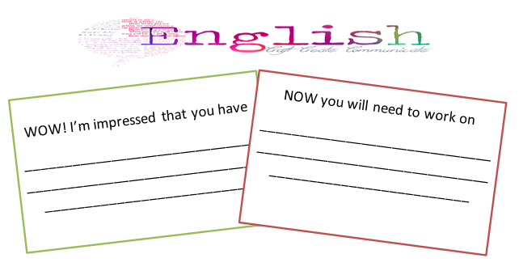

SECTION THREE: GETTING UP THE BEACH



How do you get up the beach?

How do you move?

Does anything get in your way?

Where do you take shelter?

How are you feeling at this point?

What injuries have you sustained? If so, what happened?

Can you see anyone you recognise? Who and what is happening to them?

SKILL THREE: ADDING DEVICES TO YOUR WRITING

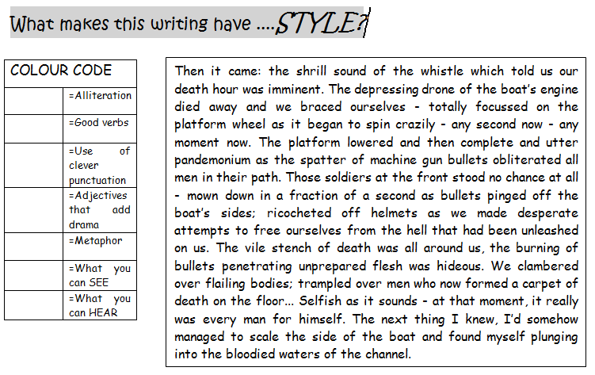

Now write out your own example of:

|  |  |
| --- | --- |
| Alliteration |  |
| Emotive language |  |
| Metaphor |  |
| Simile |  |
| Anaphora |  |

Don’t forget to put these into your paragraph!

SKILL FOUR: Using devices to add interest

Extracts taken from Clashes and Collisions.

The Drum.

Adapt these lines to create

A simile to describe the sounds of the guns:

A simile to describe the sky overhead:

A simile for the battleground on the beach:

‘ To me it talks of ravaged plains,

And burning towns, and ruined swains,

And mangled limbs, and dying groans,

And widows’tears, and orphans’ moans;

And all that Misery’s hands bestows,

To fill the catalogue of human woes.

Adapt these lines to create

A metaphor to describe the waves:

A metaphor to describe the screams of the men:

Can you personify (make human) the thud of men’s boots on the sand?

Can you personify (make human) the sun in the sky?

SKILL FOUR: Use a line of poetry to add finesse to your ending

Conscientious Objector

Now craft your last lines using these poems to inspire you:

________________________________________________________________________________________________________________________________________________________________________

Don’t forget to use this in your writing!

I shall die, but that is all that I shall do for Death.

Invasion

Soon they will come. First we will hear

the sound of their boots approaching at dawn

then they ‘ll appear through the mist.



Write 200 words about your experience of battling your way up the beach. What happens to the soldiers around you? What do you do? Do you hide? Fight? Cry?

Use all of the devices mentioned on the previous pages.

_________________________________________________________________________________________________________________________________________________________________________________________________________________________________________________________________________________________________________________________________________________________________________________________________________________________________________________________________________________________________________________________________________________________________________________________________________________________________________________________________________________________________________________________________________________________________________________________________________________________________________________________________________________________________________________________________________________________________________________________________________________________________________________________________________________________________________________________________________________________________________________________________________________________________________________________________________________________________________________________________________________________________________________________________________________________________________________________________________________________________________________________________________________________________________________________________________________________________________________________________________________________________________________________________________________________________________________________________________________________________________________________________________________________

**WORD WALL!**

**Contaminated**

**Ricochet**

**Unwholesome**

**Consumed**

**Intensified**

**Annihilated**

**Onslaught**

**Merciless**

**Blood-filled depths**

**Falling like dominoes**

**Claiming blood stained victims**

**Predators preying on the men from their wooden obelisks**

**The loaded bodies of heavy men thudded into the water**

**The whizzing bullets crumpled through the air**

**The thudding of a bomb into the ground like the last beat of a heart**

**The clattering rattle of ineffectual helmets**

**Grown men cradled and kissed their crosses**

**Craggy Cliffs, pushing water, pounding waves**

**A cloud of crimson as another soldier falls**

**A chain of bullets**

**The sea consumed them whole**

**Hollowed cheeks of the men**

**Drinking salty death**

**Churning**

**Thrashing**

**Pallor**

**Prosaic**

Now highlight 10 words or phrases from this page. Return to your previous paragraphs and add at least 3 to each to improve your vocabulary.

You may need to add or alter sentences to allow this to happen.

**Cursing**

**Frothy**

**Profanities**

**Pounding**

**Shivering**

**Quaking**

**Dismembered bodies**

**Splatter**

**Metallic scent of blood**

**Drenched**

**Salty tang**

**Death’s door**

**Pleading**

**Quavering**

**Clanging**

**Roar**