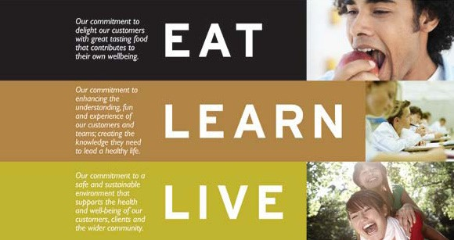

Dear Parent/Guardian

I would like to take this opportunity to introduce Chartwells, the UK’s leading provider of quality catering services to the Education sector, and to deliver an excellent piece of news for everyone who, like us, cares about the quality of food provision for our children.

Chartwells has been appointed as the new school caterer and we will be looking after Stockland Green Schools catering needs from the 24th April 2017. Our menus include the best quality ingredients sourced directly from growers and producers. This ensures we can maintain a robust supply chain and have complete traceability from the field to the plate.

The School Food Standards for school meals dictate stringent requirements in relation to the nutritional content of school meals and I am delighted to say that the menus on offer meet all of these standards.

A journey is about never standing still Chartwells, in partnership with Stockland Green School, will ensure that we offer your children a compliant, nutritionally balanced and tasty meal - eating and hydration is and will be an important part of their day.

Every day there are a range of main lunchtime meals available with vegetables or salad plus a dessert priced at £2.20, also on offer we have pasta with different toppings, trattoria pizza, panini’s, a range of grab and go sandwiches, baguettes, wraps, fruit pots, mousse pots, jelly pots and fresh fruit also a large range of compliant drinks are available.

We hope you will encourage your child to eat with us in the full knowledge that their health and nutrition is being taken care of.

Please do not hesitate to contact us should you have any queries regarding the food offer at Stockland Green School and we will be only too happy to help.

Yours Sincerely

Paul Simpson
Regional Manager Chartwells
ATLP@compass-group.co.uk

