

Energy

Combined Science

Name ______________________________

Class ______________________________

Teacher ______________________________

**Energy facts**

1. Magnetic, kinetic, heat (thermal), gravitational, electrostatic, chemical, elastic, electrical, nuclear.
2. Gravitational potential → kinetic.
3. Ek = 0.5 × m × v2
4. The speed increases.
5. Ep = m × g × h
6. Elastic potential energy
7. How much energy is needed to heat up 1 kg of a material by a temperature of 1˚C.
8. ΔE= m x c x Δϑ
9. Heater heats a metal block. Balance used to measure mass of block. Joulemeter used to measure amount of energy to block. Thermometer used to measure temp increase of block. Use mass, temperature change and energy to calculate specific heat.
10. Energy is never created or destroyed. Only changed from one form to another.
11. P = E ÷ t. It is the rate of which energy is transferred.

1. Watts (W)
2. Use lubricants (like oil)
3. True
4. Cavity walls, loft insulation, double-glazed windows, draught excluders.
5. False
6. Efficiency = useful power output ÷ total power in
7. Renewable: solar, wind, hydroelectric, wave, tidal

Non-renewable: coal, oil, gas, nuclear

1. Non-renewable energy resources will run out. Renewable energy resources will not.
2. Burning fossil fuels releases carbon dioxide (causes global warming) and sulphur dioxide (acid rain).
3. It isn’t always windy (unreliable)
4. Have to flood a valley.

**Fold page here**

1. What are four energy stores?
2. Describe the energy transfers that occur as a ball falls to the ground.
3. Give the equation for finding the energy in an object’s kinetic energy store?
4. If energy is transferred to an object’s kinetic energy store, what happens to its speed?
5. Five the equation for finding the energy in an object’s gravitational potential energy store.
6. What kind of energy store is energy transferred to when you compress a spring?
7. What is the definition of specific heat capacity of a material?
8. Give the equation that relates energy transferred and specific heat capacity.
9. Describe an experiment to find the specific heat capacity of a material.
10. State the conservation of energy principle.
11. Define power and give an equation to calculate power.
12. What are the units of power?
13. How can you reduce unwanted energy transfers in a machine with moving, touching components?
14. True or false? A high thermal conductivity means there is a high rate of energy transfer.
15. Give four ways to prevent unwanted energy transfers in a home.
16. True or false? Thicker walls make house cool down quicker?
17. Give the equation that relates efficiency to power.
18. Name four renewable energy resources and four non-renewable energy resources.
19. What is the difference between renewable and non-renewable energy resources?
20. Give two disadvantages of burning fossil fuels.
21. Give a disadvantage of wind power.
22. Give a disadvantage of hydroelectric power. (Hz) **×**

Whenever anything happens, energy is transferred from one **store** to another.

Energy stores and systems

**A** **system** is an object or a group of objects.

When a system changes, the energy stored in that system changes as well, as it is transferred from one **store** to another.

The **principle of conservation of energy** says that energy cannot be created or destroyed. It can only be **transferred** from one store to another. The following are the different stores of energy:

* **chemical** – fuels, food, batteries
* **kinetic** – moving objects
* **gravitational potential** – objects above the ground
* **elastic potential** – objects that are stretched or squashed
* **thermal energy** – due to temperature
* **magnetic** – magnets
* **electrostatic** – due to electric charges repelling or attracting
* **nuclear** – when nuclei inside atoms join or separate

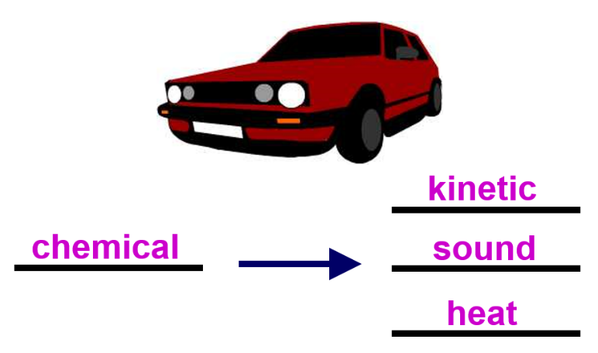In most energy transfers, the energy is transferred to several different forms, which may be useful or not useful. The energy that is transferred to unwanted forms of energy is **wasted**. This is by raising the **thermal energy store** of the surroundings.

thermal

kinetic

chemical

You can show the energy transfers by using **an energy transfer diagram.** Energy has units of **Joules**.

**Task: Complete in your exercise book**

**Basic**

1. What are the units of energy?
2. What does the principle of conservation of energy say?
3. Name four different energy stores?
4. What is unwanted energy called?
5. Unwanted energy is usually transferred to what energy store?
6. What store of energy does a chocolate bar have?
7. What store of energy does a moving motorbike have?
8. What two stores of energy does a moving aeroplane that’s high in the sky have?
9. What store of energy does a helicopter hovering (not moving) have?
10. What store of energy does a stretched elastic band have?
11. What store of energy does petrol have?

**Medium**

1. What are the input and output energies for each of the following (including any wasted energies):
2. A light bulb
3. A cyclist travelling along a road.
4. A calculator with a solar panel.
5. A bow and arrow being fired.
6. An aeroplane taking off.
7. Turning on a torch.
8. Lighting a candle.
9. Rubbing your hands to keep them warm.
10. Bouncing on a trampoline.

**Hard**

1. Roger Federer serves a tennis ball directly into the air. List all of the energy transfers that occur. Include the tennis ball returning to the ground, and then bouncing back up again.
2. 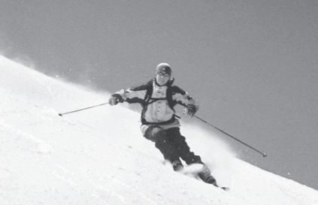Andrew skis down a hill. Andrew starts from the top of the hill and his speed increases as he goes downhill.

He controls his speed and direction by using his skis.

He brings himself to a stop at the bottom of the hill.

Describe the energy changes that happen between starting and stopping. [3 marks]

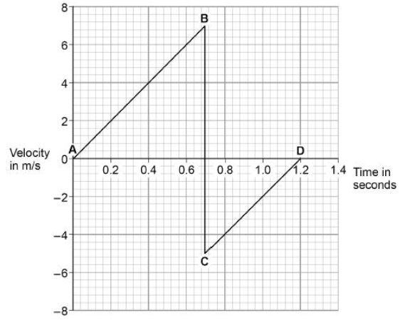15. A child drops a ball.

The ball hits the ground and bounces.

The graph to the left shows the velocity-time graph for the ball from when the ball is dropped until when the ball reaches the top of its first bounce.

Air resistance has been ignored.

When the ball hits the ground, energy is transferred from the ball to the Earth.

Explain how the data in the graph above shows this energy transfer.

**Q1.**

The image below shows a student before and after a bungee jump.

The bungee cord has an unstretched length of 20 m.

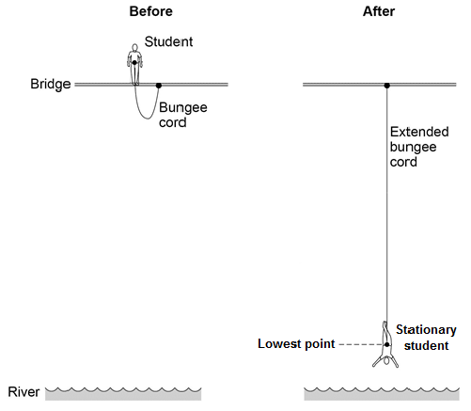

(a)     For safety reasons, it is important that the bungee cord used is appropriate for the student’s weight.

Give **two** reasons why.

1. _________________________________________________________________

___________________________________________________________________

2. _________________________________________________________________

___________________________________________________________________

**(2)**

(b)     The student jumps off the bridge.

Complete the sentences to describe the energy transfers.

Use answers from the box.

|  |
| --- |
| **elastic potential**      **gravitational potential**      **kinetic**      **sound**      **thermal** |

Before the student jumps from the bridge he has a store of

_____________________ energy.

When he is falling, the student's store of _____________________

energy increases.

When the bungee cord is stretched, the cord stores energy as

_____________________ energy.

**(3)**

Power is defined as **the rate at which energy is transferred**. Energy has units of joules. Power can be calculated using the formula:

Power

**P = E ÷ t P = W ÷ t**

Where:

* P = power in watts (W)
* E = energy in joules (J) W = work done in joules (J)
* t = time in seconds (s)

Energy transfer

Note that an alternative unit for energy is the **kilowatt hour** (kWh). This means that a power of one kilowatt (equal to 1,000 watts) has been used for one hour. The equation can be re-written as follows:

**E = P × t**

Where:

* P = power in kilowatts (kW)
* E = energy in kilowatt hours (kWh)
* t = time in hours (h)

The kilowatt hour is a convenient unit to measure how much electrical energy a household has used. This is because a household uses a very large number of joules.

One kilowatt hour is equal to 1,000 Watt hours, and as there are 3,600 seconds in one hour one kilowatt hour is equal to 3,600,000 Joules. A smaller number is of kilowatt hours is more appropriate unit to measure electrical energy used within a household.

**Mini-task:** We need to be able to convert power to and from kilowatts. It is the same process as converting between kilometres and metres.

**W → kW ÷ 1000 kW → W × 1000**

**Example:** 2 kW = 2 × 1000 = 2000 W

100 W = 100 ÷ 1000 = 0.1 kW

1. Convert 5 kW to W.
2. Convert 7 kW to W.
3. Convert 0.2 km to m.
4. Convert 1500 W to kW.
5. Convert 3700 W to kW.
6. Convert 9800 m to km.

****Worked example**

*Calculate the energy transferred from   
the mains when the TV has 3000 kW*  *of power and is turned on for 3 hours.*

Step 1: Write the equation

**E = P x t**

Step 2: Write the variables

P = 3000 kW

**t = 3 h**

Step 3: Calculate the answer

**E = P x t = 3000 x 3 = 9000 kWh**

**The energy transferred from the mains to the TV is 9000 kWh**.

**Part 1 – Electrical energy – Calculations**

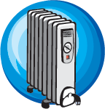You will need to use the formula: **E = P x t**

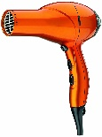Where:

* E is measured in kWh
* P is measured in kW
* 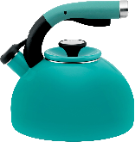t is measured in h

1. Calculate E, from the following:

P = 1 kW

t = 10 h

1. Calculate the electrical energy from the following:

Power = 0.1 kW

time = 24 h

1. An electrical appliance has a power equal to P = 5 kW. Calculate the energy supplied to the appliance in 10 h.
2. A 1.5 kW hairdryer is switched on for half an hour (0.5 h). Calculate the energy supplied to the hairdryer.
3. A 2 kW kettle is switched on for half an hour. Calculate the energy used by the kettle.
4. An electric heater has a power equal to P = 3 kW. The heater is switched on for a whole day. Calculate the energy used by the heater.

**Part 2 – Electrical power – Calculations**

You will need to use the formula: **P = E ÷ t**

Where:

* P is measured in W
* E is measured in J
* t is measured in s

1. Calculate P, from the following:

E = 20 000 J

t = 20 s

1. Calculate P from the following:

E = 5 000 J

t = 35 s

1. Calculate the power from the following:

Energy = 800 J

time = 60 s

1. Calculate the power from the following:

Energy = 1 000 J

time = 1 h   
**Hint:** before you calculate the power you need to convert h (hours) into s (seconds).

1. A kettle is supplied with **100 000 J** for **120 s**. Calculate the power generated by the kettle.
2. A fridge is supplied with 20 000 J of electrical energy for 10 s. Calculate the power generated by the fridge.
3. A television is supplied with 60 000 J of electrical energy. The television is on for 20 s. Calculate the power generated by the TV.
4. An electric motor is supplied with 100 000 J of electrical energy. The motor works for 2 hours. Calculate the power generated by the motor.

**Q1.**

The diagram shows a helicopter being used to rescue a person from the sea.

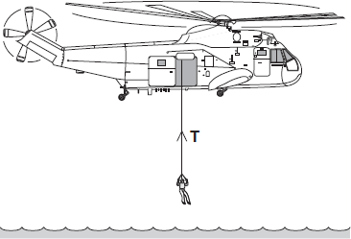

(a)     (i)      The mass of the rescued person is 72 kg.

Use the equation in the box to calculate the weight of the rescued person.

|  |
| --- |
| weight    =    mass    ×    gravitational field strength |

gravitational field strength = 9.8 N/kg

Show clearly how you work out your answer.

______________________________________________________________

______________________________________________________________

Weight = _________________________ N

**(2)**

(ii)     An electric motor is used to lift the person up to the helicopter.  
The motor lifts the person at a constant speed.

State the size of the force, **T**, in the cable.

Force **T** = _________________________ N

**(1)**

(b)     To lift the person up to the helicopter, the electric motor transformed 21 600 joules of energy usefully.

(i)      Use a form of energy from the box to complete the following sentence.

|  |  |  |
| --- | --- | --- |
| gravitational potential | heat | sound |

The electric motor transforms electrical energy to kinetic energy. The kinetic

energy is then transformed into useful _________________________ energy.

**(1)**

(ii)     It takes 50 seconds for the electric motor to lift the person up to the helicopter.

Show clearly how you work out your answer and give the unit.

Choose the unit from the list below.

|  |  |  |
| --- | --- | --- |
| **coulomb (C)** | **hertz (Hz)** | **watt (W)** |

______________________________________________________________

______________________________________________________________

Power = _________________________

**(3)**

**(Total 7 marks)**

**Q2.**

A student used an electric heater to heat a metal block. The student measured the energy input to the heater with a joulemeter.

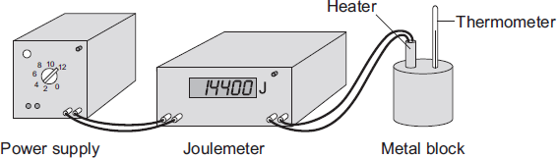

Before starting the experiment, the student reset the joulemeter to zero. The student switched the power supply on for exactly 10 minutes. During this time, the reading on the joulemeter increased to 14 400.

(a)     (i)      Calculate the energy transferred each second from the power supply to the heater.

Show clearly how you work out your answer.

______________________________________________________________

______________________________________________________________

Energy transferred each second = ___________________ J/s

**(2)**

(ii)     What is the power of the heater?

______________________________________________________________

**(1)**

(b)     The student measured the temperature of the metal block every minute. The data obtained by the student is displayed in the graph.

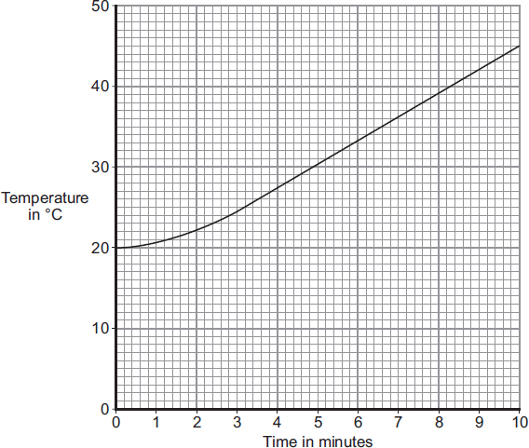

(i)      What range of temperatures did the student measure?

From _______________________ °C to _______________________ °C

**(1)**

(ii)     Before starting the experiment, the student had calculated that the temperature of the block would go up by 36 °C.

The student's data shows a smaller increase.

Which **one** of the following statements gives the most likely reason for this?

Put a tick () in the box next to your answer.

|  |  |
| --- | --- |
| The student does not read the thermometer accurately. |  |
| The block transfers energy to the surroundings. |  |
| The power supply is not connected correctly to the joulemeter. |  |

**(1)**

**(Total 5 marks)**

The more energy something wastes, the less **efficient** it is. Energy is **wasted** by raising the **thermal energy store** of the surroundings.

Efficiency

**Mini-task:** For the following devices state what energy is used from this list: *Chemical Kinetic Thermal Electrical Light*

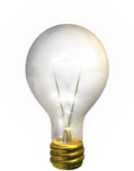

Light bulb: Input Energy ____________

Useful Energy ___________ Waste Energy _________

C:\Users\Liv\AppData\Local\Microsoft\Windows\Temporary Internet Files\Content.IE5\QXWTUTT3\MC900151965[1].wmf

Electric Drill: Input Energy ___________

Useful Energy ___________

Waste Energy___________

C:\Users\Liv\AppData\Local\Microsoft\Windows\Temporary Internet Files\Content.IE5\17VGHSNQ\MC900432517[1].wmf

TV: Input Energy ____________

Useful Energy ___________

Waste Energy ___________

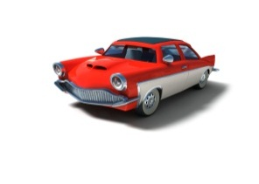Car engine: Input Energy ____________

Useful Energy ___________

Waste Energy ___________

Efficiency is a measure of how good a device is at changing energy (or power) from one form to another. Efficiency can be calculated using the formula:

**Efficiency = Useful energy out Efficiency = Useful power out**

**Total energy in Total power in**

To then turn this into a percentage; you can multiply either equation by 100:

**Efficiency = Useful energy out x 100%**

**Total energy in**

**Task: Complete in your exercise book**

**Basic:**

1. **Useful energy out = 100 J**

**Total energy in = 120 J**

1. **Useful energy out = 60 J**

**Total energy in = 240 J**

1. **Useful energy out = 50 J**

**Total energy in = 150 J**

1. **Useful energy out = 2,000 J**

**Total energy in = 4,000 J**

1. **Useful energy out = 117 J**

**Total energy in = 443 J**

1. **Useful energy out = 1,200,000 J**

**Total energy in = 1,600,000 J**

**Medium:** (wordy questions)

1. **An electric Drill uses a total of 160 J and produces 90 J of kinetic energy and transfers 70J of energy to the thermal energy store of the surroundings.**

**What is the efficiency of the electric drill?**

1. **A hair drier uses a total of 180 J and produces 170J of useful energy and 10J of wasted energy.**

**What is the efficiency of the hair drier?**

1. **A mobile phone charger uses a total of 1 J and produces 0.8 J of electrical energy and transfers 0.2 J to the thermal energy store of the surroundings.**

**What is the efficiency of the mobile phone charger?**

1. **An electric hob uses a total of 1,500 J and produces 1,300 J of useful energy and 200 J of wasted energy.**

**What is the efficiency of the electric hob?**

1. **A kettle uses a total of 2,500 J and produces 2,200 J of useful energy and 300 J of wasted energy.**

**What is the efficiency of the kettle?**

**Hard:** (you have to re-arrange the equation)

1. **A car engine is 25% efficient. How much input energy produces 100 J of useful energy?**
2. **A motor has an efficiency of 40%. How much useful energy is produced from 250 J?**
3. **A hair dryer has an efficiency of 80%. How much useful energy is produced from 2000 J?**
4. **An electric heater is 90% efficient. How much useful energy is produced from 8000 J?**
5. **If a 50% efficient motor is supplied with 30 kJ of energy, how much useful energy is transferred?**

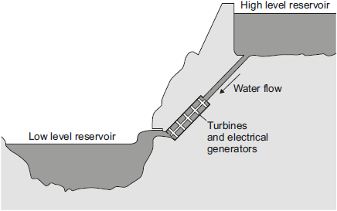(a)     Energy can be stored in a pumped storage power station.

The figure shows a pumped storage power station. When electricity is needed, the water in the high level reservoir is allowed to flow to the low level reservoir. The flowing water generates electricity.

Use the correct answer from the box to complete each sentence. **(3)**

|  |  |  |  |  |
| --- | --- | --- | --- | --- |
| **electrical** | **gravitational potential** | **kinetic** | **nuclear** | **thermal** |

The water in the high level reservoir stores ____________ energy.

The flowing water has ____________ energy.

The water turns the turbine which is connected to the generator.

The generator raises the _____________ energy store of the surroundings.

(b)     The total power input to a pumped storage power station is 600 MW.

The useful power output is 540 MW.

(i)      Calculate the efficiency of this pumped storage power station. **(2)**

______________________________________________________________

______________________________________________________________

Efficiency = _______________

(ii)     Calculate how much power is wasted by the pumped storage power station. **(1)**

______________________________________________________________

Power = ______________ MW

(iii)    How is the temperature of the surroundings affected by the energy wasted by the pumped storage power station? **(1)**

______________________________________________________________

A Sankey diagram shows you how well a machine uses energy. In other words, it tells you if it uses it efficiently (without much waste) or inefficiently (with a lot of waste).

The thickness of the arrows shows how much energy is involved. (The length of the arrows does not matter in a Sankey Diagram, but the width should be *proportional* to the amount of energy being transferred.) Useful energy transfers are shown going left to right. Wasteful energy transfers are shown going upwards or downwards.

Useful Energy out of machine

(50 %)

Energy into machine (100 %)

The following is an example of a Sankey diagram:

Wasted Energy

(50 %)

Complete the two questions below:

1. In one second, a lightbulb uses 25J of electricity. It produces 10J of light, and the rest is wasted as thermal energy.
2. In one second, an energy efficient light bulb produces the same about of light as the previous bulb, but only uses 12J of energy. Draw a Sankey diagram for this below.

Any object that is moving has **kinetic energy**. The greater the mass or velocity of the object, the greater the amount of kinetic energy. It can be calculated using the following equation:

Kinetic energy

**Ek = ½ x m x v²**

Where Ek is the kinetic energy in joules (J)

m is the mass in kilograms (kg)

v is the velocity in metres per second (m/s)

**Worked example 1:** Cristiano Ronaldo kicks a football of mass 500 g at a speed of 40 m/s. Calculate the kinetic energy of the football.

m = 500 g = 0.5 kg

**Study tip**

Don’t forget to convert non-standard units into standard units!

conversion

v = 40 m/s

Ek = 0.5 x m x v2

Ek = 0.5 x 0.5 x 402

units

Ek = 400 Joules

**Worked example 2:** A car of mass 800 kg is travelling with a kinetic energy of 1.44 MJ. Calculate its velocity.

m = 800 kg

conversion

Ek = 1.44 MJ = 1,440,000 J

**Study tip**

Remember to re-arrange the equation!

Ek = 0.5 x m x v2

transformation

v = √(Ek ÷ 0.5m)

V = √(1,440,000 ÷ 400)

V = 60 m/s

**Basic:**

1. What types of objects have kinetic energy?
2. What is the equation for kinetic energy?
3. What are the units of kinetic energy, mass and velocity?
4. Calculate the **kinetic energy** of the following:
5. A car that travels at a speed of 20m/s and has a mass of 1200 kg.
6. A Year 10 student with a mass of 55kg swinging back on their chair and falling off it at a speed of 0.6m/s.
7. A runner with a mass of 62kg running at a speed of 0.8m/s.
8. A tennis ball traveling at a speed of 46m/s with a mass of 58kg.
9. A dog running across a field at a speed of 1.2m/s with a mass of 3.2kg.

**Medium:** Requires rearranging.

1. Rearrange the equation to give an equation for the mass.
2. Calculate the **mass** of the following:
3. Automatic door closing 0.2m/s, with a kinetic energy of 1.6J.
4. Wind turbine blade with a kinetic energy of 104040J, turning at 6m/s.
5. Aeroplane traveling at 75m/s with a kinetic energy of 843700J.
6. Canoe moving down the river with a kinetic energy of 5J and a speed of 0.5m/s.
7. Child riding a bike at a speed of 6m/s, with a total kinetic energy of 1224J. If the mass of the child is 30kg, what is the mass of the bike?
8. Rearrange the equation to give an equation for the velocity.
9. Calculate the **velocity** of the following:
10. Bus traveling through town, with a mass of 5040kg and kinetic energy of 493900J.
11. A lift traveling up to the top floor of the Empire State building with a mass of 4200kg and a kinetic energy of 4116J.
12. Bird flying towards its nest with a mass of 0.25kg and a kinetic energy of 40.5J.
13. A Wii remote flung from a hand through a TV, with a kinetic energy of 1.44J and a mass of 4.5kg.
14. Hot air balloon with a kinetic energy of 76550J and a mass of 1890kg.

**Hard:** Rearranging and unit conversions.

1. A 4.2 g bullet travels at 1,700 mph. How much kinetic energy does it have?
2. A car travelling at 10 m/s has 75 kJ of KE. Calculate the car’s mass.
3. A bullet was fired from a gun. The bullet had a mass of 50g and the kinetic energy of the bullet was 25 kJ. How fast did it go?
4. A truck carrying heavy equipment travelled at 40 m/s and had a kinetic energy of 9 MJ, what was its mass?
5. A man started out with 1 kJ of kinetic energy and a mass of 100 kg. He then increased his kinetic energy by 100%. What was his speed after that?
6. An eagle flying at a constant 120 km/h and has kinetic energy of 2,800 J. What is the mass of the eagle?
7. A mosquito has a mass of 5 mg. Given that its kinetic energy is 0.8 mJ, how far will it travel in one hour?
8. A rocket was launched from a space station, it weighed 50,000 kg and travelled at 3 km/h. What was its kinetic energy?

**Q1.**

A rocket has a mass of 5000 kg and is travelling at a speed of 600 m/s.



Calculate the rocket’s kinetic energy in kilojoules. Show your working. **(3)**

_______________________________________________________________________

_______________________________________________________________________

_______________________________________________________________________

_______________________________________________________________________

_______________________________________________________________________

Kinetic energy = _______________ kJ

**Q2.**

A car which is moving has kinetic energy.

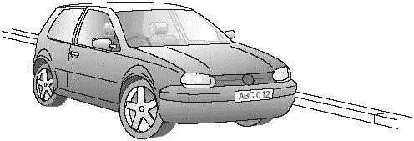

          The faster a car goes, the more kinetic energy it has. The kinetic energy of this car was   
472 500 J when travelling at 30 m/s.  
Calculate the total mass of the car.  
Show clearly how you work out your answer and give the unit. **(5)**

_______________________________________________________________________

_______________________________________________________________________

_______________________________________________________________________

_______________________________________________________________________

_______________________________________________________________________

_______________________________________________________________________

Mass of the car = ______________________________

**Q3.**

**‘SPEED KILLS’ -** was the heading of an advertising campaign. The scientific reason for this is that energy is transferred from the vehicle to the person it knocks down.



(a)     The bus and the van are travelling at the same speed. The bus is more likely to cause more harm to a person who is knocked down than the van would. Explain why.

___________________________________________________________________

___________________________________________________________________

___________________________________________________________________

**(2)**

(b)     A car and its passengers have a mass of 1200 kg. It is travelling at 12 m/s.

(i)      Calculate the increase in kinetic energy when the car increases its speed to 18 m/s.

Show clearly how you work out your answer and give the unit.

______________________________________________________________

______________________________________________________________

______________________________________________________________

______________________________________________________________

______________________________________________________________

______________________________________________________________

______________________________________________________________

______________________________________________________________

Increase in kinetic energy = ___________________

**(5)**

(ii)     Explain why the increase in kinetic energy is much greater than the increase in speed.

______________________________________________________________

______________________________________________________________

______________________________________________________________

**(1)**

**(Total 8 marks)**

**Gravitational potential energy** (GPE) is the energy an object has due to being raised above the ground.

Gravitational potential energy

The greater the height on an object above the ground, the greater the GPE it will have. The stronger the gravitational field strength, again the greater the GPE. On Earth, the gravitational field strength is **9.8 N/kg**.

Gravitational potential energy, in joules (J)

Mass, in kilograms (kg)

Gravitational field strength, in newtons per kilogram (N/kg)

Height above the ground, in metres (m)

**Worked example 1:** The record for the highest hot air balloon flight is 21,027 m. At this height, the balloon had an estimated 735 MJ of GPE. What was the mass of the balloon?

Step 1: Rearrange the GPE equation to make mass the subject…

Step 2: Substitute in our known values for GPE, h and g…

**Worked example 2:** At what height would the same hot air balloon have 50 kJ of GPE?

Step 1: Rearrange the GPE equation to make height the subject…

Step 2: Substitute in our known values for GPE, h and g…

**Basic:**

1. What type of objects have gravitational potential energy?
2. What is the equation for gravitational potential energy?
3. What are the units for gravitational potential energy, mass, gravitational field strength and height?
4. What is the value of the gravitational field strength on Earth?
5. Calculate the **gravitational potential energy** of the following objects on Earth:
6. m = 10 kg

h = 5 m

1. m = 20 kg   
   h = 15 m
2. m = 100 g (you must convert g into kg before you calculate EK)  
   h = 100 cm
3. If an object is raised 100m above ground with a mass of 100kg, how much **gravitational potential energy** did it gain?
4. If an object with a mass of 25kg is raised 10m how much **gravitational potential energy** did it gain?
5. A diving platform is 10 m above the ground. When an 80 kg diver climbs to the top of the platform, how much **GPE** does he acquire?
6. A window cleaner, who’s mass is 65 kg, is cleaning the first floor windows the academy 2.5 m above the ground. The third floor windows are 7.5 m above the ground. How much **GPE** would she gain climbing to the third floor?

**Medium**: Rearranging needed

1. Rearrange the equation for GPE to give an equation for the **height**.
2. An object gains gravitational potential energy of 300J. If the mass of the object is 3kg, what is the **height** that the object has been raised?
3. If the Ep of an object is 1000J and the mass is 25kg, what is the **height** of the object?
4. What is the **height** of an object with a mass of 10kg and gravitational potential energy of 3500J?
5. Rearrange the equation for GPE to give an equation for **mass**.
6. What is the **mass** of an object when it is raised 25m and gains gravitational potential energy of 50 000J?
7. An object has a gravitational potential energy of 500 J and is located at a height of 20m above the ground. Calculate the **mass** of the object.
8. Calculate the **mass** of an object that has a gravitational potential energy of 250 J and is up at a height of 20 cm.

**Hard:** Rearranging and unit conversion needed

1. A rocket is stationary at a height of 3000 m; its gravitational potential energy is 300 kJ, what is its **mass**?
2. A Boeing 747, climbs from 3,000 m to 9,000 m, and gains 19,980,000 kJ of GPE. Calculate the **mass** of the plane.
3. A skier, with a mass of 70 kg, loses 140 kJ of energy when skiing down the slope. What was the **height** which the skier descended.
4. A fighter jet, flying 8 km above the ground, drops a bomb on an enemy target. The bomb loses 160,000 kJ of energy during its decent. What was the **mass** of the bomb?
5. 2 J of GPE are lost by a 50 g conker which falls from a tree. How **high** did it fall from?
6. A crane lifts a pallet of bricks to the top of a 80 m building, requiring 400 kJ of energy. What was the **mass** of the pallet?
7. Which statements are true, and which are false?

|  |  |
| --- | --- |
| A | A 65 kg bungee jumper stood over a 80 m drop has 52000 J of GPE |
| B | A 130,000 kg jet plane must reach an altitude of 1 km to gain 1.3 GJ of GPE |
| C | Tom Cruise hangs off the edge of a 1.2 km – high cliff face. If he has 81 000 J of GPE then he must weigh 75 kg. |
| D | A bowling ball has a mass of 7 kg. If the gravitational field strength on the moon is 1.6 N/kg, how much GPE is stored when it is lifted 0.5 m from the moon’s surface? |

The image shows a battery-powered drone.

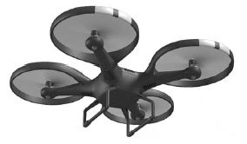

(a)     Complete the sentences.

Choose the answers from the box.

|  |  |  |  |
| --- | --- | --- | --- |
|  | **chemical** | **elastic potential** | |
| **gravitational potential** | | **kinetic** | **nuclear** |

As the drone accelerates upwards

its _________________________________________ energy increases

and its _________________________________________ energy increases.

The _________________________________________ energy store

of the battery decreases. **(3)**

(b)     In the USA, drones are not allowed to be flown too high above the ground.

Suggest **one** possible risk of flying a drone too high above the ground. **(2)**

___________________________________________________________________

___________________________________________________________________

___________________________________________________________________

(c)     Write down the equation that links energy transferred, power and time. **(1)**

___________________________________________________________________

(d)     The drone can fly for 25 minutes before the battery needs recharging.

The power output of the battery is 65.0 W

Calculate the maximum energy stored by the battery. **(3)**

___________________________________________________________________

___________________________________________________________________

___________________________________________________________________

___________________________________________________________________

Maximum energy = ____________________ joules

The **principle of conservation of energy** says that energy cannot be created or destroyed. It can only be **transferred** from one store to another.

Kinetic and gravitational potential energy

For example, consider a book that is about to fall off a high shelf.

Initially, the book has **gravitational potential energy** as it is high up. As it falls, this energy is converted into **kinetic energy.** As the book reaches the ground its final kinetic energy will be equal to its initial gravitational potential energy.

**Worked example 1:** Kris is at the top of a 5 m high slide. Assuming that all of her GPE is converted to KE, what will be her maximum speed when she reaches the bottom? Kris has a mass of 55 kg.

Step 1: Calculate Kris’s GPE at the top of the slide:

Step 2: As Kris slides down, her GPE is converted to KE. At the bottom of the slide, all her GPE will have been converted to KE, i.e. her KE equals 2750 J.

**Study tip**

Here we assumed that **all** of the GPE was converted to KE. However, in the real world some energy would be dissipated as heat, due to friction and air resistance. This means that Kris’s true speed will be **less** than we have calculated here.

Next, rearrange the KE equation to find her speed:

Step 3: Substitute our known values for m and KE:

**Worked example 2:** Roger Federer hits a tennis ball of mass 50 g directly upwards in the air, at a velocity of 25 m/s. What is the maximum possible height the ball could reach?

**Study tip**

Don’t forget to convert grams into kilograms to use the KE equation!

Step 1: Calculate the ball’s initial kinetic energy

Step 2: The maximum possible height that the ball could reach would be if all this KE was converted to GPE, i.e the GPE becomes 15.6 J.

Next, rearrange the GPE equation for height:

Step 3: Substitute in the known values for GPE, mass, and gravitational field strength:

**Did you know?**

We don’t really **need** to know the mass to solve this problem!

We could have started by setting the KE and GPE equations equal to each other to get:

Notice that we have m on both sides, so we can cancel out a factor of m to get:

Then all we need to do is to rearrange this equation for the height…

…and finally, put in our known values!

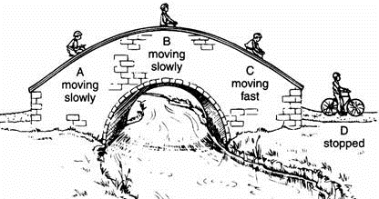**GPE and KE conversions**

**g = 9.8 N/kg for all questions**

**Basic**

1. A cyclist cycles over a humpback bridge.
2. At what point (A-D) does she have the most GPE?
3. At what point (A-D) does she have the most KE?
4. At what point (A-D) does she have the least GPE?
5. The bridge has a height of 8m, and the cyclist has a mass of 60 kg. What is the cyclist’s maximum GPE?
6. What therefore is the cyclist’s maximum KE (assuming no energy is lost to environment)?
7. Dr. Edmunds drops his iPad from a height of 2m. The iPad has a mass of 470g.
8. Describe the energy changes that occur as the iPad is dropped.
9. What is the initial GPE of the iPad?
10. What therefore is the maximum KE of the iPad?

**To go from g to kg → ÷ 1000**

**Medium**

1. Roger Federer hits a tennis ball of mass 50g directly upwards in the air at a velocity of 25 m/s.
2. Calculate the initial KE of the tennis ball?
3. What therefore is the maximum GPE of the tennis ball?
4. Calculate the maximum height that the tennis ball reaches?
5. An irresponsible tourist drops a penny of mass 2.5g from the top of the Burj Khlalifa (height 828m).
6. Calculate the initial GPE.
7. What therefore is the maximum KE of the penny?
8. Calculate the velocity of the penny just before it hits the ground (hint: re-arrange equation for KE to give an equation for v).
9. Why in practice will the penny not reach a velocity quite as high as you calculated in part c).

**To go from kJ to J → × 1000**

**Hard**

1. A bullet of mass 11.3g is fired directly up into the air with an initial KE of 3.6 kJ.
2. How high (in km) does the bullet travel?
3. What is initial velocity of the bullet?
4. Felix Baumgartner jumps out of a hot air balloon at a height of 39 km. He had to wear a special suit and his total mass (including the suit) was 120 kg. He was the first person the break the sound barrier (at a velocity of 343 m/s). Calculate how far (in km) he had fallen to break the sound barrier.
5. A space X rocket of mass 550,000 kg is delivering cargo to the International Space Station (ISS). While it is docked with the ISS it has a GPE of 2.2 × 1012 J.
6. Calculate the height of the International Space Station (in km).
7. If the space X rocket then fell straight back down to Earth, what would the maximum velocity of the rocket be?
8. As the Earth orbits the Sun, it moves at a speed of 30 km/s. The Earth has a mass of 5.97 × 1024 kg. Calculate the kinetic energy of the Earth.

**Stretch: Write some of your own questions and solve them. To make them hard, use kJ/g/km or standard form. Try to make the numbers realistic.**

The diagram shows a tennis ball thrown vertically into the air.

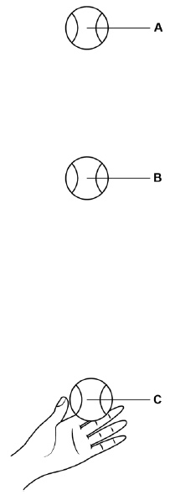

At position **C**, the ball has just left the tennis player's hand at a speed of 5.0 m/s

The tennis ball has a mass of 0.058 kg

(a)     Write down the equation that links kinetic energy, mass and speed.

___________________________________________________________________

**(1)**

(b)     Calculate the kinetic energy of the tennis ball at position **C**.

___________________________________________________________________

___________________________________________________________________

Kinetic energy = ____________________ J

**(2)**

(c)     At position **A** the tennis ball is at maximum height.

What is the gravitational potential energy of the tennis ball at position **A**?

Ignore the effect of air resistance.

___________________________________________________________________

**(1)**

At position **B** the tennis ball has 0.38 J of gravitational potential energy.

(d)     Write down the equation that links gravitational field strength, gravitational potential energy, height and mass.

___________________________________________________________________

**(1)**

(e)     Calculate the height of the tennis ball above the tennis player's hand when at position **B**.

gravitational field strength = 9.8 N/kg

___________________________________________________________________

___________________________________________________________________

___________________________________________________________________

___________________________________________________________________

___________________________________________________________________

Height = ____________________ m

**(3)**

**(Total 8 marks)**

The energy stored in a spring when work is done in compressing or stretching it is called **elastic potential energy.**

Elastic potential energy

This can be calculated by using the following equation:

**Ee = ½ x k x e²**

Where Ee is the Elastic potential energy in **Joules**

k is the Spring constant in **Newtons per metre**

e is the Extension in **metres**

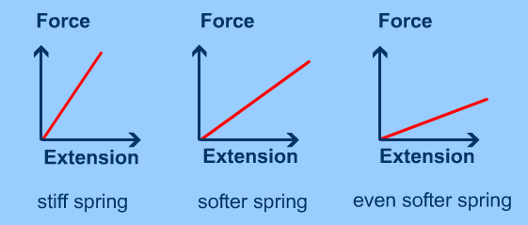The **spring constant** measures how difficult it is to compress or stretch a spring.

The larger the spring constant the more difficult is to compress or stretch.

**Worked example 1**

How much work must be done to compress a spring by 4.0 cm if the spring constant is 55 N/m.

**Study tip**

Don’t forget to convert non-standard units into standard units!

*e = 4 cm = 0.04 m*

conversion

*k = 55 N/m*

*Ee = 0.5 x k x e2*

*Ee = 0.5 x 55 x 0.042*

units

*Ee = 0.044 Joules*

**Worked example 2**

*A coil spring on a car’s suspension have a value of k = 64 kN/m. When the car strikes a bump the spring briefly stores 80 Joules of energy. How much does the spring compress?*

conversion

*k = 64 kN/m = 64,000 N/m*

*Ee =80*

transformation

*Ee = 0.5 x k x e2* ***→*** *e = √(Ee ÷ 0.5k)*

*e = √(80 ÷ (0.5 × 64,000))*

*Ee = 0.05 metres*

**EPE calculations**

**Basic**

1. Calculate the **Elastic Potential Energy** (in J) for each of the following:
2. Spring constant k = 5 N/m, spring extension e = 0.1 m.
3. Spring constant k = 20 N/m, spring extension e = 0.15 m.
4. Calculate the **spring constant** (in N/m) for each of the following:
5. Elastic potential energy 0.1 J, spring extension e = 0.05 m.
6. Elastic potential energy 5 J, spring extension e = 0.2 m.
7. Calculate the **extension** (in m) for each of the following:
8. Elastic potential energy 7 J, spring constant k = 15 N/m.
9. Elastic potential energy 2.5 J, spring constant k = 20 N/m.

**Medium**

**To go from cm to m → ÷ 100**

**To go from mm to m → ÷ 1000**

1. Solve for each unknown.

a) A spring with k = 450 N/m is compressed by 13 cm. How much **energy** is stored?

b) A spring with k = 520 N/m stores 7.04 J. How far is it **extended** from the equilibrium position?

c) A spring, when compressed 20 cm from the equilibrium position, stores 26 J. What is the value of the **spring constant**?

1. The coil springs on a car's suspension have a value of k = 6.4 x 104 N/m. When the car strikes a bump the springs briefly compress by 4.0 cm. How much **energy** is momentarily stored in each spring?
2. How much **work** must be done to
3. compress a spring 4.0 cm if the spring constant is 55 N/m?
4. 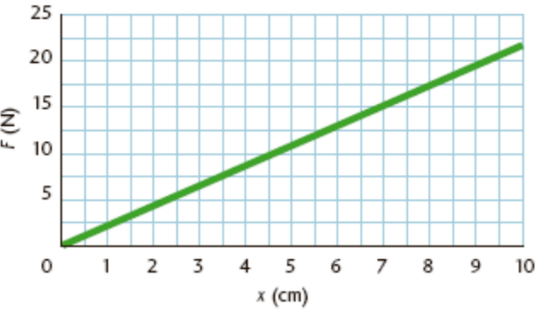stretch a spring 8.0 cm if the spring constant is 85 N/m?

**Hard**

1. A spring attached to a ceiling has a mass of 500 g suspended from it such that the spring stretches 4.0 cm. Calculate the **spring constant**. (g=9.8 N/kg)
2. To the right is a graph of F versus e for an elastic spring. Determine:
3. The spring constant.
4. The spring’s maximum amount of elastic potential energy.
5. The change in elastic potential energy when the spring extends from 3 cm to 4 cm.
6. At maximum extension a bungee cord stores 2.0 × 106 J of energy. A 10-kg mass extends the bungee cord 1.3 m. What is the maximum extension of the bungee cord?
7. An arrow of mass 300g is shot directly upwards by a bow of spring constant 2000 N/m, that is extended by a distance of 20 cm. Calculate:
8. The maximum elastic potential energy stored by the bow.
9. The initial velocity of the arrow.
10. The maximum height that the arrow reaches. (g=9.8 N/kg)

**Stretch: Write some of your own questions and solve them. To make them hard, use kJ/cm or standard form. Try to make the numbers realistic.**

1. By referring to the diagrams, discuss some of the energy changes involved in a bungee jump. You should make reference to *gravitational potential energy, kinetic energy* and *elastic potential energy* in your answer. [4 marks]

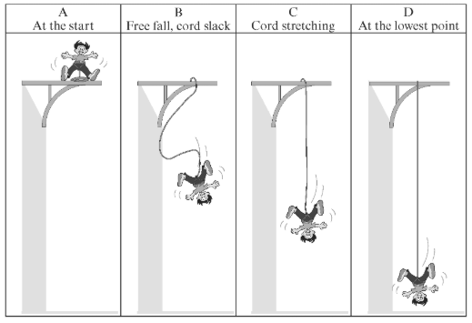

________________________________________________________________________________________________________________________________________________________________________________________________________________________________________________________________________________________________________________________________________________________________________________________________________________________________________________________________________________________________________________________________________

1. At point D, the bungee rope has stretched by a distance of 20 metres. If the rope has a spring constant of 70 N/m, how much elastic potential energy is stored. [3 marks]

______________________________________________________________________________________________________________________________________________________________________________________________________________________________________________________________________________________________________________________________________________________________________________________________________

Specific heat capacity

Putting the same amount of heat energy into some materials gives a bigger temperature rise than in other materials. This is due to **specific heat capacity**.

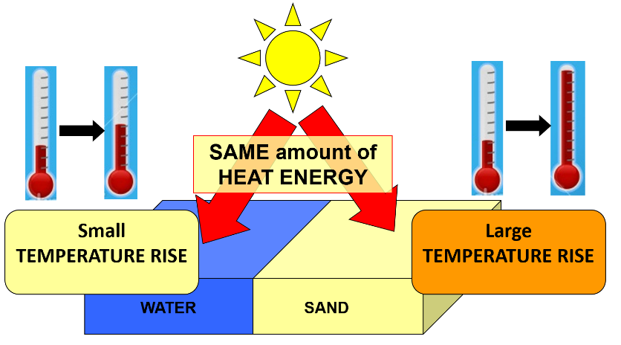An example of this is on a sandy beach on a sunny day. The water in the sea will be relatively cool, but the sand will be much hotter. This is because water has a higher specific heat capacity than air, and therefore takes more energy to increase in temperature.

The specific heat capacity (c) is the amount of energy needed to increase the temperature of 1 kg of a substance by 1 °C.

A material with a higher specific heat capacity takes more energy to heat up 1 kg by 1 °C than a material with a lower specific heat capacity.

Energy can be calculated using the following:

**ΔE = m x c x Δθ**

Where:

* **Δ**E = change in thermal energy (J)
* **m** = mass (kg)
* **c** = specific heat capacity (J/kg°C)
* **Δθ** = change in temperature (°C)

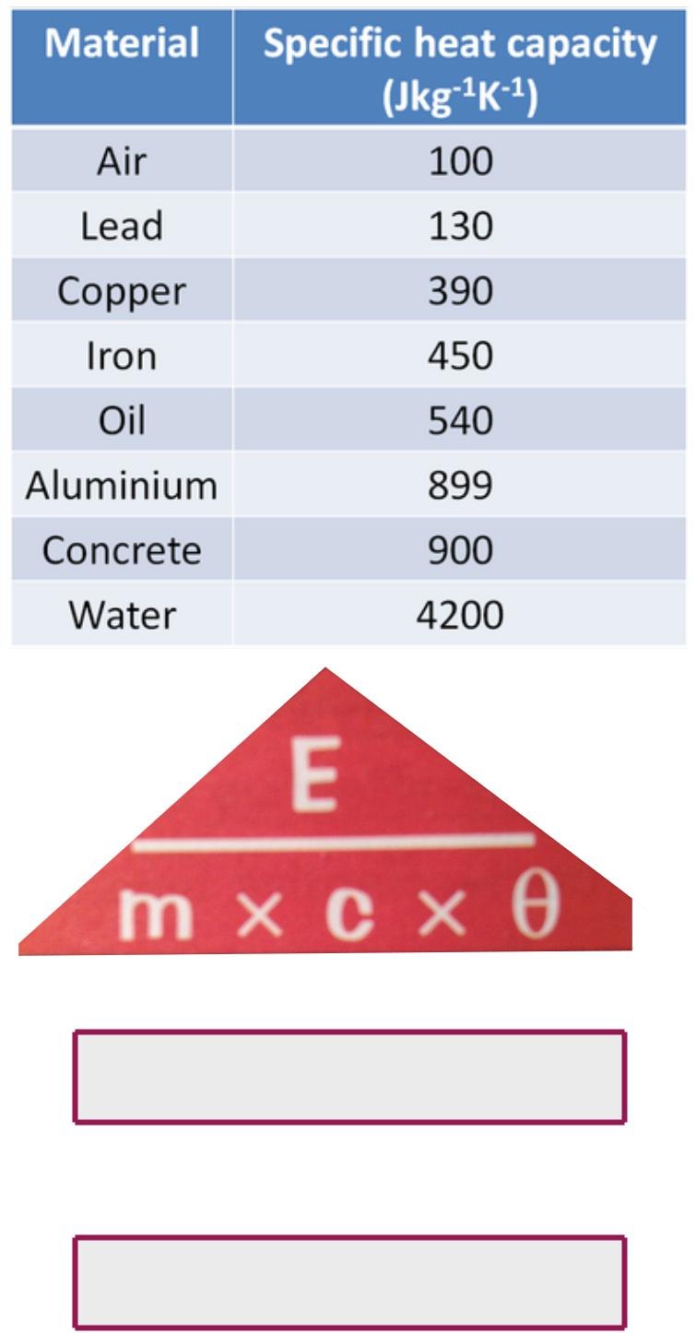**BASIC**

1. Calculate the **energy ΔE** (in **J**) for each of the following:

1. m = 10 kg and Δθ = 4 °C (for **water**)
2. m = 15.5 kg and Δθ = 0.5 °C (for **aluminium**)
3. m = 0.5 kg and Δθ = 20 °C (for **copper**)
4. m = 2 kg and Δθ = 60 °C (for **oil**)
5. m = 800 kg and Δθ = 7.5 °C (for **concrete**)
6. m = 1.2 kg and Δθ = 0.5 °C (for **air**)
7. m = 2 kg and Δθ = 8 °C (for **lead**)
8. m = 1500 kg and Δθ = 0.2 °C (for **iron**)

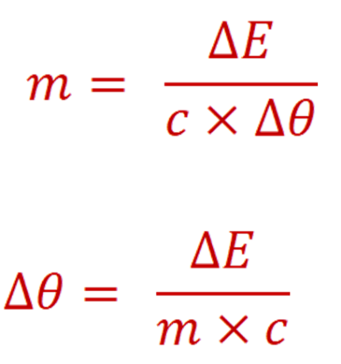**MEDIUM** (have to use rearranged equations)

1. Calculate the **mass m** (in **kg**) for each of the following.
   1. ΔE = 1 000 J and Δθ = 2.5 °C (for **oil**)
   2. ΔE = 2 500 J and Δθ = 0.2 °C (for **lead**)
   3. ΔE = 200 J and Δθ = 1 °C (for **concrete**)
   4. ΔE = 5,000,000 J and Δθ = 15 °C (for **water**)
2. Calculate the **temperature change** **Δθ** (in **°C**) for each of the following:
   1. ΔE = 3 000 J and m = 20 kg (for **air**)
   2. ΔE = 6 600 J and m = 0.3 kg (for **iron**)
   3. ΔE = 700 J and m = 0.1 kg (for **aluminium**)
   4. ΔE = 20 J and m = 0.02 kg (for **copper**)

**HARD** (have to convert units)

4. Calculate the **energy** **E** (in **J**) for each of the following:

1. m = 10 g and Δθ = 5 °C (for **water**)   *You need to change* ***g*** *into* ***kg***

*m = 10 g = ______ kg*

*Now you can calculate the energy in* ***J.***

*E = ______ J*

1. m = 12.2 g and Δθ = 10.1 °C (for **concrete**)

to go **from g to kg → ÷ 1 000**

1. m = 300.3 g and Δθ = 0.8 °C (for **copper**)
2. Calculate the **mass m** (in **kg**) for each of the following:
   1. E = 10 kJ and Δθ = 20 °C (for **aluminium**)   *You need to change* ***kJ*** *into* ***J***

*E = 10 kJ = ______ J*

to go **from kJ to J → × 1 000**

*Now you can calculate the mass in* ***kg* .**

*m = ______ kg*

* 1. E = 0.6 kJ and Δθ = 2.2 °C (for **lead**)
  2. E = 0.05 kJ and Δθ = 50 °C (for **oil**)

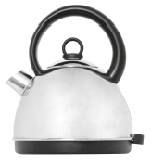**Q1.** The electric kettle shown is used to boil water.

(a)     After the water has boiled, the temperature of the water decreases by 22 °C.

The mass of water in the kettle is 0.50 kg.

The specific heat capacity of water is 4200 J/kg °C.

Calculate the energy transferred to the surroundings from the water.

___________________________________________________________________

___________________________________________________________________

___________________________________________________________________

Energy = ____________ joules

|  |  |
| --- | --- |
|  | **Tick** (✔) |
| Energy is absorbed from the surroundings. |  |
| Energy is used to heat the kettle. |  |
| The kettle is more than 100% efficient. |  |
|  |  |

(b)     Why is the total energy input to the kettle higher than the energy used to heat the water?

Tick (✔) **one** box.

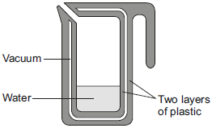**Q2.** A new design for a kettle is made from two layers of plastic separated by a vacuum. After the water in the kettle has boiled, the water stays hot for at least 2 hours.

(a)     The energy transferred from the water in the kettle to the surroundings in 2 hours is   
46 200 J.

The mass of water in the kettle is 0.50 kg.

The specific heat capacity of water is 4200 J/kg °C.

The initial temperature of the water is 100 °C.

Calculate the temperature of the water in the kettle after 2 hours.

___________________________________________________________________

___________________________________________________________________

___________________________________________________________________

Temperature after 2 hours = ___________ °C

(b)     Calculate the average power output from the water in the kettle to the surroundings in 2 hours.

___________________________________________________________________

___________________________________________________________________

Average power output = ______________ W

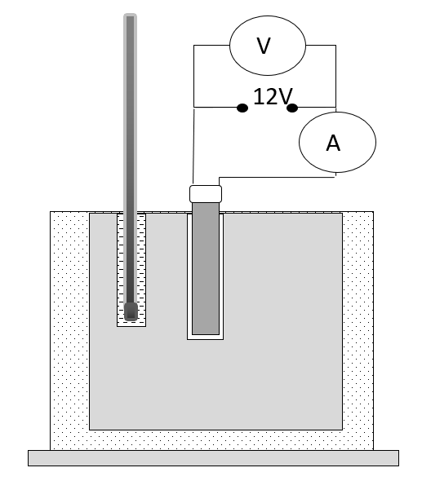

Specific heat capacity practical

***Method and notes***

1. Using a balance measure the mass of the block, then wrap the block in insulation

*This will help to prevent dissipation of the energy to the surroundings*

2. Measure the starting temperature of the block

*You may want to put some oil into the hole with the thermometer as this will prevent an air gap and allow a more accurate reading on the thermometer*

3. Put a heater in the larger hole in the block. Connect the ammeter, power pack and heater in series

4. Connect the voltmeter across the power pack

This needs to be in parallel (VIP).

5. Start the stopwatch as you turn on the power pack

6. Record the ammeter and voltmeter readings.

7. Calculate the power by using the equation P = I x V

7. Record the temperature every minute in your results table

8. After 10 minutes, turn off the power pack

9. Calculate the temperature change for each result

10. Calculate the energy transferred to the block by using the equation E = P x t

11. Calculate the specific heat capacity by using the equation specific heat capacity = energy / (mass x temperature change)

|  |  |
| --- | --- |
| Energy transferred (J) | Temperature (˚ C) |
|  |  |
|  |  |
|  |  |
|  |  |
|  |  |
|  |  |
|  |  |
|  |  |

Plot a graph of energy transferred (on the y axis) against the temperature (on the x axis) below:



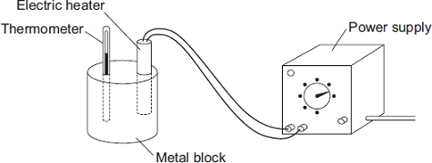(a)     A student used the apparatus drawn below to investigate the heating effect of an electric heater.

(i)      Before starting the experiment, the student drew **Graph A**.

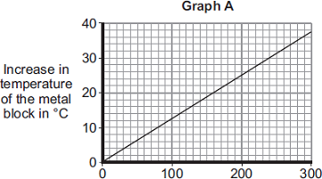**Graph A** shows how the student expected the temperature of the metal block to change after the heater was switched on.

Describe the pattern shown in **Graph A**. **(2)** ___________________________________ ___________________________________ ___________________________________ ___________________________________ ___________________________________

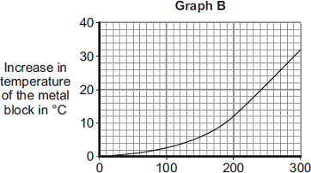(ii)     The student measured the room temperature. He then switched the heater on and measured the temperature of the metal block every 50 seconds.

The student calculated the increase in temperature of the metal block and plotted **Graph B**.

After 300 seconds, **Graph B** shows the increase in temperature of the metal block is lower than the increase in temperature expected from **Graph A**.

Suggest **one** reason why. **(1)**

______________________________________________________________

(iii)    The power of the electric heater is 50 watts. Calculate the energy transferred to the heater from the electricity supply in 300 seconds. **(2)**

______________________________________________________________

Energy transferred = ______________________ J

|  |  |
| --- | --- |
| **Metal** | **Specific heat capacity in J/kg°C** |
| Aluminium | 900 |
| Iron | 450 |
| Lead | 130 |

(b)     The student uses the same heater to heat blocks of different metals. Each time the heater is switched on for 300 seconds.

Each block of metal has the same mass but a different specific heat capacity.

Which **one** of the metals will heat up the most?

Draw a ring around the correct answer.

|  |  |  |
| --- | --- | --- |
| **aluminium** | **iron** | **lead** |

During heat transfer, thermal energy always moves in the same direction:

Thermal energy transfer

Heat can be transferred (moved) by three main processes:

1. **conduction** (mostly in solids)

2. **convection** (in liquids and gases)

3. **radiation** (a type of electromagnetic radiation that can travel through a vacuum)

**Thermal conductivity** (in units of W/m°C) tells you how well a material conducts heat.

The higher the thermal conductivity of a material the higher the rate of energy transfer by conduction across the material.

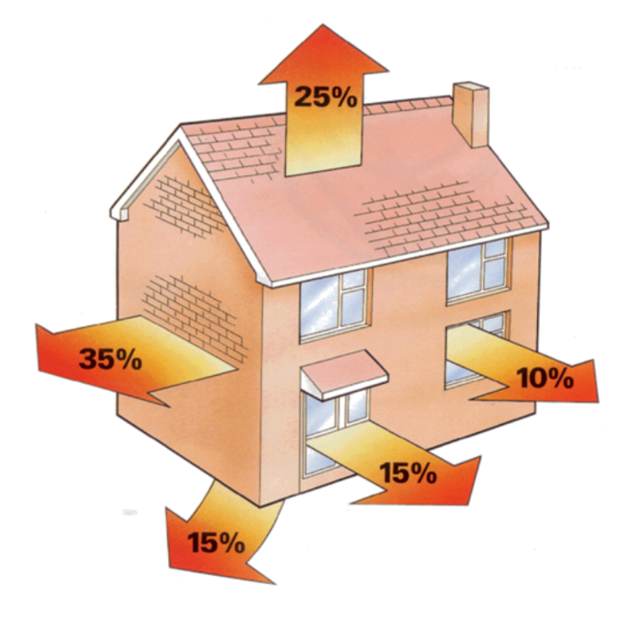Note that the units tell us that the thicker the material, the lower the thermal conductivity. This can be applied to buildings, **where a thicker wall will conduct less heat away.**

In a house, heat is lost by conduction through the walls, windows, roof and floor.

Drafts can also enter the house through gaps in doors/windows and lose heat through convention currents.

All heat is lost to the outside environment and is bad because using gas/electricity to heat a house costs money.

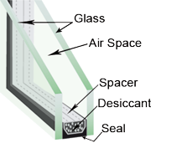We can reduce heat loss from a house by using draught stoppers, loft **insulation**, double glazing, carpets, cavity wall insulation or silvered plaster.

Double glazed windows have two panes of glass separated either by air or a vacuum.

This gap means that no conduction can happen through the window, and it also stops convection currents.

**Basic**

1. What are the three ways that thermal energy can be transferred?
2. What does thermal conductivity mean?
3. What are the units of thermal conductivity?
4. Which of the following statements are true, and which are false:
5. Energy is only transferred by heating if there is no temperature difference.
6. The particles in a hot solid vibrate more than those in an identical but cold solid.
7. Conduction is when vibrating particles pass on energy to neighbouring particles.
8. Only hot objects radiate energy to the surroundings.
9. Energy can only be transferred by radiation if the objects are touching.
10. Substances like wood and plastic are better conductors than metals.
11. Use words in the box to complete the paragraph below:

Thermal energy temperature cooler hotter

When _________________ is transferred between objects of different temperatures, it is transferred from the _____________ object to the _____________ object. When the two objects reach ________________ equilibrium it means they are at the same _______________.

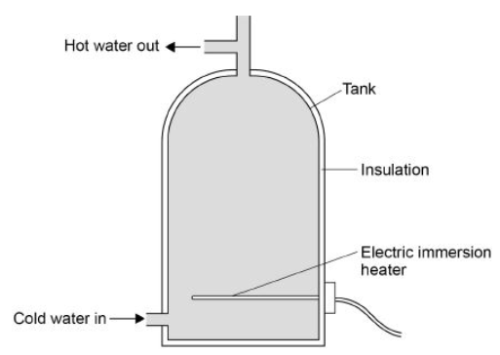**Medium:** The diagram shows a hot water tank made of copper.

1. Copper has a higher thermal conductivity than most metals. How does the rate of energy transfer through copper compare with the rate of energy transfer through most metals?
2. The tank is insulated. When the water is hot, the immersion heater switches off. Complete the sentences.

Compared to a tank with no insulation, the rate of energy transfer from the water in an insulated tank is ___________. This means that the water in the insulated tanks stays ___________ for longer.

1. 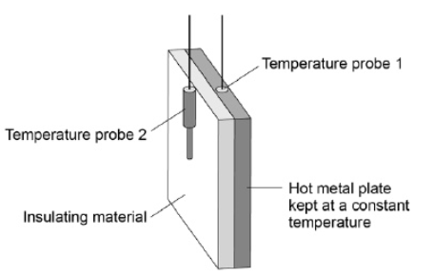The power output of the immersion heater is 5000W. Calculate the time taken for the immersion heater to transfer 4,070,000 J of energy.

**Hard**: A student investigated the properties of three types of insulation. The diagram shows the apparatus the student used. In the investigation, different insulating materials were placed in contact with the hot metal plate. Temperature probes measured the temperature on each side of the material. The temperature probes were connected to a data logger.

The graph shows how the temperature measured by temperature probe 2 changes over 20 minutes for each of the materials.

1. 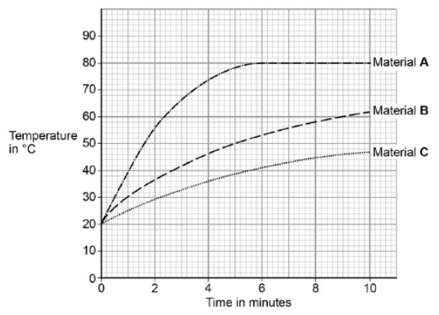What was the temperature of the hot metal plate?
2. Which material is the best insulator? Explain why.
3. Another student repeated the investigation but doubled the thickness for all three insulating materials. Suggest how using thicker insulation would affect the results of the seconds student’s investigation compared with the first student’s results.
4. 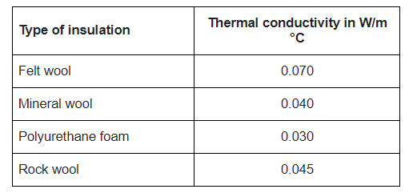Using the table, explain which material would be the best to use in cavity wall insulation.

**Q1.**

The drawing shows parts of a house where it is possible to reduce the amount of energy lost.

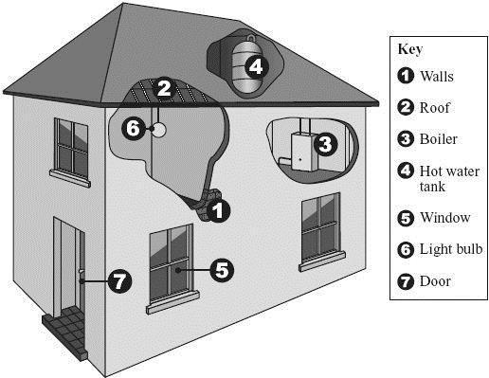

(a)     Give **one** way in which the amount of energy lost can be reduced from each of the following parts of the house.

**1**, **2** and **4** _________________________________________________________

**5** ________________________________________________________________

**7** ________________________________________________________________

**(3)**

(b)     Energy consumption can be reduced by using a more efficient boiler or more efficient light bulbs.

What is meant by a *more efficient* light bulb?

___________________________________________________________________

___________________________________________________________________

**(1)**

**(Total 4 marks)**

**Q2.**

An electric immersion heater is used to heat the water in a domestic hot water tank.  
When the immersion heater is switched on the water at the bottom of the tank gets hot.

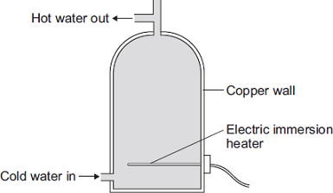

(a)     Complete the following sentence.

The main way the energy is transferred through the copper wall of the water tank is

by the process of ________________________________________ .

**(1)**

(b)     The immersion heater has a thermostat to control the water temperature.

When the temperature of the water inside the tank reaches 58°C the thermostat switches the heater off. The thermostat switches the heater back on when the temperature of the water falls to 50°C.

**Graph A** shows how the temperature of the water inside a hot water tank changes with time. The tank is **not** insulated.

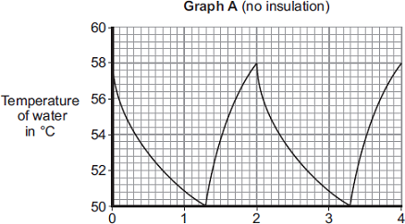

Time in hours

(i)      The temperature of the water falls at the fastest rate just after the heater switches off.

Explain why.

______________________________________________________________

______________________________________________________________

______________________________________________________________

______________________________________________________________

**(2)**

(ii)     To heat the water in the tank from 50°C to 58°C the immersion heater transfers 4032 kJ of energy to the water.

Calculate the mass of water in the tank.

Specific heat capacity of water = 4200 J/kg°C

______________________________________________________________

______________________________________________________________

______________________________________________________________

Mass = _______________________________ kg

**(3)**

(iii)    An insulating jacket is fitted to the hot water tank.

**Graph B** shows how the temperature of the water inside the insulated hot water tank changes with time.

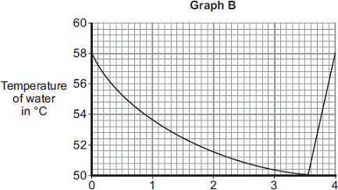

Time in hours

An insulating jacket only costs £12.

By comparing **Graph A** with **Graph B**, explain why fitting an insulating jacket to a hot water tank saves money.

______________________________________________________________

______________________________________________________________

______________________________________________________________

______________________________________________________________

______________________________________________________________

______________________________________________________________

**(3)**

There are two ways that we generate electricity: through renewable and non-renewable resources. Each of the ways of generating electricity has its own unique advantages and disadvantages.

National and global energy resources

**Non-renewable** energy resources will eventually run out. The main non-renewable resources are **fossil fuels** (coal, oil and gas) and nuclear.

|  |  |  |
| --- | --- | --- |
| Energy source | Main uses | Environmental impacts, ethics, reliability, and other information |
| Coal | Electricity generation, heating and some transport. | Burning produces greenhouse gases (CO2) and contributes to acid rain (SO2). Reliable output |
| Oil | Transport and heating. | Reliable output. Provides a compact source of energy for transport. Burning produces greenhouse gases (CO2) and contributes to acid rain (SO2). Serious environmental damage if spilt. |
| Gas | Electricity generation, heating and some transport. | Reliable output. Burning produces greenhouse gases (CO2) but not SO2. |
| Nuclear | Electricity generation and some military transport | Produces radioactive waste but no other emissions. Costly to build and decommission. Reliable output. |

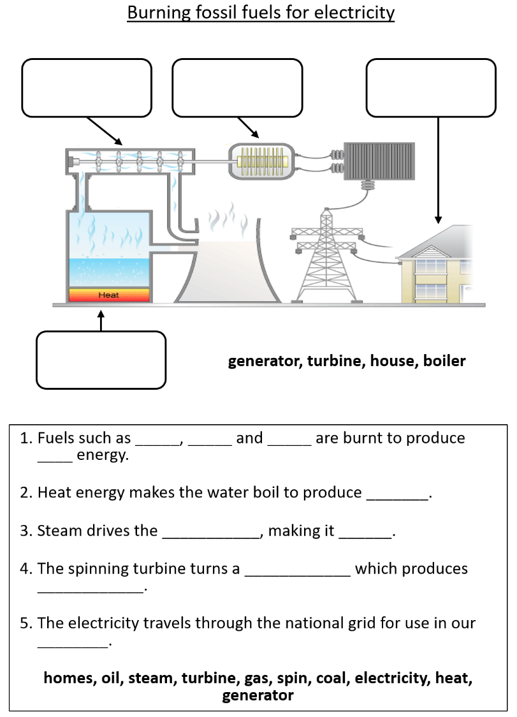In fossil fuel power plants, the fuel is burnt to heat water in a **boiler**. This water then turns into highly pressurised steam that turns the blades on a **turbine** which then turns a **generator**. This generator then produces electrical energy which is distributed to houses via the **National Grid** (a network of cables and transformers).

**Mini-task:** Label the diagram opposite.

Burning fossil fuels produces carbon dioxide. This causes **global warming** which is an increase in the temperature of Earth. This happens because carbon dioxide reflects infra-red radiation back towards Earth and traps it.

**Renewable** energy resources will never run out, or can be regenerated. Examples of renewable energy resources include biofuel, wind, hydro-electric power, geothermal, tidal energy, solar energy and water.

|  |  |  |
| --- | --- | --- |
| Energy source | Main uses | Environmental impacts, ethics, reliability, and other information |
| Biofuel | Transport and electricity generation. | Large areas of land are needed for growing fuel crops. This can be at the expense of food crops in poorer nations. |
| Wind | Electricity generation. | Unreliable as only provides energy while there is wind. Turbines can be noisy/dangerous to birds. Some people think they ruin the appearance of the countryside. |
| Hydro-electric | Electricity generation. | Requires large area of land to be flooded, altering ecosystems and displacing the people that live there. |
| Geothermal | Electricity generation and heating. | Only available in a limited number of places where hot rocks can be found close to the surface (e.g. Iceland). |
| Tidal | Electricity generation. | Variation in tides affect output. Have a high initial set-up cost. Can alter habitats/cause problems for shipping. |
| Solar | Electricity generation and some heating. | Depends on light intensity, so no power produced at night. High cost in relation to power output. |
| Water waves | Electricity generation. | Output depends on waves, so can be unreliable. Can alter habitats. |

**Basic:**

1. What is the definition of a renewable energy resource?
2. What is the definition of a non-renewable energy resource?
3. 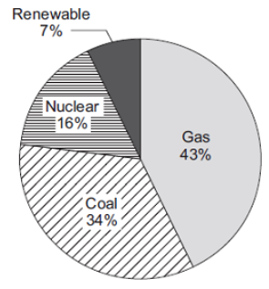Give four examples of non-renewable energy.
4. What are the three fossil fuels?
5. Give four examples of renewable energy resources.
6. Give a disadvantage of:
7. Burning a fossil fuel.
8. Wind power
9. Solar power
10. Hydro-electric power
11. Nuclear power.

**Medium:**

1. a) The pie chart shows the proportions of electricity generated in the UK from different energy sources in 2010. Calculate the percentage of electricity generated using fossil fuels.

b) Complete the following sentence:

In some types of power station, fossil fuels are burned to heat ____________ to produce steam.

c) Burning fossil fuels releases carbon dioxide into the atmosphere. Why do many scientists think adding carbon dioxide to the atmosphere is harmful to the environment?

1. The graph gives information about the production of electricity in the UK in 2016.
2. 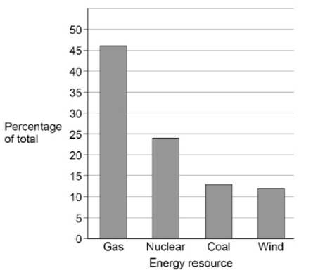The UK government signed the Paris Climate Agreement in April 2016. The agreement commits the UK to reduce the amount of carbon dioxide released into the atmosphere. Explain which energy resources in the graph should be used to meet the UK’s commitment to the Paris Climate Agreement.
3. On average, there is enough wind in the UK each year to supply all of the UK’s electricity needs. Explain why the UK may still need power stations that use fuel to generate electricity.
4. All European countries signed the Paris Climate Agreement in 2016. In the future, some European countries will only allow electric vehicles. Suggest how this is likely to affect methods of electricity generation in these countries.

**Hard:**

1. 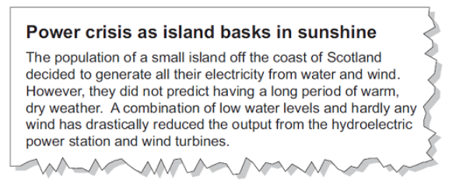Shale gas is natural gas trapped in rocks. Shale gas can be extracted by a process called fracking. There is some evidence that fracking causes minor earthquakes. Burning shale gas adds carbon dioxide to the atmosphere. Describe the advantages of nuclear power compared with the use of shale gas to generate electricity. (3)
2. Read this extract from a newspaper. Explain one way in which the islanders could try to ensure that a similar power crisis does not happen in the future?

**Q1.**

Energy resources can be renewable or non-renewable.

(a)     Coal is a non-renewable energy resource.

Name **two** other non-renewable energy resources. **(2)**

1. _________________________________________________________________

2. _________________________________________________________________

(b)     Wind turbines are used to generate electricity.

The graph below shows how the power output of a wind turbine changes over one day.

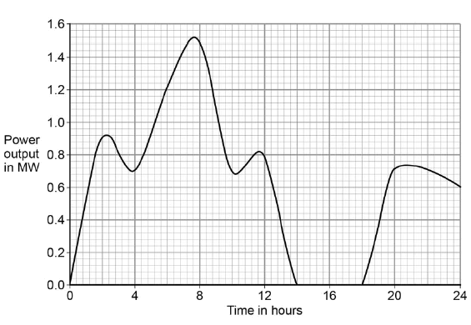

A wind turbine does not generate electricity constantly.

For how many hours did the wind turbine generate no electricity? **(1)**

___________________________________________________________________

Time = ________________________________ hours

(c)     An island has a large number of wind turbines and a coal-fired power station.

The island needs to use the electricity generated by the coal-fired power station at certain times.

Choose **one** reason why.

|  |  |
| --- | --- |
| Tick **one** box. |  |
| Wind is a renewable energy resource. |  |
| Wind turbine power output is constant. |  |
| The power output of wind turbines is unpredictable. |  |
| The fuel cost for wind turbines is very high. |  |

**(1)**

(D)     A wind turbine has an average power output of 0.60 MW.

A coal-fired power station has a continuous power output of 1500 MW.

Calculate how many wind turbines would be needed to generate the same power output as one coal-fired power station.

___________________________________________________________________

___________________________________________________________________

Number of wind turbines = ______________________

**(2)**

(E)      It is important that scientists develop new energy resources.

Choose **one** reason why.

|  |  |
| --- | --- |
| Tick **one** box. |  |
| All energy resources are running out. |  |
| All energy resources are used to generate electricity. |  |
| Most energy resources have negative environmental effects. |  |

**(1)**

**(Total 8 marks)**

**Q2.**

All European Union countries are expected to generate 20% of their electricity using renewable energy sources by 2020.

The estimated cost of generating electricity in the year 2020 using different energy sources is shown in **Table 1**.

**Table 1**

|  |  |
| --- | --- |
| **Energy source** | **Estimated cost (in the year 2020) in pence per kWh** |
| Nuclear | 7.8 |
| Solar | 25.3 |
| Tidal | 18.8 |
| Wind | 10.0 |

France generated 542 billion kWh of electricity using nuclear power stations in 2011.

France used 478 billion kWh of electricity and sold the rest of the electricity to other countries in 2011.

(a)     France may continue generating large amounts of electricity using nuclear power stations instead of using renewable energy resources.

Suggest **two** reasons why.

1. _________________________________________________________________

___________________________________________________________________

2. _________________________________________________________________

___________________________________________________________________

**(2)**

(b)     Give **two** disadvantages of generating electricity using nuclear power stations.

1. _________________________________________________________________

___________________________________________________________________

2. _________________________________________________________________

___________________________________________________________________

**(2)**

(c)     A panel of solar cells has an efficiency of 0.15.

The total power input to the panel of solar cells is 3.2 kW.

Calculate the useful power output of this panel of solar cells in kW.

___________________________________________________________________

___________________________________________________________________

___________________________________________________________________

___________________________________________________________________

Useful power output = _______________ kW

**(2)**

(d)     **Table 2** shows the manufacturing cost and efficiency of different types of panels of solar cells.

**Table 2**

|  |  |  |
| --- | --- | --- |
| **Type of Solar Panel** | **Cost to manufacture a 1 m2 solar panel in £** | **Efficiency in %** |
| A | 40.00 | 20 |
| B | 22.50 | 15 |
| C | 5.00 | 10 |

Some scientists think that having a low manufacturing cost is more important than improving the efficiency of solar cells.

Use information from **Table 2** to suggest why.

___________________________________________________________________

___________________________________________________________________

___________________________________________________________________

___________________________________________________________________

___________________________________________________________________

___________________________________________________________________

**(2)**

**(Total 8 marks)**