Year 10 CURRICULUM MAP: French
 | Autumn | Spring | Summer
Unit Length | 13 weeks | 13 weeks | 13 weeks
Assessment Objectives | AO1 Listening (25%)  AO2 Speaking (25%)  AO3 Reading & Translation (25%)  AO4 Writing & Translation (25%) | AO1 Listening (25%)  AO2 Speaking (25%)  AO3 Reading & Translation (25%)  AO4 Writing & Translation (25%) | AO1 Listening (25%)  AO2 Speaking (25%)  AO3 Reading & Translation (25%)  AO4 Writing & Translation (25%)
Description of the Topic and Key Learning Outcomes | Module 5 The Wider World  - Ideal holidays  - Booking and reviewing hotels  - Ordering in a restaurant  - Travelling  - Buying souvenirs | Module 6 School Life  - School  - Comparing schools in France and UK  - School rules  - School success | Module 7 The World of Work  - Career choices  - Plans, hopes and wishes  - Importance of languages  - Applying for jobs  - Understanding case studies
Milestone Assessments | End of Module Knowledge Audits | End of Module Knowledge Audits | GCSE Trial Exams
CEIAG | Careers links this term will focus on learning about the wider world. There will also be a focus on developing the key skills of communication, logical and lateral thinking, budgeting and problem solving. | Careers links this term will focus on the benefits of a good education. There will also be a focus on developing the key skills of communication, empathy, debate and memory. | Careers links will focus on making career choices, identifying personal strengths and weaknesses, applying for jobs and understanding the importance of good language skills. The focus will be on working in the service (tertiary) industry. The emphasis on developing key skills will continue.
RRSA | Article 28: Right to education  Article 29: Goals of education  Article 31: Right to leisure, play and culture | Article 14: Freedom of thought, belief and religion  Article 28: Right to education  Article 29: Goals of education  Article 31: Right to leisure, play and culture | Article 28: Right to education  Article 29: Goals of education
Wider Curriculum Links | Geography: French-speaking countries, French towns, Climate | Maths: Using money  Technology: French food & drink  English: Debating | Careers: Occupations, Applying for jobs, Understanding the importance of languages
Literacy Programme | - Adjectives and adjectival agreement  - Articles: definite, indefinite, partitive  - Cognates  - Comparatives and superlatives  - Connectives  - Idiomatic phrases  - Impersonal structures  - Infinitives and infinitive structures | - Modal verbs  - Negatives  - Nouns: singular and plural  - Numbers 1-100  - Opinions  - Phonics  - Polite noises | - Possessive adjectives  - Prepositions  - Pronouns  - Quantifiers & intensifiers  - Question words  - Reflexive verbs  - Tenses: Present, perfect, imperfect, (near) future, conditional
Useful websites | www.duolingo.com Free login. Add your friends and get competing.  www.linguascope.com Ask your teacher for login information. Use the Intermediate link for GCSE vocabulary and structures.  www.theday.com Read an article in English then read through the French version and see which words you can understand.  www.memrise.com Free login. Search for GCSE French (Foundation or Higher) and start learning. Add your friends and get competing.
Independent Learning Tasks  (in French) | 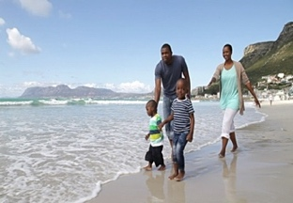  - Write 20-30 words to describe the photo above.  - Write 40-50 words about your holiday preferences and future holiday plans.  - Write 80-90 words to describe a disastrous holiday and what you would prefer for your next holiday. | 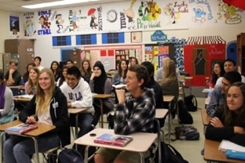  - Write 20-30 words to describe the photos above.  - Write 40-50 words about school life in the UK (uniform, hours, lunch, recent event, plans for September).  - Write 80-90 words to describe your ideal school, if you were the headteacher. | - Write 20-30 words to describe the photo above.  - Write 40-50 words about languages (which you speak, which you'd like to learn and why it's important to speak other languages).  - Write 80-90 words to apply for your dream job (personal qualities, describe your work experience, say why you want this job and state your ambitions.)

