Year 10 CURRICULUM MAP: Spanish
 | Autumn | Spring | Summer
Unit Length | 13 weeks | 13 weeks | 13 weeks
Assessment Objectives | AO1 Listening (25%)  AO2 Speaking (25%)  AO3 Reading & Translation (25%)  AO4 Writing & Translation (25%) | AO1 Listening (25%)  AO2 Speaking (25%)  AO3 Reading & Translation (25%)  AO4 Writing & Translation (25%) | AO1 Listening (25%)  AO2 Speaking (25%)  AO3 Reading & Translation (25%)  AO4 Writing & Translation (25%)
Description of the Topic and Key Learning Outcomes | Module 1 Who am I?  - Friendships and what makes a good friend  - Family relationships  - Making arrangements to go out  - Describing a daily out  - Discussing role models  Module 2 Leisure  - Sports  - Using technology  - Reading habits and music  - Television programmes  - A night out with friends | Module 3 Daily Life  - Describing daily life  - Shopping for clothes  - Describing festivals and traditions  - Shopping for a special meal  - Describing family celebrations  Module 4 Where I live  - Where you live and the climate  - Describing a town and directions  - What to see and do  - Making plans and the weather  - Describing community projects | Module 5 The Wider World  - Ideal holidays  - Booking and reviewing hotels  - Ordering in a restaurant  - Travelling  - Buying souvenirs  Module 6 School Life  - School  - Comparing schools in France and UK  - School rules  - School success
Milestone Assessments | End of Module Knowledge Audits | End of Module Knowledge Audits | GCSE Trial Exams
CEIAG | Careers links this term will focus on developing relationships and being inspired by the example of others and discussing interests. There will be a focus on developing the key skills of communication, logical and lateral thinking, memory, perseverance, problem solving, and identifying strengths and weaknesses. | Careers links will focus on diversity and tolerance; developing an understanding of festivals, customs and traditions of others and how to communicate effectively about daily life. There will be a focus on developing the key skills of handling different social interactions, making educated choices and adopting a healthy lifestyle. | Careers links this term will focus on learning about the wider world and the benefits of a good education. There will be a focus on developing the key skills of communication, logical and lateral thinking, budgeting, problem solving, empathy, debate and memory.
RRSA | Article 28: Right to education  Article 29: Goals of education  Article 31: Right to leisure, play and culture | Article 14: Freedom of thought, belief and religion  Article 28: Right to education  Article 29: Goals of education  Article 31: Right to leisure, play and culture | Article 28: Right to education  Article 29: Goals of education
Wider Curriculum Links | Citizenship: Relationships, Role models  Literature: French authors  Music: French musicians  PE: French sports | Maths: Money  Technology: Fashion, Foods & drink  History: The French Revolution  Citizenship: Customs and traditions  RE: Celebrations  Geography: French-speaking countries, French towns, Climate | Maths: Using money  Technology: French food & drink  English: Debating
Literacy Programme | - Adjectives and adjectival agreement  - Articles: definite, indefinite, partitive  - Cognates  - Comparatives and superlatives  - Connectives  - Idiomatic phrases  - Impersonal structures  - Infinitives and infinitive structures | - Modal verbs  - Negatives  - Nouns: singular and plural  - Numbers 1-100  - Opinions  - Phonics  - Polite noises | - Possessive adjectives  - Prepositions  - Pronouns  - Quantifiers & intensifiers  - Question words  - Reflexive verbs  - Tenses: Present, perfect, imperfect, (near) future, conditional
Useful websites | www.duolingo.com Free login. Add your friends and get competing.  www.linguascope.com Ask your teacher for login information. Use the Intermediate link for GCSE vocabulary and structures.  www.theday.com Read an article in English then read through the French version and see which words you can understand.  www.memrise.com Free login. Search for GCSE French (Foundation or Higher) and start learning. Add your friends and get competing.
Independent Learning Tasks  (in French) | - Write 20-30 words to describe the photo above.  - Write 40-50 words about yourself and your family.  - Write 80-90 words to describe your friends, relationships and role-models.  - Write 20-30 words to describe the photos above.  - Write 40-50 words about the Internet, it's dangers and advantages.  - Write 80-90 words to describe your past, current and future TV viewing habits. | - Write 20-30 words to describe the photo above.  - Write 40-50 words about your daily life.  - Write 80-90 words about a festival and how you celebrated last year and will celebrate next year.  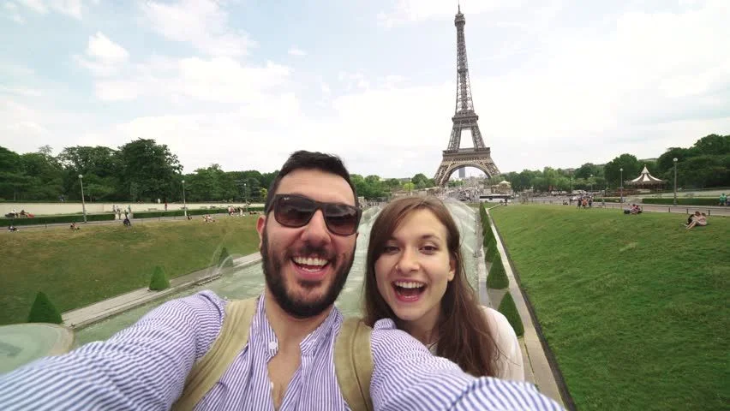  - Write 20-30 words to describe the photo above.  - Write 40-50 words about where you live.  - Write 80-90 words about where you would live in the future, if you had the choice. | 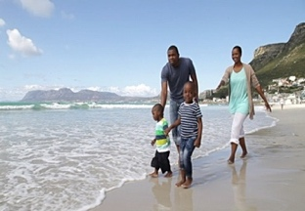  - Write 20-30 words to describe the photo above.  - Write 40-50 words about your holiday preferences and future holiday plans.  - Write 80-90 words to describe a disastrous holiday and what you would prefer for your next holiday.  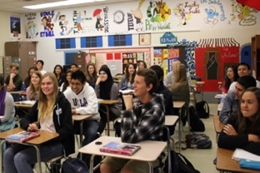  - Write 20-30 words to describe the photos above.  - Write 40-50 words about school life in the UK (uniform, hours, lunch, recent event, plans for September).  - Write 80-90 words to describe your ideal school, if you were the headteacher.

