Overview of topic: You will become accustomed to and explore rhythmic patterns through notation, improvisation, controlling and manipulating the elements of music.
Key content/ ideas/ concepts | Keywords/ Glossary
Texture – The different layers of music and how they work together.  Monophonic: one part  Homophonic: chords and melody  Polyphonic: many melodies  Heterophonic: simultaneous playing of variations of the same melody  Traditional Notation  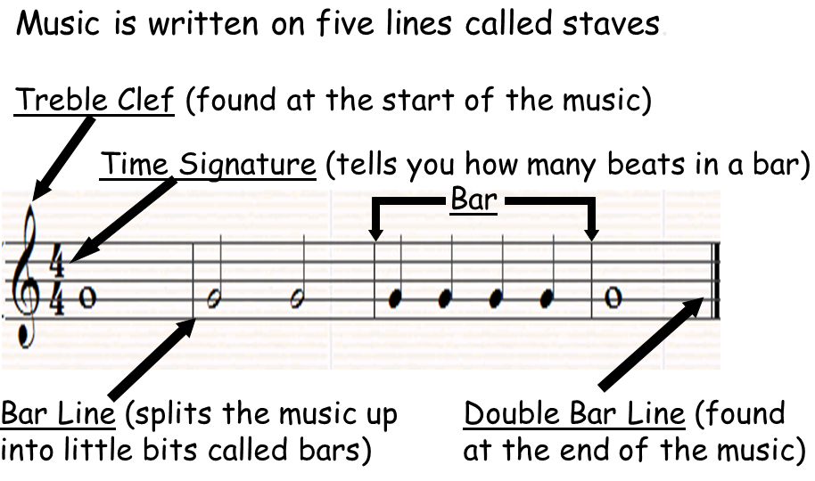  An example of Graphic Notation  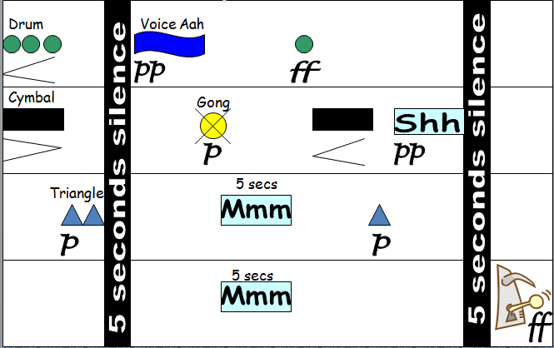  Traditional Notation  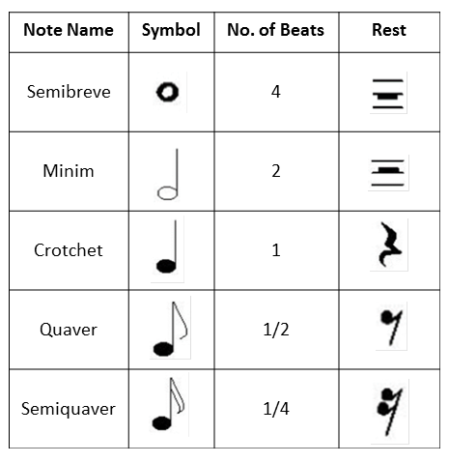  Tempo: Tempo tells you the speed of a piece of music. In music, we often use Italian terms to describe different tempi.  Largo Very slow  Adagio Slow  Andante Walking Pace  Allegro Fast  Presto Very Fast  Rhythm – The patterns of beats in a piece of music  - Tempo: The speed of music  - Beat: A unit of rhythm eg. Crotchet or Quaver  - Pulse: The steady beat that continues throughout a piece of music. I is the rhythm you would normally ‘tap your foot’ along to. | Pitch High and low  Duration Length of sound  Tempo Speed  Dynamics Volume  Timbre Sounds/instruments/voices  Texture Layers of sound  Structure Organisation/order of sound  Silence No sound  Pulse Regular beat  Rhythm Patterns of beats  Notation Way of writing music down  Traditional Notation A way of writing music down that musicians understand  Graphic Notation A way of writing music down using symbols
Wider Reading
https://www.musicnotes.com/now/tips/how-to-read-sheet-music/

Self-Quiz Questions | Self-Quiz Questions | Challenge Self-Quiz Quizzing
1. What is the definition of pitch? | 1. What is the definition of notation? | 1. What is the definition of monophonic?
2. What is the definition of duration? | 2. What is the definition of traditional notation? | 2. What is the definition of homophonic?
3. What is the definition of tempo? | 3. What is the definition of graphic notation? | 3. What is the definition for polyphonic?
4. What is the definition of dynamics? | 4. Draw a semibreve. | 4. What is the definition of heterophonic?
5. What is the definition of timbre? | 5. Draw a minim. | 5. What are the 5 Italian terms for tempo?
6. What is the definition of texture? | 6. Draw a crotchet. | 6. Draw a treble clef.
7. What is the definition of structure? | 7. Draw a quaver. | 7. Draw a keyboard.
8. What is the definition of silence? | 8. Draw a semiquaver. | 8. What is notation?
9. What is the definition of pulse? | 9. What is found at the start of a piece of music? | 9. What is traditional notation?
10. What is the definition of rhythm? | 10. What is found at the end of a piece of music? | 10. What is graphic notation?
Total score | Total score | Total score

