Overview of topic: You will become accustomed to and perform a typical piece of Blues music, incorporating chords, bass line and improvisation.
Key content/ ideas/ concepts | Keywords/ Glossary
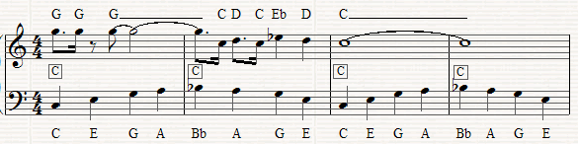  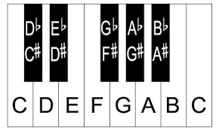  Improvisation  A melody that it made up ‘on the spot’. You will use the notes from the C blues scale for this.  Riff/Fill  C Blues scale  You will use  Blues vs. Jazz  The main focus of jazz music is the dynamics and improvisations of an ensemble, while the focus of blues music is usually the personal lyrical content of the song. Most jazz tunes are purely instrumental, while a blues song always contains lyrics.  Chords  Blues Lyrics  The lyrics follow the pattern AAB:  I’ve got the blues ‘cos I’m back at school  I’ve got the blues ‘cos I’m back at school  And I gotta follow all the rules!  Walking Bass  History of Blues  Blues music was first composed by black Americans of African descent. The Africans had been brought to America as slaves and the lyrics reflected their suffering. Therefore, the mood of blues music is sad. | Blues A music genre which was has roots from African slaves. The music reflects their suffering, meaning it is often slow.  Jazz A music genre which developed it roots from Blues. Jazz is often instrumental and known for its improvisation. Jazz music is often lively.  Riff A short, repeated phrase used in jazz.  Chords A group of (typically three or more) notes sounded together, as a basis of harmony  Walking Bass A bass line which is commonly heard in Blues music.  Improvisation A melody that is made up ‘on the spot’ and not pre-planned.  Structure How music is put together (the layout of a song)  Lyrics The names for the words within a song.  Wider Reading  https://www.bbc.co.uk/bitesize/guides/z3q47p3/revision/2

Self-Quiz Questions | Self-Quiz Questions | Challenge Self-Quiz Quizzing
- Where did Blues music originate? | 1.What is the definition of structure? | Task 1: Write your own Blues song, using the typical lyric format. Make sure your lyrics reflect the mood of how an African slave would have felt during that time.
- How did blues music begin? | 2.What are the notes of the C blues scale?
- What is a walking bass line? | 3.What is the definition of lyrics? | Task 2: Create a poster/revision resource that details the clear similarities and differences between blues music and jazz music. You can include images if needed.
- What is a chord? | 4.What does ‘instrumental’ mean?
- What is a riff? | 5.What mood would you associate with Blues? | Task 3: Create a blues help sheet which includes all the performance information for blues music performance (chords, improvisation, riff, walking bassline). You may want to include a keyboard picture, chord explanations etc.
- What is improvisation? | 6.What mood would you associate with Jazz?
- What is the definition of structure? | 7.What are the main differences between Blues and Jazz?
- What pattern does blues lyrics follow? | 8.What are the notes of a C chord?
- What is the structure for the 12 bar blues? (using roman numerals?) | 9.What are the notes of a G chord?
- What is the pattern for the 12 bar blues? (using the chord names) | 10.What are the notes of an F chord?
Total score | Total score | Total score

