Overview of topic: You will become accustomed with playing melody on a Ukulele and reading music from TAB.
Key content/ ideas/ concepts | Keywords/ Glossary
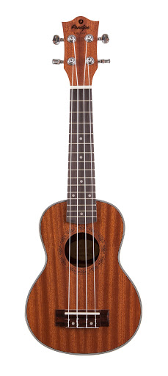  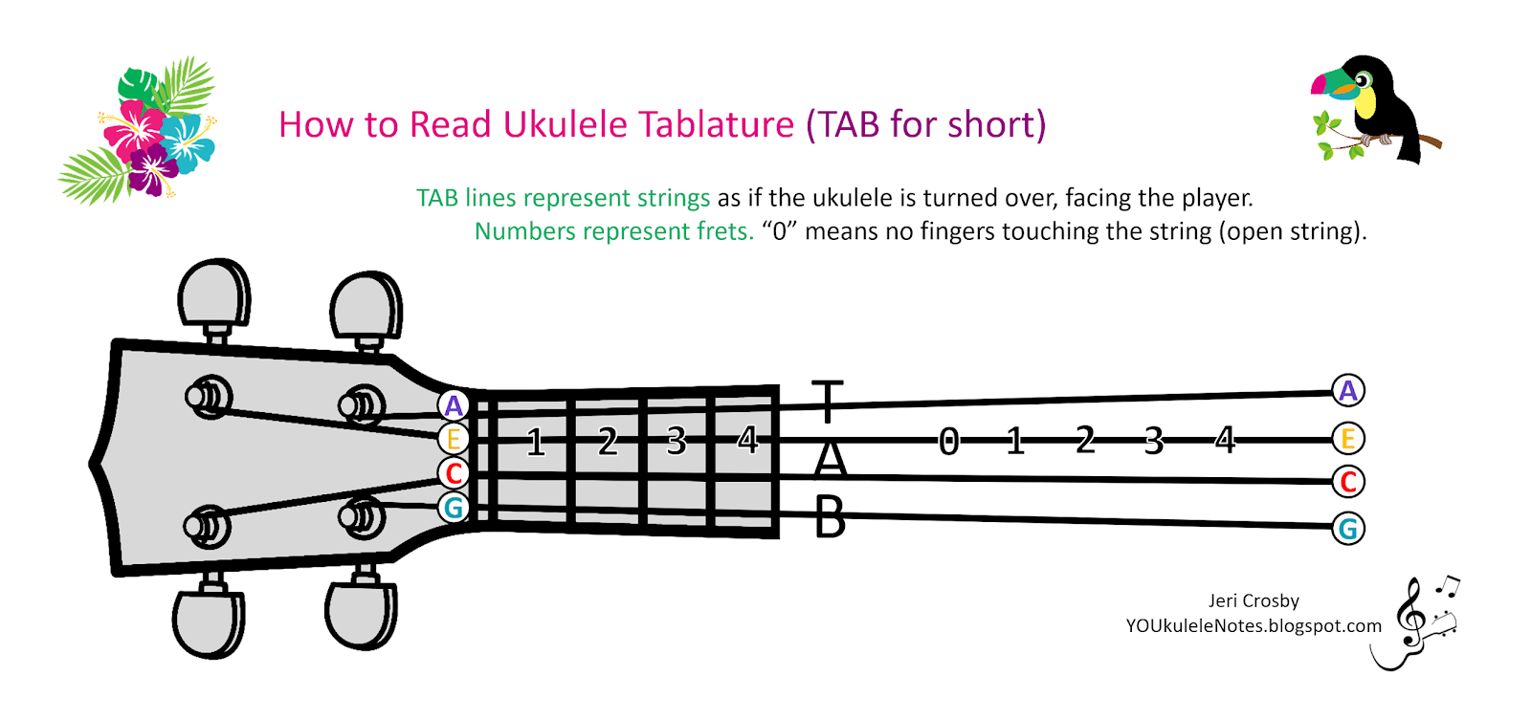  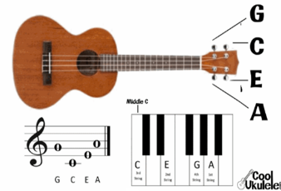  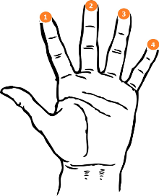  What makes a strong performance…?  - Band interaction: This helps with your stage presence and keeping everyone focused and together.  - Fluency: Keeping your part regular, fluent and in time will help the flow of the music.  - Eye contact with your audience: This shows your confidence and that you acknowledge they are there.  - Professionalism: No talking to band members during a performance and acknowledging an applause at the end.  Ukulele Fingering  Strings  These are the notes of the strings.  TAB  The lines and strings match up. ‘0’ on TAB means you just play the strings – no frets.  Frets  The frets are strips of metal that go vertically across the fretboard.  If the TAB says ‘1’ on a line, then you play fret 1 on the string that matches the line. | TAB Short for ‘Tablature’. Tab is a type of sheet music scoring specifically designed to help guitarists, bassists, and ukulele players to quickly learn how to play music.  Fret The frets are strips of metal that go vertically across the fretboard. If the TAB says ‘1’ on a line, then you play fret 1 on the string that matches the line.  Melody Also known as the ‘tune’. A sequence of notes played one after the other.  Chords A group of (typically three or more) notes sounded together, as a basis of harmony  Stage Presence How you act and perform on stage, or to an audience  Fluency The ability to perform easily and accurately, with hesitations.  Wider Reading  https://liveukulele.com/songs/easy-ukulele-songs/

Self-Quiz Questions | Self-Quiz Questions | Challenge Self-Quiz Quizzing
- What are the notes of the strings on a Ukulele? | 1. What are chords? | Task 1: Draw out a blank TAB a compose your own 4-bar Ukulele melody. Think about which strings and which frets you want to use.  You can use a Ukulele to experiment the notes with.
- How do you tune a Ukulele? | 2. If you play a melody, how many strings should you be strumming?
- Over which part of the Ukulele do you strum? | 3. If you are playing a chord, how many notes should you be strumming?
- Where do you place your hands to change notes on a Ukulele? | 4. What is stage presence? | Task 2: Create a poster on ‘how to rehearse effectively’ for other students to read and use.
- What is TAB short for? | 5. How do you make a performance fluent?
- Explain what TAB is? | 6. What is the definition of dynamics? | Task 3: Create a poster with information on for ukulele players, which gives advice on how to perform on stage (use the first Wider Reading link)
- What does it mean if TAB says play ‘0’? | 7. How do major chords sound?
- What does it mean if TAB says play ‘1’? | 8. How do minor chords sound? | Task 4: Create a poster for beginner ukulele players which explains what a ukulele is, how to play it, how to tune it and with details of some ukulele chords.
- What is the connection between the strings and lines on TAB? | 9. Name 3 things that make a strong performance?
- What is a melody? | 10. Why is eye contact with your audience important?
Total score | Total score | Total score

