Y10 Cells Booklet Mark Schemes
Lesson 1
Q1.
(a) (i) C and D
no mark if more than one box is ticked
1
(ii) any one from:
do not allow if other cell parts are given in a list
• (have) cell wall(s)
• (have) vacuole(s)
1
Q2.
(a) (i) (cell) membrane
1
(ii) vacuole
1
(b) any two from:
• (cell) wall
• chloroplast(s)
ignore chlorophyll
• vacuole
ignore cell sap
2
Q3.
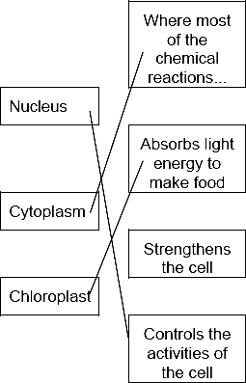
1 mark for each correct line
mark each line from left hand box
two lines from left hand box cancels mark for that box
3
Q4.
(a) A nucleus
1
B (cell) membrane
1
C cytoplasm
1
Q5.
(a) A nucleus
1
B (cell) membrane
1
C cytoplasm
1
Medium
Q1.
A – (cell) membrane
1
B – cytoplasm
1
C – nucleus
1
must be in correct order
accept phonetic spelling – see marking guidance 3.6
[3]
Q2.
(a) (i) the three features correctly labelled on
cheek cell (which are referred to in
part (ii)
label lines should touch or end very close to part no marks if leaf cell labelled
nucleus
cytoplasm
cell membrane
mitochondrion
accept mitochondria or one of these could be labelled vacuole
3
(ii) any three from
feature function
nucleus controls cell
accept contains genetic material or genes or chromosomes or stores information
do not credit the brain of the cell
cytoplasm where respiration
occurs
accept contains food or mitochondria
or reactions occurs
membrane less water or
chemicals
accept surrounds the cell or lets some things in but not others
do not credit keeps things out or protection
in and or out
mitochondria where energy released
ecf from leaf cell labelling
accept chloroplasts make sugar or glucose
accept vacuole contains sap
accept if cell wall mis labelled on cheek cell, support or hold together
3
Q3.
(a) (cell) wall
(cell) membrane
cytoplasm
vacuole
for 1 mark each
4
Q4.
(a) (i)
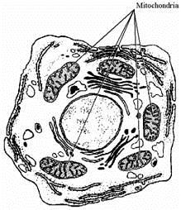
award 1 mark for any of the mitochondria correctly labelled if a number are labelled and one is incorrect award 0 marks
1
(ii) respiration or the release or transfer
of energy or it contains the enzymes
for respiration
do not accept energy produced
1
Q5.
(i) one mark for each correctly labelled part
cell wall
do not accept anything inboard of the inner edge vacuole
accept anything inboard of transplant
chloroplast: site of photosynthesis/ for photosynthesis
accept word equation or balanced equation
1
cell wall: supports the cell/keeps the shape/keeps it rigid
do not accept protects the cells
2
(ii) vacuole: acts as reservoir for water / chemicals/(cell)/sap
3
or
keeps cell turgid/pushes content to
edge
or
maintains concentration gradient
or
allows cell elongation (not growth)
1
[12]

Lesson 2
Q1.
(a) D
1
any one from:
• has chloroplasts
• has a (large) vacuole
ignore has a (cell) wall
1
(b) B
1
does not have a (cell) wall
allow has only a nucleus, (cell) membrane and cytoplasm
1
(c) C
1
any one from:
• genetic material is not in a nucleus
allow no nucleus
• has a single loop of DNA
1
Q2.
(a) any one from (bacterial cell):
• has a cell wall
• has plasmids
allow converse
• has a single DNA loop
• has no nucleus
• is much smaller
1
Q3.
(a) any two from:
• only one ‘chromosome’
allow one strand of DNA
• circular
allow loop
• may have plasmids
• not in a nucleus / no nucleus
2
Q4.
(a) (i) A = (cell) wall
ignore cellulose
1
B = cytoplasm
1
(ii) any one from:
accept has DNA instead of a nucleus, but not just has DNA
• bacterial cell / it has no nucleus
allow no mitochondria
• DNA free in cytoplasm
ignore size
• has no vacuole / no vesicles
ignore strands of DNA
1
Q5.
(a) (i) A − (cell) wall
1
B − cytoplasm
1
C − plasmid
1
(ii) bacterium cell has cell wall / no nucleus / no mitochondria / plasmids present
accept its DNA / genetic material is not enclosed / it has no nuclear membrane
it = bacterium cell
accept converse for animal cell
ignore flagella
1
(iii) any one from:
• chloroplast
ignore chlorophyll
• (permanent) vacuole

Lesson 3
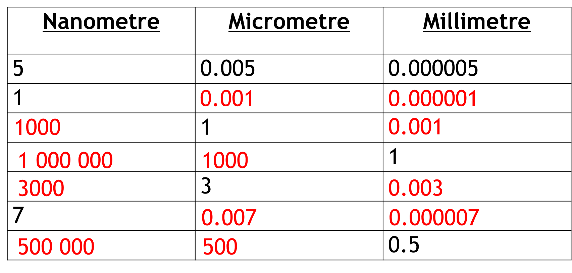
Q1. conversion of units:
(112 mm ⟶) 112 000 (µm)
or
(280 µm ⟶) 0.28 (mm)
1
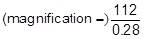
or
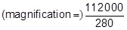
allow 1 mark for no conversion of units 112 / 280
or
incorrect value from step 1 correctly substituted
1
400 (×)
do not accept if units are given
if no other mark scored allow 1 mark for:
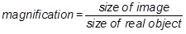
a triangle with words or letters in is insufficient, as the correct rearrangement is needed
1
an answer of 400 (×) scores 3 marks
Q2.
(b) 400
acceptable range 390-410
allow 1 mark for answer in range of 39 to 41
allow 1 mark for answer in range of 3900 to 4100
2

Q3.
(ii) 0.5
gains 2 marks
(5/100 × 10 or ½ /1 gains 1 mark if 0.5 not given)
2
Q4.
(a) 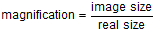
= 29 ÷ 0.03
1
= 967
1
allow 967 with no working shown for 2 marks
Q5.
(d) real size = 25 / 100 000
1
0.00025
1
(conversion to) 0.25 (µm)
allow 0.25 (µm) with no working shown for 3 marks
1

Lesson 4
Q1. too small / very small

allow light microscope does not have sufficient magnification / resolution

allow ribosomes are smaller than mitochondria

ignore not sensitive enough

ignore ribosomes are transparent

1
Q2.
(a) ×4
1
reason: any one from:
• gives the largest field of view
• easier to focus
1
(b) eyepiece lens: ×10
and
objective lens: ×40
or
eyepiece lens: ×5
and
objective lens: ×80
allow sensible suggestions that give a magnification of ×400
1
(c) real width =
1
0.031 (mm)
an answer of 0.031 (mm) scores 2 marks
allow ecf from part (f)
1

Q3.
(a) electron (microscope)
1
(b) 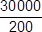
an answer of 150 (μm) scores 2 marks
1
150 (μm)
if answer is incorrect allow for 1 mark sight of 0.015 / 0.15 / 1.5 / 15
allow ecf for incorrect measurement of line X for max 1 mark
1
Q4.
(a) turn the (fine focusing) knob until the cells are in focus
allow focus it
do not accept increase magnification
ignore decrease magnification
ignore clear
ignore references to resolution / illumination
ignore zoom in / out
1
(b) (rotate the) nosepiece / objective lens
allow change the (objective / eyepiece) lens
1
to a higher power (lens)
allow (to) increase the magnification
a comparator is required
ignore change / adjust the magnification
allow stronger or more powerful lens
ignore references to resolution / illumination unqualified
ignore zoom in / out
ignore references to an electron microscope
1

