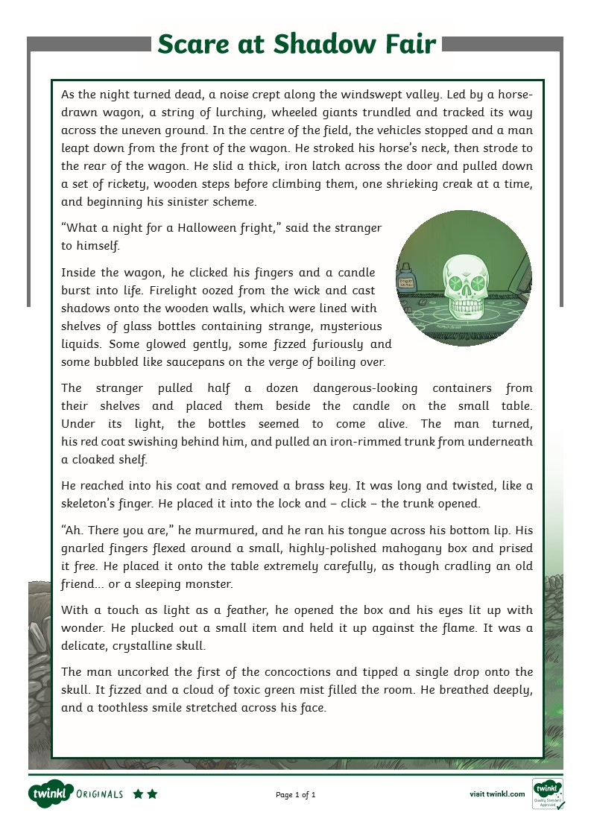

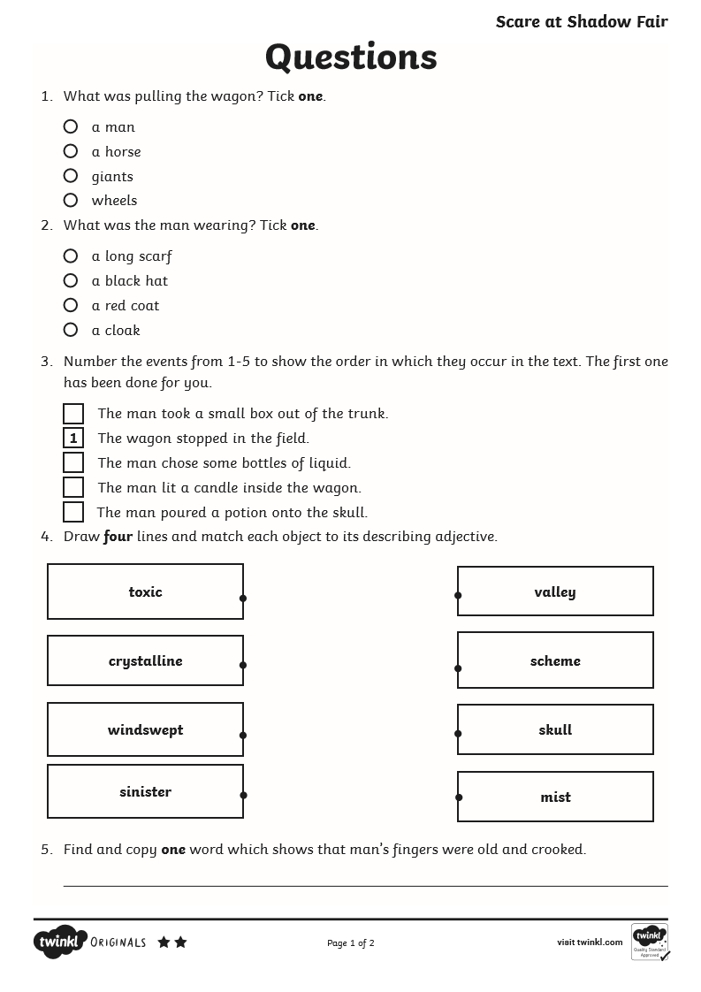

9. What genre is this text? How do you know?
___________________________________________________________________________________________________________________________________________________________________________________________________

10. Make a prediction of what will happen next.
_______________________________________________________________________________________________________________________________________________________________________________________________________________________________________________________________________________________________________________________________________________________________________________________________________________________________________________________________________

