Policy
Author/Contact | Name: p.mccarthy@stockgrn.bham.sch.uk
Version | 1.
Status

Revised Policies

Review Date | January 2022
Approved/Ratified by | Trust Board | Date:

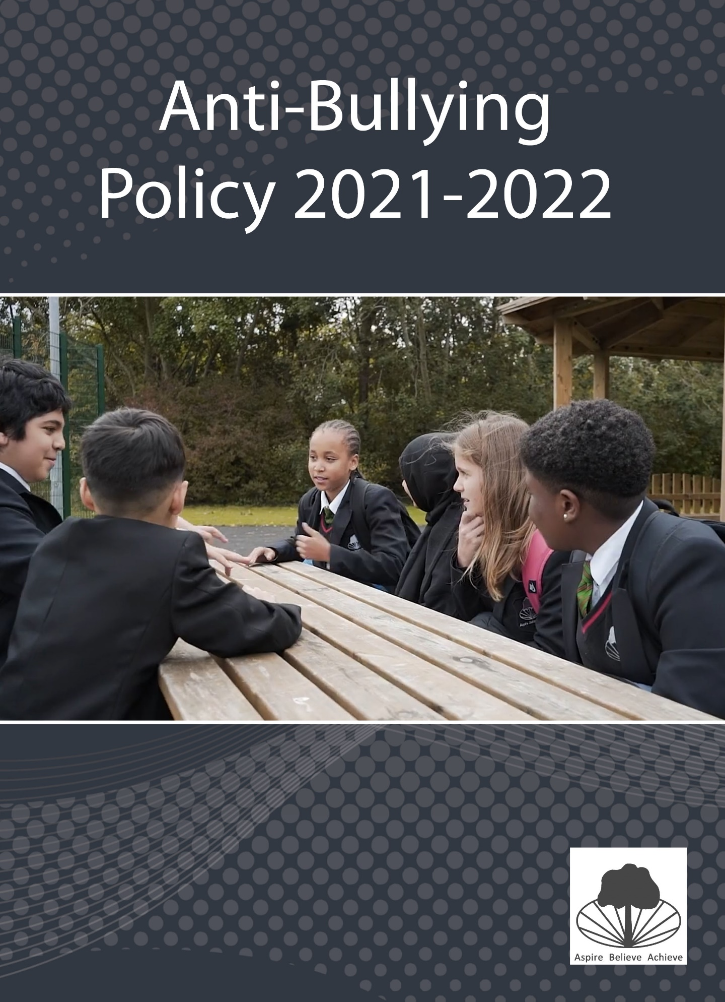

Anti-Bullying Policy Revision 2021-22
Statement of intent
The aim of the anti-bullying policy is to ensure that pupils learn in a supportive, caring and safe environment without fear of being bullied and that the Stockland Green Standard is upheld. This is in accordance with our PRIDE values and status as a Rights Respecting School. Bullying is anti-social behaviour and affects everyone; it is unacceptable. We are committed to providing a caring, friendly and safe environment for all of our pupils so they can learn in a relaxed and secure atmosphere. If bullying does occur, all pupils should be able to tell and know that incidents will be dealt with promptly and effectively. Our ultimate goal must be to eliminate bullying from Stockland Green School. This policy has been informed by research into best practice and the guidelines provided by The Anti-Bullying Alliance.
Why do we need an Anti-Bullying Policy?
Persistent bullying can severely inhibit a child’s ability to learn effectively. The negative effects of bullying can have an impact on a person for their entire life. Stockland Green School wishes to promote a secure and happy environment free from threat, harassment and any type of bullying behaviour. Therefore this policy promotes practices within the school to reinforce our ethos and culture, and to remove or discourage practices that negate them.
What is Bullying?
Bullying occurs when an individual or a group uses strength, power or aggression to hurt, either physically or emotionally, by intimidating or demeaning others. Bullying can be emotional, physical, racist, homophobic, biphobic, transphobic, verbal or cyber. It is usually persistent and is often covert, and is a conscious attempt to hurt, threaten or frighten someone. A bully has a wilful, conscious desire to hurt/threaten/frighten someone else.
Bullying may start from an individual or from a group and girls and boys are equally involved in bullying/being bullied. We know that bullying occurs more frequently when there is less teacher supervision, before or after school, during break and lunch-hour, in toilets, PE changing rooms, or other times when such behaviour is more difficult to detect. Most bullying is hidden from teachers; they may be the last to learn about incidents of bullying taking place in their own environment.
Pupils who are being bullied, may show changes in behaviour, such as becoming shy and nervous, feigning illness, taking unusual absences or clinging to adults. There may be evidence of changes in work patterns, lacking concentration or truanting from school. Students being bullied tend to be isolated, anxious, feel inadequate, and are unable to make and maintain friendships and have a low self-image. Bullying can also lead to risky behaviours such as self-harm and may make students vulnerable to exploitation.
Bullying can take many forms including:
• Physical bullying which can include kicking, hitting, pushing and taking away belongings;
• Verbal bullying which includes name calling, mocking and making offensive comments;
• Emotional bullying which includes isolating an individual or spreading rumours about them;
• Cyber-bullying where technology is used to hurt an individual – for instance text messaging or posting messages/images on the internet or any form of social media, this includes Smoothwall alerts on all school and loan devices.
• Racist bullying occurs when bullying is motivated by racial, ethnic or cultural prejudice.
• Sexual bullying is where someone makes unwanted physical contact or makes sexually abusive comments.
• Homophobic and biphobic bullying occurs when bullying is motivated by a prejudice against lesbian, gay or bisexual people.
• Transphobic bullying occurs when bullying is motivated by a prejudice against people who identify as trans
• Disablist bullying occurs when bullying is motivated by a prejudice against people with any form of disability.
• Sexist bullying occurs when bullying is motivated by a prejudice against someone because of their gender.
Stockland Green School is aware there is an increased risk of cyber bullying using e-mails, instant messenger, social networking sites, and public websites inappropriately due to increased engagement with technology amongst our cohort for a variety of reasons.. Therefore our school has an ICT acceptable use policy which all students sign when using school platforms and devices.
Some warning signs that a student is being bullied
• Changes in academic performance
• Appears anxious
• Regularly feeling sick or unwell. Wanting to visit the nurse regularly. Reluctance to come to school. • Clothes/bags torn or damaged.
• Money/possessions going missing.
• Unexplained cuts and bruises.
• Unexplained behaviour changes, e.g. moody, bad-tempered, tearful. Unhappiness.
• Loss of appetite. Not sleeping. Loss of weight
• Seen alone a lot
• Not very talkative
Some reasons why people bully
• Desire to appear powerful
• Unhappiness
• Feelings of inadequacy
• Difficulties at home.
• Learned behaviour (They too have been bullied
In keeping with our commitment to Trauma-Informed practice, it is important that we understand that the victim of bullying is likely to find this experience traumatic but equally that the behaviour may stem from insecure attachment and/or a desire for attachment on the part of the aggressor.

Strategies for dealing with bullying
A consistent whole staff approach to dealing with bullying is essential. All staff should be committed to watching out and listening for incidents of bullying and dealing with any incident, however trivial or serious it may seem. All staff, including non-teaching staff, must ensure that the safeguarding of students is at the forefront of their conduct when dealing with issues of bullying. It is important that lunchtime and break time duty staff should be aware and alert, keeping a watchful eye upon quiet corners and students who might be at risk. It is vital that we use the vehicles at our disposal, be that The Stockland Green Standard, Personal Development lessons, our PRIDE values and Citizenship programme or our work with outside agencies to make it clear to all students that Stockland Green School will not condone bullying and that all incidents of bullying will be dealt with appropriately, through intervention and education. All staff will be made aware of the signs of bullying identified above and be vigilant in challenging, supporting and educating as necessary in response to instances of bullying.
It is important that students know that appropriate action will be taken and also that they feel comfortable in challenging behaviour that falls short of the standard that we expect. With this in mind, we have begun work on delivering a programme based around the Mentors in Violence Prevention approach during Citizenship time.
How to get help
Students should feel able to approach any member of staff for support. However, it is most likely that they will wish to speak to a trusted adult. This may include but is not limited to:
- Teachers
- Tutors
- TAs/Inclusion Staff
- The B2A Team
- Pastoral Leaders
- House Leaders
- SLT
- Office Staff
- Internal and External Mentors
- People from Outside Agencies
Students can feel confident that any of the above will listen to their problem. Pupils who have been bullied will be supported by:
- Discussion
- Reassurance
- Continuous support
- Support to restore self-esteem and confidence through B2A or other appropriate sources of guidance

It is also important that those who have bullied:
- provide an account of their involvement and the events that happened;
- discuss wrongdoing and redress;
- are given an opportunity for mediation with other parties;
- are given support and education to alter their behaviour in the future;
- are subject to an appropriate sanction.
Anti-Bullying Procedures
- Stockland Green School makes it clear that bullying in any form is unacceptable. It will be taken seriously and dealt with promptly. Appropriate communication with parents, carers and any relevant agencies will take place in a timely and appropriate fashion.
Staff Responsibilities
  - To implement school policies to confront bullying in any form
  - To listen to all parties involved in incidents
  - To investigate incidents promptly and as fully as possible
  - To take appropriate action or to refer to Tutor/Pastoral Staff/SLT as appropriate
  - To record in the appropriate students’ files and in the racist/HBT (homophobic, biphobic, transphobic) record if appropriate
  - To share with parents of the victim and bully any incidences of bullying, including incidents of persistent and/or serious bullying
  - To implement appropriate procedures for a member of staff
  - To promote the use of a range of learning styles and strategies which challenge bullying behaviour
  - To promote communication and consultation within the school and relevant outside agencies when appropriate
  - To model the pride values and our ethos
  - To act in a Rights Respecting and Trauma-Informed manner
  - To promote the use of effective interventions
  - To record incidences of bullying on the most appropriate platform
Practicalities & Communication
- All tutors/teachers should record incidents of bullying on Go 4 Schools and inform the House Pastoral Team.
- Relevant information should be recorded on MyConcern
- Pastoral House Team members will record how incidents of bullying are dealt with on Go 4 Schools.
- Pastoral House Team members should monitor victims of bullying to check for reoccurrence.
- Racial and Homosexual incidents should be logged as such on Go 4 Schools. Such incidents are monitored separately and require recording on MyConcern
- Parents/carers of bullies/victims should be kept informed and in serious cases, invited in to participate in counselling sessions.

Anti Bullying Strategies
- Promotion of anti-bullying in assemblies and through wellbeing weeks.
- Use of opportunities within curriculum time to highlight our values and to challenge prejudice.
- Use of CCTV within the school grounds to help with the prevention of bullying.
- A duty rota for staff so they patrol key areas before school, break, lunchtime and after school
- Gathering student voice to inform practice in relation to bullying, including through student leaders.
- Citizenship and Personal Development lessons on anti-bullying, the Bystander Approach and equality and diversity.
- A special e-mail address to report any incidents of bullying
- Counselling and intervention through B2A, the Pastoral House Team and outside agencies
- Strong teacher-student relationships so students feel comfortable in reporting any issues
- Use of the school Police Liaison Officer
- CEOP training for staff (Child exploitation & online protection)

Anti-bullying advice to Parents / Carers
This policy will be communicated to parents. We also run groups for parents to provide a forum for discussion as well as advice and guidance where necessary.
• A great deal of bullying is CYBER-BULLYING. Please regularly monitor your child’s use of texting, Facebook, Twitter and other social media sites. Access to these is out of the schools control when your child is not in school
• TALK to your child on a regular basis, so any problem is easier to share
• LISTEN to what they say
• ENCOURAGE your child to feel good about themselves, realising that we are all different and equally important
• If you believe your child is being bullied, or is a bully, talk to other adults at home or at school and explore the options. DON’T STAY SILENT
• If your child is a victim assure them that it is not their fault and that you are going to do something to help
• Be realistic in your expectations, sometimes on-going problems can take time to resolve
• TRY to be patient and co-operative. Without a good working relationship between parents and the school the situation could deteriorate, which won’t help you or them
• ALWAYS remember that children can’t solve bullying on their own. They NEED the support of parents/carers and our school

The law
Some forms of bullying are illegal and should be reported to the police. These include:
- violence or assault
- theft
- repeated harassment or intimidation, e.g. name calling, threats and abusive phone calls, emails or
- text messages
- hate crimes
Call 999 if you or someone else is in immediate danger.
Schools and the law
By law, all state (not private) schools must have a Behaviour policy in place that includes measures to prevent all forms of bullying among pupils.
This policy is decided by the school. All teachers, pupils and parents must be told what it is.
Anti-discrimination law
Schools must also follow anti-discrimination law. This means staff must act to prevent discrimination, harassment and victimisation within the school. This applies to all schools in England and Wales, and most schools in Scotland. Northern Ireland has different anti-discrimination law.
Reporting bullying
You should report bullying to your school in the first place - or someone you trust if it happens outside school, e.g. in a club or online. Emails can be sent to:
Rea@stockgrn.bham.sch.uk
Tame@stockgrn.bham.sch.uk
Cole@stockgrn.bham.sch.uk

Tell the police if the bullying involves a crime.
Schools - reporting bullying
School staff will deal with bullying in different ways, depending on how serious the bullying is.
They might deal with it in school, e.g. by disciplining bullies, or they might report it to the police or social services. Any discipline must take account of special educational needs or disabilities that the pupils involved may have.
Police - reporting bullying
Anyone can make a complaint to the police about bullying but it’s usually a good idea to speak to your school first.
If you’re reporting cyberbullying, keep a record of the date and time of the calls, emails or texts - don’t delete any messages you receive.
Monitoring, evaluation and review
The school will review this policy annually and assess its implementation and effectiveness. The policy will be promoted and implemented throughout the school.

