Forces 2
Complete some of the tasks from the grid below to reach a total of points over this unit of work. Try and cover a variety of tasks over the unit so that you’re practicing different skills. Once you’ve completed a task, colour that box on the grid to keep a record of your points. Can you get the highest point score this unit?

Topic | 1 Point | 2 Points | 4 Points | 6 Points | 10 Points
Upthurst | Define upthrust | Draw a force diagram that includes upthrust in it. | Do the same activity as the box to the left but add numbers to show forces are balanced. | Write a paragraph outlining how you could test the upthrust on an object. | Read this article and write an A4 side on what you have learnt. It has to be in your own words and include diagrams.  https://www.explainthatstuff.com/how-ships-work.html
Pressure | Define pressure | Recall the equation to calculate pressure, include the units. | Calculate:  The pressure when force is  20N and surface area is 3m²  ‘  The surface area when the force is 300N and the pressure is 2.5 N/m²  The force when the surface area is 1.5m² and the pressure is 200N/m² | Write 3 of your own calculation questions, this must include a markscheme. | Mrs Cooper wants to go to space without a helmet on.  Explain using your knowledge of air pressure, why this is a bad idea.
Work and moments | Write the definition of work and moments | Write the equations to calculate:  Work =  Moment = | Calculate:  The work when the force is 5N and the distance is 15m.  The distance when the force is 0.8KN and the and the work is 2.7KJ | 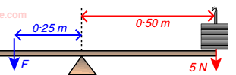  Calculate the missing values.  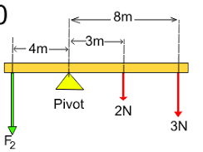 | Use your knowledge of moments to explain why a crane needs a counterweight.  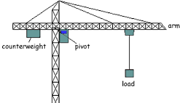
Elasticity | What is an elastic object?  Name 3 elastic objects. | Define Hooke’s law and sketch a graph that shows this. | Use examples to explain what directly proportional means. | Write a practical method on how you could calculate the spring constant of a spring. | Design a product that uses elasticity. You must explain the science behind it.
Speed graphs | How can you tell from a graph if an object is moving faster? |  | 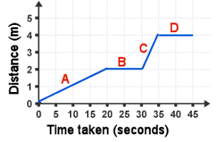 Calculate the speeds of A-D | Sketch a distance-time graph of a journey. You must describe the journey. | Sketch a speed-time graph of a journey. You must describe the journey.
Stopping distances | List all the factors that affect a vehicles stopping distance. | Write the definitions of thinking distance, breaking distance, and stopping distance.  What is the equation to calculate stopping distance | Explain fully how drinking alcohol affects the stopping distance. | What safety feature would you like to see added to all new cars? Why? | Read this article and write an A4 side on what you have learnt. It has to be in your own words and include diagrams.  https://www.smmt.co.uk/2015/02/car-safety-brief-history/

