Curriculum intent

At Stockland Green School we are a school with the highest aspirations for our young people and wider community. We believe that our curriculum should provide a broad and balanced experience for all our students, following our fundamental principles that all students Aspire, Believe and Achieve.
Our curriculum, through these principles, should develop young adults that demonstrate our PRIDE characteristics of Perseverance, Resilience, Integrity, Determination and Empathy, and allow for the development of our students into well rounded individuals.
As part of our drive for a knowledge rich curriculum, we focus on cognitive learning strategies; embedding strategies across the curriculum that support the learning process.

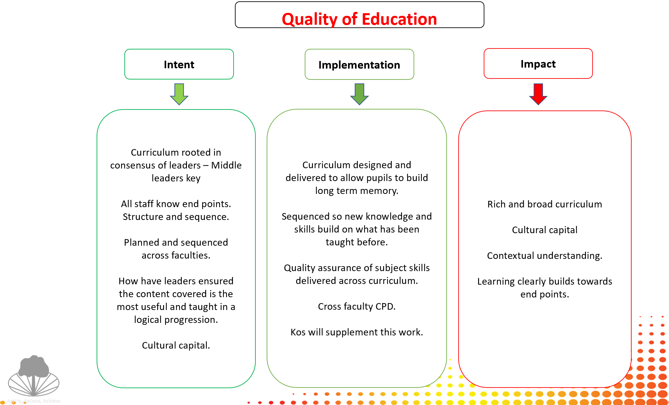

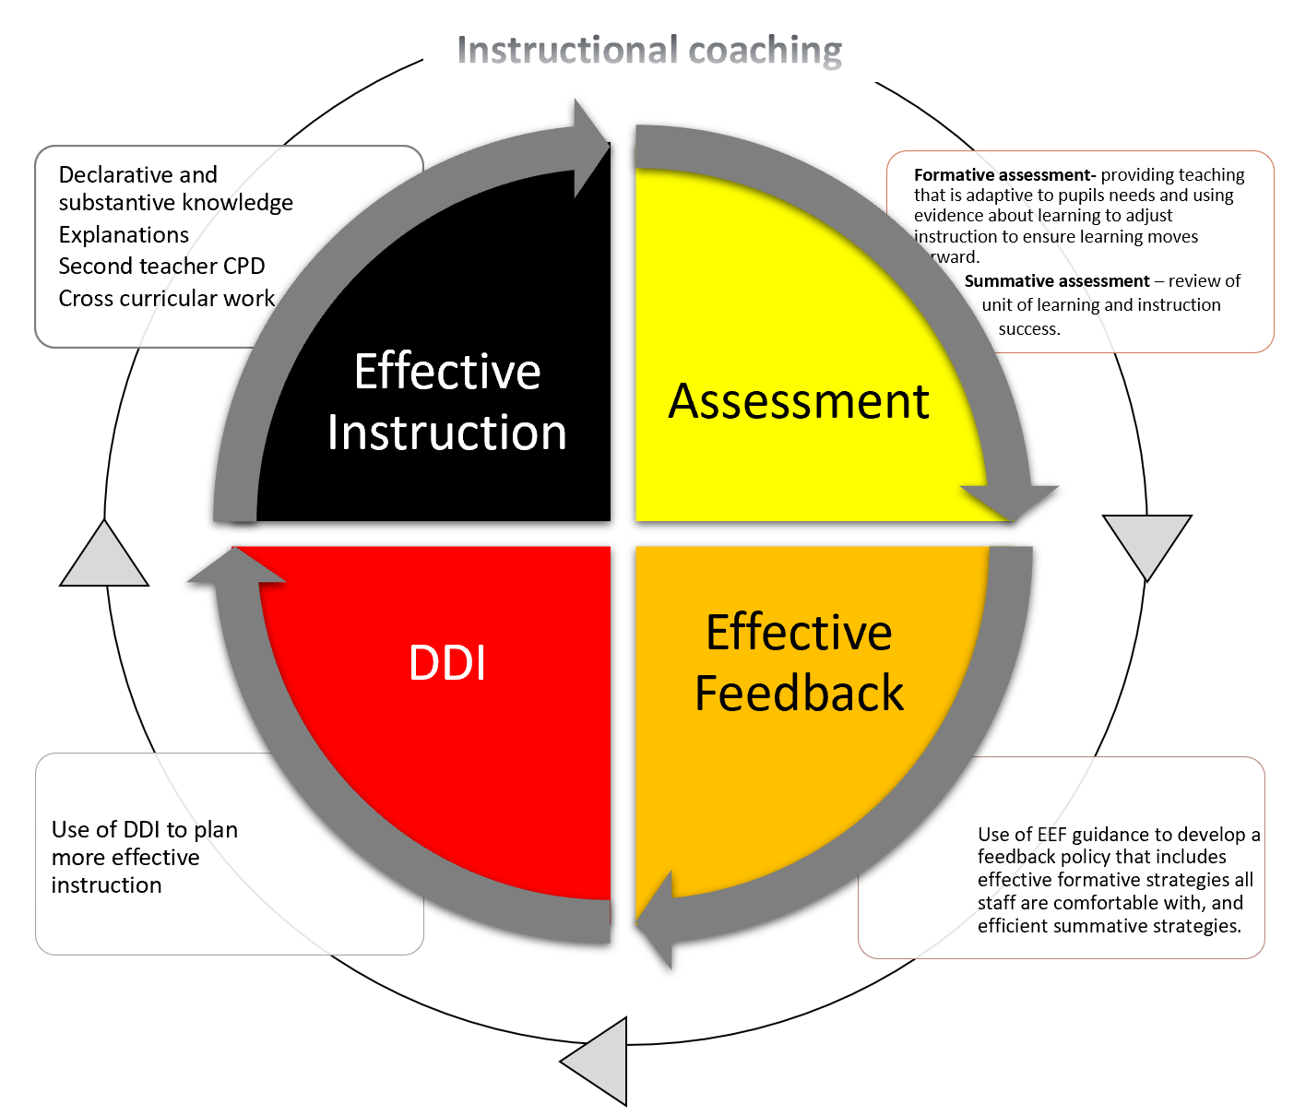
Effective Instruction

“Every teacher needs to improve, not because they are not good enough, but because they can be even better” Dylan William

The quality of teaching is the single most important in-school factor for improving pupil outcomes and it is particularly important for pupils from disadvantaged backgrounds. We believe subject mastery will ensure our students are taught the very best of each of the subjects on offer by highly skilled, expertly equipped professionals.
- The CPD calendar has been designed to focus all professional development for teachers within one of the four quarters of our curriculum focus.
- All teachers will receive subject specific instruction to bring about subject mastery.
- Instruction needs to build on knowledge over time, provide an opportunity for students to deepen their knowledge and model ways in which knowledge can be presented.

CPD

“The danger of CPD “is like saying a shopping trip is a good meal”. Of course it’s what you bring back and do with the ingredients that count.” David Weston, TDT (2018)

The quality of teaching is the single most important in-school factor for improving pupil outcomes – and it is particularly important for pupils from disadvantaged backgrounds. Professional Development at Stockland Green School will take place over directed hours of Teams Mastery. The teacher development at Stockland Green School will provide high-quality training and development available for all staff. Through Learning Walks and Coaching staff have access The Teaching and Learning Toolkit providing ongoing support and guidance.
ATLP Shared Resource Centre - Secondary Teacher Toolkit - All Documents (sharepoint.com)

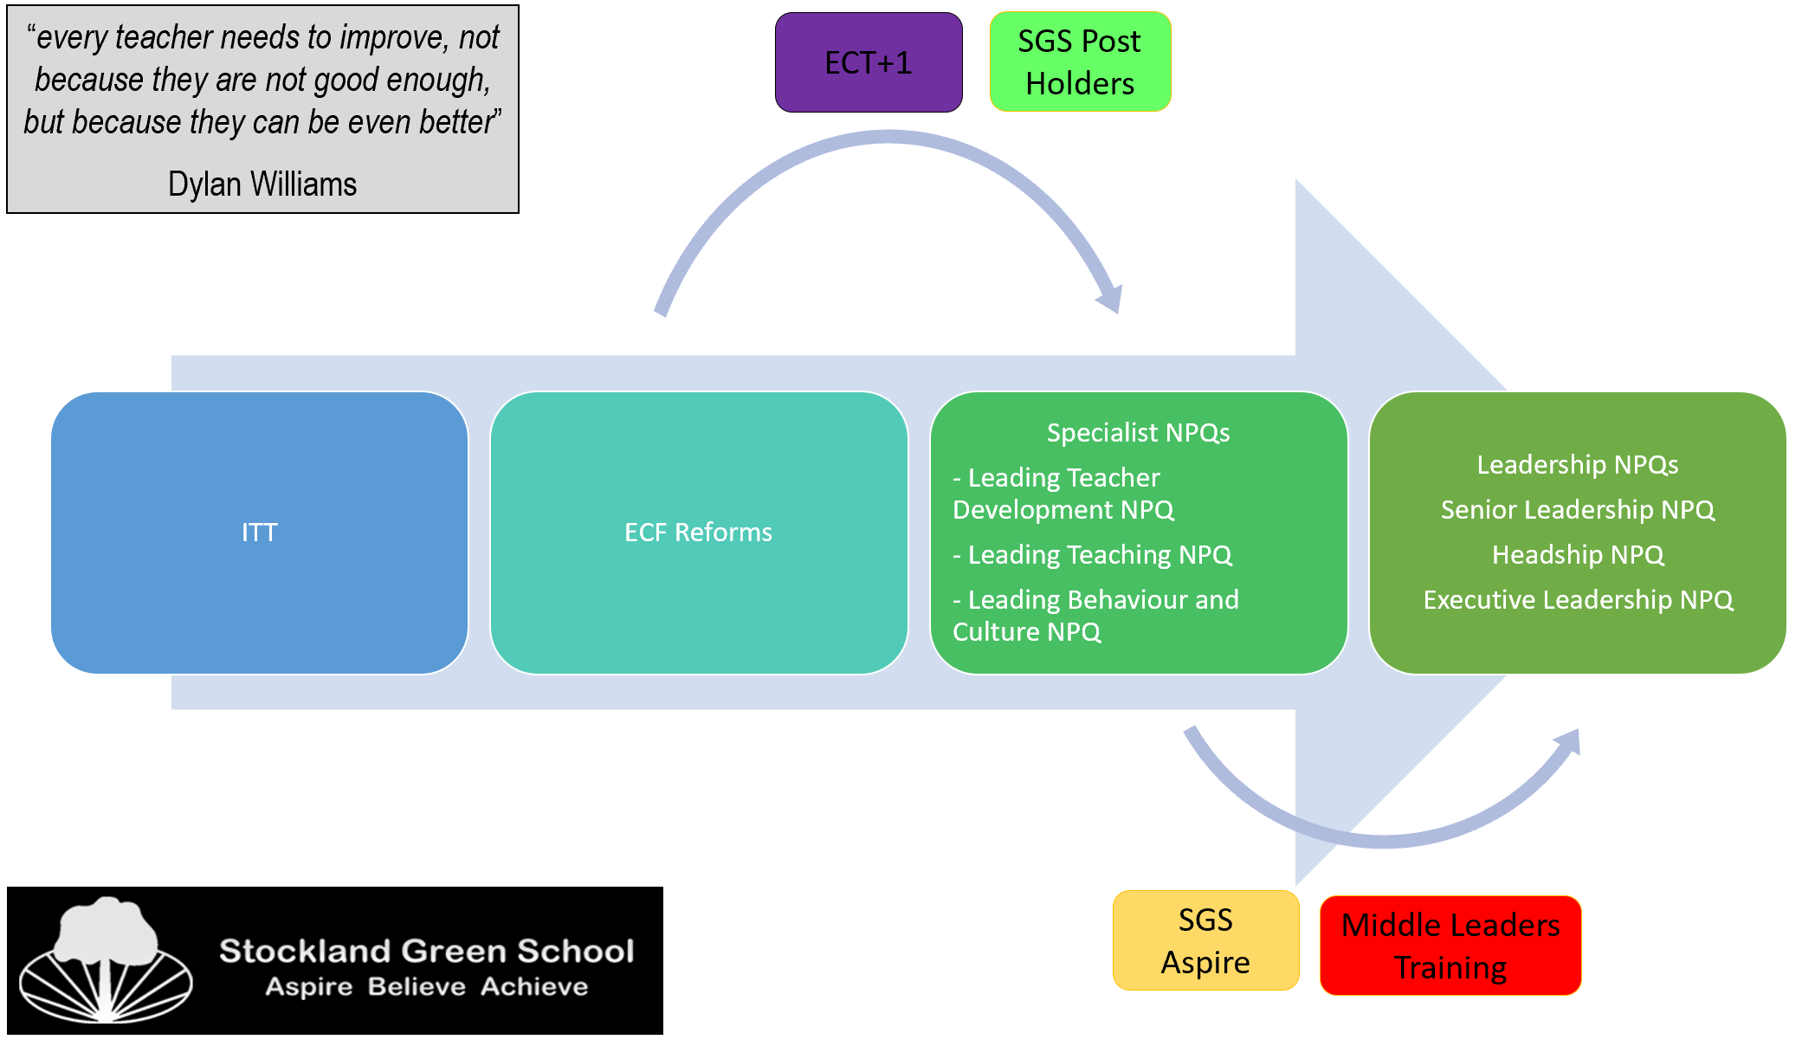

Knowledge driven curriculum

The ambition at Stockland Green School is to provide a high-quality education that transforms the life chances of our students through a ‘knowledge engaged’ curriculum.

An understanding of Cognitive Load Theory is central to the development of an effective knowledge engaged curriculum:

Teacher development will continue to focus on the principles of cognitive load theory with an appreciation that new information must be processed in the short-term working memory before being stored in the long-term memory. The capacity and duration of the working memory is limited and can become overloaded, limiting the ability of the brain to process new information.
Planning needs to consider that:

- The novice learner requires additional support to ensure that they do not experience overload of their working memory (cognitive overload), which inhibits their ability to process and learn new information.
- However, overly supporting the learning can limit the depth of understanding for those with greater expertise in a subject.

New knowledge is stored in the long-term memory in schemata [complex structures that link related topics together]. The schemata create meaning and can be built on over time.

The practical application of cognitive load theory and teaching strategies are key in lesson planning and will be developed through all teaching staff engaging in instructional coaching.

Cross curricular work

‘Being able to see these links allows careful sequencing of knowledge in a curriculum in order to allow students to travel a meaningful journey along the curriculum path’ – Ruth Ashbee

At Stockland Green School, we are driven to have a carefully sequenced, collaborative, knowledge driven curriculum (see above for our knowledge driven approach).

- STEM: We have developed an aspirational, carefully sequenced, collaborative STEM curriculum to inspire students to reflect on and appreciate the wonders of the wider world. Students will leave with an understanding of their role as stakeholders in the future of STEM. Teaching will be founded on a shared vision centred around enquiry questions that are shared across the knowledge found in our subject disciplines.
- Communications: Within the communications faculties we provide a broad curriculum that fosters mastery in individual subject areas. We want our students to be confident in their use of ambitious language, curious to enquire about the world around them and to both articulate and challenge big ideas.
- Numeracy skills: are mapped, embedded and carefully sequenced across the curriculum. We aim to develop consistent and effective explanations of key mathematical principles so students can apply their knowledge and skills across the curriculum. Our Numeracy curriculum gives our students the opportunity to study beyond the numbers, shapes and patterns, it also provides important tools for work in fields such as engineering, physics, architecture, medicine and business. It nurtures the development of a logical and methodical mindset, as well helping to inculcate focus and the ability to solve all manner of problems.
- Literacy: All aspects of literacy, whether that is reading, oracy or writing are central to academic success. However, recent research suggests that up to 20% students nationally leave school without mastering the essential skills of language. For this reason, we have placed the acquisition of these essential foundational skills at the heart of our curriculum. Through a range of common activities and processes across faculties, students are given the opportunity to develop their reading, writing and speaking skills regularly in multiple disciplines. It is our ultimate goal that no student leaves Stockland Green School without the capacity for communication necessary to succeed in life beyond school.

Assessment

‘At this time, the focus needs to be on the role that assessment plays in informing our current understanding of how students learn, and how their knowledge and conceptual understanding grows’ Chris Harrison, Professor of Science Education, Kings College London

What do we want from our assessment models?

“Wrong forms of assessment impact on the breadth and depth of curriculum, understanding of standards and the tools we use to raise them.” – Christodoulou

- Formative assessment geared towards identifying consequences. Providing information that can directly feed back into the teaching process. This needs to be specific, frequent and repetitive. Responsive teaching; short cycle, in the moment feedback, in tight loops.
- Summative assessment geared at creating a ‘shared meaning’, beyond the context of a classroom so that standards can be compared between classes and cohorts in school and the wider community. Infrequent. Subject specific assessment – in the form most useful for a particular discipline.
- Authentic assessment, focused on learning, not on generating datasets for the purposes or tracking performances of minute sub groups.

Formative Assessment
“The process of regular testing can strengthen retrieval and improve our retention of knowledge in our long term memory.” – Bjork

- Formative assessment (checking for understanding): Ongoing classroom assessment practices that inform teaching
- Frequent formative assessment opportunities for the teacher to check the students understanding and eliciting evidence of learning
- Formative assessment embedded into lessons including low stakes frequent testing, open-question quizzes, multiple-choice questions, questioning and modelling.
- Low stakes testing is designed to help pupils embed and use knowledge frequently and develop their understanding. Retrieval of relevant and interleaved knowledge from previous lessons, previous units, and previous years.
- This results in responsive teaching, pupils receive instant feedback, correct mistakes and improve answers.
- Clarifying, sharing, and understanding learning intentions and success criteria
- Self-assessment opportunities embedded within lessons using criteria, checklists and model answers. Students correct and improve their answers immediately after completing the task.
Summative Assessment

“Assessment has different forms in different subject disciplines. Imposing a general system loses the information that supports actual improvement.” – Sherrington

- Summative assessment regularity will be dependent on the needs of the subject. Maths and Science for example will have more ‘End of Unit’ style assessments than English and Humanities subjects would with longer essay assessed units of work.
- Summative assessments are carefully designed to create a successful progression model
- There is no ‘fixed’ summative assessment calendar, and faculty areas have mapped out, subject to their curriculum coverage and workload demands, their desired summative points throughout the year.
- 3 accumulative summative assessment points throughout the academic year
- The weeks leading up to summative assessments will focus on revision skills for students of all year groups.
- Access arrangements will be organised for all students entitled to them for key summative assessments
- See Assessment and Feedback Policy for Further Details.

Teacher Judgement

“Assessment data has no value in relation to improving the quality of student learning.” – Sherrington
- Too much assessment data will stop real learning, and overwork staff.
- In between assessment points, student work needs to be monitored, with misconceptions addressed and teaching processes reviewed and adapted to reflect this process.
- Teacher workload and wellbeing is important to us, and we trust our staff explicitly on the working levels of their students. To not overwork staff with extra marking, whilst also tracking student progress regularly, we rely in between assessment points on teacher judgement. These judgements will continue to be Working Towards, Meeting or Exceeding targets as set above, through standardisation processes.
- Frequency of teacher judgement between review points will depend wholly on the regularity of curriculum contact with students and will vary between CORE and Non-CORE faculty areas. A judgement should be made every time there is work of note to comment on.

Use of assessment data

Targets are challenging rather than estimates of future performance. Please see whole school target setting for further guidance on target setting. All KS3 students are targeted at age related expectations.

- Heads of Faculty, Subject Leaders, House and Pastoral Leaders should work where necessary with class teachers in reviewing the data at different stages throughout the year in order to inform future teaching and learning.
- There should be appropriate review points consisting of a student conference throughout the year according to the needs of individual subject curriculums. These review points will usually take the shape of summative assessments, but with Teacher Judgement cycles in between as necessary.

Following Review Points (Student Conferences)
There should be a standardised process following ‘review points’ from Heads of Faculty, House and Pastoral Leaders, SENCO. Calendared time should be used to assess current Attitudes to Learning and Attainment data, and performance of key sub groups, faculties and subject areas etc identified to target support. From these meetings a student conference is attended, where a shared and agreed set of actions for targeted students are determined in order to ‘close gaps’ in data and support a united T&L / pastoral approach.

It is the responsibility of the classroom teachers to ensure that the assessment data that they generate informs future planning, intervention and evaluations. Interventions should be put into place as a result of these analyses in order to ensure that all students are supported to make further progress.

Reporting
It is fundamental to student progress that parents / guardians are involved in the process of their child’s learning. Part of this process is the reporting, at various stages throughout the year, of a child’s attitude to learning, and progress towards their targets.

It is the responsibility of the classroom teacher to report to parents / guardians their child’s progress (KS3) / attainment (KS4) at specified review points in the year. A teacher should judge student’s attitude to learning as working towards, Meeting SGS or Exemplifying the Stockland Green Standard. At KS3 progress is reported in relation to their age related expectations. At KS4, the 1-9 national guidance is utilised.

All reports will require a short supporting statement from the classroom teacher where a student’s attainment, progress or attitude does not meet SGS. It is also expected that for students not meeting the required standards, contact home is made at the appropriate points throughout the year.

There is no expectation for full reports to be sent home, as all relevant information regarding a student should be communicated home regularly throughout the year.

Feedback

EEF- ‘Teacher feedback is an area of teaching and learning that is a central priority for teachers and is often associated with improving pupil attainment’

“Learning only happens in the detail of what students know and understand and the things they can do.”

- Feedback strategies at Stockland Green School are based on evidence informed principles
- Feedback does not exist in isolation; it must be rooted in the firm foundations of effective instruction.
- Methods and timings left to a teachers professional judgement- when and how to offer feedback is most appropriately answered by the teacher responding to the particular learning context of an individual.
- At Stockland Green School we believe feedback is crucial to your child reaching his / her full potential. With this view, our new Feedback Policy includes the following main features:

- Summative feedback: This will be through the grading of examinations and other assessments.
- DIRT Feedback: After work has been assessed, the following lesson must include ‘DIRT’ (Dedicated Improvement and Reflection Time)
- This DIRT should provide students with praise, misconceptions, model/ exemplar work and specific targets with the time given to respond, address misconceptions and improve responses. This will also allow teachers the opportunity to recognise excellent student work through rewards and support students who haven’t fully grasped concepts effectively. Students must respond to all targets in Green pen.
- Self / Peer feedback: Student will be expected to engage with marking criteria at appropriate intervals
- Whole class feedback: Following some assessment, students receive feedback that is prompt, immediately actioned, workload-efficient and effective in securing improvement.
- Live Feedback: Taking place during lesson time, this feedback will be responsive to student understanding as the lesson progresses. This will involve verbal feedback as teachers work alongside students to improve knowledge and correct errors / misconceptions. Use of visualisers and model answers can also be used
- Coded marking
- Thinking like the teacher
- Written comments

Marking / Frequency of Marking / Quality Assurance
All students have two exercise books per lesson. One exercise book (green) will be a work book. This will contain students practice notes and will not be formally marked. One exercise book (yellow) will be an assessment book. The assessment book will receive teacher, self and peer feedback and requires student DIRT to be evident following key assessments.

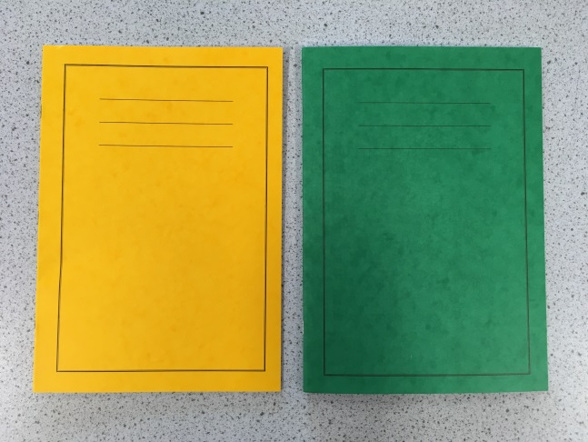

The frequency of marking in the yellow assessment books should be in line with the assessment calendar which aligns with Faculty curriculum needs. There is an expectation that all summative assessments must be marked using a model which provides a strength and offers specific feedback for improvement, one example used is a whole class feedback sheet.

Feedback may include both self and peer assessment opportunities. Assessment marking will be reviewed at scheduled points throughout the year by Faculty teams. Assessment books should also include intermittent diagnostic feedback to support students in their progress towards summative assessments.

Quality assurance: regular QA of students’ assessment books and lessons will take place in accordance with the assessment calendar and learning walk rota. The focus of this will be of the quality of effective instruction, feedback given and the impact on pupils learning. It is the responsibility of Heads of Faculty to conduct QA in Team meetings / CPD as appropriate, and to ensure follow up actions are completed.
Literacy
Literacy must be marked using specified codes.
It is recognised that it may not always be appropriate for every punctuation or grammatical error in a piece of writing to be corrected.
Corrections may be limited to subject specific key words and words it is felt that students should know. It is expected that correction of errors of literacy is a substantial focus in the marking of summative assessments.

Numeracy
Errors in calculations, vocabulary and units of measurement should be identified and students should make appropriate corrections.
Graphs tables and diagrams should be drawn in pencil and axes must be labelled correctly. When using computers, the correct graphs should be chosen, and axes must be labelled.
Teachers should comment on numeracy in feedback where relevant.
Numeracy skills to be assessed where relevant in low stakes testing.

Data driven instruction

- Data Driven instruction develops a culture of collaborative conversations about assessment. Such quality conversations lead to the, ‘distillation of the collective understanding from across the organisation to ensure exceptional provision and planning’ (Helen Angell, Director of School Improvement, Cabot Learning Federation).
- ‘Know and Show’ charts developed at the start of a unit to describe what brilliance looks like and what matters most at a subject level to improve teaching and student learning.
- Assessment is developed in line with this
- Data driven instruction meetings following key summative assessments to plan reteach lessons and any curriculum changes
- Data driven instruction meetings included in faculty assessment mapping and adapted to meets the needs of different faculties

Remote Learning

- Please refer to separate remote learning policy

Appendix 1 - DIRT (Dedicated Improvement and Reflection Time)
DIRT is about having the highest expectations of students and them having the highest expectations of themselves. DIRT is a great way for students to act upon the feedback that have been given from their teacher or peers. DIRT allows students to reflect/act upon the comments that have been written, as feedback. Ensuring the feedback is being put to use and is supporting progress. Not for their next piece of work but NOW!
‘DIRT lessons’ can form the starter or longer pieces of work; they could take the whole lesson. Students should complete the ‘DIRT’ work in a green where appropriate.
DIRT can be used for self and peer assessment – clear, measurable learning objectives, assessment bubbles or assessment objectives can support students reflecting or giving peer to peer assessment.
Keep it focused
Select the most relevant pieces of work, at the most appropriate time.

Directed
Give the process some structure. This will vary with subject and task. Don’t leave students with 15 minutes to fill and only your written comments to go on.

Model and scaffold
Use exemplar, giving students a high standard to reach for with their work. Reviewing a poor example, with the teacher, or improving upon a weak example of work also helps scaffold their understanding. DIRT time may seem to be about independent work, but teacher guidance is key.

Make oral feedback count
With good quality modelling and scaffolding students should be sufficiently focused to allow the teacher to undertake good quality ‘one to one feedback’ whilst DIRT is taking place.

Time
Plan for DIRT! Set aside some of your lesson time for this process, this might even be a whole lesson. Never a token 5 minutes.

Examples of DIRT Activity’s
Reflection and responding to precise feedback
Students using teacher feedback to analyse their own work, question by question improving methodology and accuracy of answer.

Feedback in the form of questions to extend students understanding
This scaffolds student understanding, step by step, with the expectation that students act upon their feedback using DIRT – writing an appropriate detailed response to teacher feedback.

Drafting and proof reading, their books with a clear signal that improving their writing and literacy is a basic, but crucial expectation of their learning. In this case DIRT marking is about improving extended writing and ensuring students proof read their work automatically.

Appendix 2 – SPAG as part of the Stockland Green Standard
Throughout the section of work that is marked, teachers and students will use the following notation to highlight Spelling, Punctuation and Grammar.

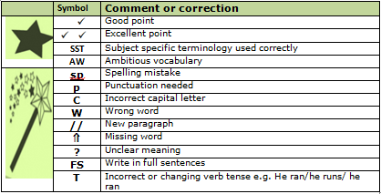

Appendix 3 – The Stockland Green Standard

Appendix 4 - Presentation Expectations (as part of the Stockland Green Standard)
