Year 11 CURRICULUM MAP | French
 | Autumn Term | Spring Term | Summer Term
Unit Length | 13 weeks | 13 weeks | 3 weeks
Assessment Objectives (and skills taught) | AO1 Listening  AO2 Speaking  AO3 Reading & Translation  AO4 Writing & Translation | AO1 Listening  AO2 Speaking  AO3 Reading & Translation  AO4 Writing & Translation | AO1 Listening  AO2 Speaking  AO3 Reading & Translation  AO4 Writing & Translation
Description of the topic and key learning outcomes | Module 8: Un oeil sur le monde  - Weather & natural disasters  - Protecting the environment  - Ethical shopping  - Volunteering  - Big events  Revision:  Module 1: Who am I?  Module 2: Festivals | Revision  Module 3: Daily life  Module 4: Town  Module 5: Holidays  Module 6: Education | Module 7: Work  Final GCSE Exams
Milestone assessments | End of Module GCSE style Assessments in all 4 skills | End of Module GCSE style Assessments in all 4 skills  + Trial Exams | April – May: Speaking Exams  May – July: Listening, Reading and Writing Exams
CEIAG | Careers links this year will focus on preparing fully for further education. There will be a focus on developing the key skills of communication (particularly oracy, literacy, listening), self-confidence, self-assessment (identifying strengths and weaknesses), target setting, team work, problem-solving, organisation, hard work, creativity, compassion, numeracy and reliability.
Wider Curriculum Links | Geography: Climate, environment  Citizenship: Fair trade  PE: National and international events | Citizenship: Well-being  PRIDE | Citizenship: Well-being  PRIDE
Wider reading | www.duolingo.com  www.memrise.com  www.gojimo.com
Literacy programme | - Simple future tense  - on doit/on peut + infinitive  - The passive  - Emphatic pronouns  - Three time frames | - Exam strategies  - (Near) cognates, false friends  - Listening & reading for gist  - Listening & reading for detail  - Spotting grammar clues  - Question words | - Exam strategies  - (Near) cognates, false friends  - Listening & reading for gist  - Listening & reading for detail  - Spotting grammar clues  - Question words
Independent Learning Tasks  (in French) | 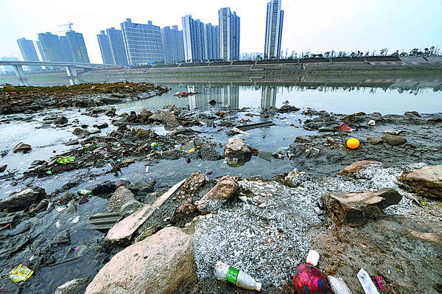  - Write 20-30 words to describe the photo above.  - Write 40-50 words about charity work (what you do to help others, a recent charity activity, why it's important to help others and future charity plans).  - Write 80-90 words about protecting the environment (what you do(n't do), what we should do, what you will do in the future). | Work through your:  - GCSE Photo-card booklet  - GCSE Role-play booklet  - GCSE Conversation booklet  - GCSE Writing booklet  Revise vocabulary and structures using the websites above. | Work through your:  - GCSE Photo-card booklet  - GCSE Role-play booklet  - GCSE Conversation booklet  - GCSE Writing booklet  Revise vocabulary and structures using the websites above.

