Overview of topic: You will become accustomed to the preparation, rehearsal process and organisation of a live performance on stage whilst learning the Ukulele!
Key content/ ideas/ concepts | Keywords/ Glossary
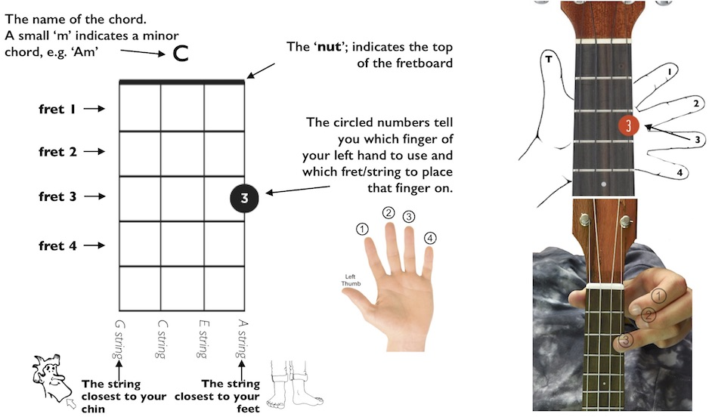  From rehearsal to performance…  in 1 – 2 – 3 – 4  1. Before you rehearse…  - Check your instrument is in tune (if appropriate)  - Do some warm-up exercises on your instrument/voice (vocal warms up if you’re a singer)  - Consider your posture and technique as this will improve your tone  - Make sure you are prepared with all of the equipment you need (instrument, leads, music etc.)  2. How to rehearse effectively…  -Write on your music (add notes to help you remember certain parts)  - Highlight the difficult parts  - Play the difficult parts on their own  - Practise your part slowly and repeatedly, then gradually build up the tempo  - Repeat. Repeat. Repeat.  - Record yourself practising so that you can listen back and reflect  - Rehearse in front of other people to help build confidence  4. After your performance/rehearsal…  Evaluate your performance. You can do this by:  - Listening/watching back to a recording if your performance  - Writing down how you felt the performance went  - Identifying the positives of your performance.  - Identifying areas that you think needs improving  3. What makes a strong performance…?  - Keeping rehearsals focused  - Practicing Tops and Tails (beginning and end).  - Band interaction: This helps with your stage presence and keeping everyone focused and together.  - Eye contact with your audience: This shows your confidence and that you acknowledge they are there.  - Professionalism: No talking to band members during a performance and acknowledging an applause at the end. | Melody A tune, where one note is played after another.  Fluency The ability to play a piece of music without any gaps or stutters.  Intonation The pitch accuracy of singer or instrument.  Accuracy To be precise or correct.  Dynamics The volume of music.  Articulation How specific notes or passages are played or sung.  Chords A group of (typically three or more) notes sounded together, as a basis of harmony  Major Chords Happy-sounding chords  Minor Chords Sad-sounding chords  Stage Presence How you act and perform on stage.  Wider Reading  https://liveukulele.com/songs/easy-ukulele-songs/  https://www.knowyourinstrument.com/basic-ukulele-chords-beginners/

Self-Quiz Questions | Self-Quiz Questions | Challenge Self-Quiz Quizzing
- What is a melody? | 1. What should you do before you begin rehearsing? (name 3 things) | Task 1: Create a resource that will help prepare other students for a live music performance. It must include the preparation process, rehearsal process and tips for good stage presence.
- What does fluency mean? | 2. Name 3 strategies on how to rehearse effectively.
- What does accuracy mean? | 3. Name 3 things that make a strong performance.
- What does intonation mean? | 4. What should you think about when evaluating your performance? | Task 2: Create a poster on ‘how to rehearse effectively’ for other students to read and use.
- What does articulation mean? | 5. What is meant by stage presence?
- What are dynamics? | 6. What does crescendo mean? | Task 3: Create a poster with information on for ukulele players, which gives advice on how to perform on stage (use the first Wider Reading link)
- What is tempo? | 7. What does diminuendo mean?
- What are chords? | 8. What does forte mean? | Task 4: Create a poster for beginner ukulele players which explains what a ukulele is, how to play it, how to tune it and with details of some ukulele chords.
- How do major chords sound? | 9. What does piano mean?
- How do minor chords sound? | 10.What are the names of the strings on a Ukulele?
Total score | Total score | Total score

